Gene Technology Ethics and Community Consultative Committee
2026-2029
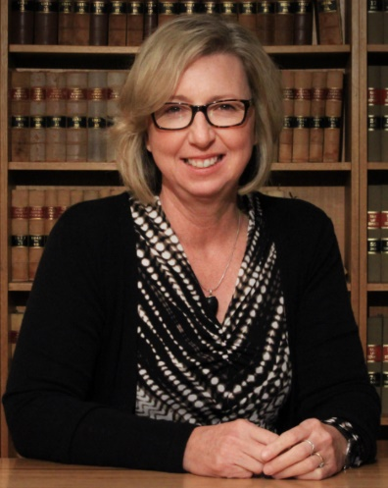 | Judith Jones, GTECCC Chair  Associate Professor BSc (Syd); LLB (NSW); DipPracLegTraining (UTS); Solicitor NSW  Judith is an Associate Professor at the ANU College of Law.  Harnessing her dual background in both science and law, Judith began her research career as an environmental and planning lawyer by focussing on uncertainty, precaution and risk assessment. This has included almost two decades of service, in different capacities, on the federal non-statutory and statutory bodies that provide advice to the Gene Technology Regulator on legal and ethical issues relating to risk assessment and the regulation of gene technology in Australia. Judith has a range of scholarly publications in the areas of environmental impact assessment, risk regulation and precaution. The emphasis in those publications is designing regulation in conditions of scientific and other uncertainty. She is also a member of the ANU Institutional Biosafety Committee.  Judith’s research also combines her environmental law research interests with her own rural background and interests in Australian legal history to examine the impact of historical and current practices on Australian soils, water and vegetation. This research focusses on the impact of colonial property law and culture on landuse practices and consequent environmental degradation. In terms of contemporary agricultural landuse, this research focusses on law and culture relevant to encouraging sustainable landuse practices in regions of high agricultural value.
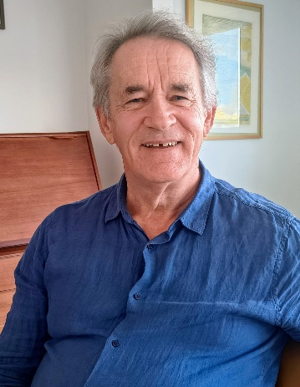 | Ian Sanders  BSc(Ag) (Sydney University), B Ed (Edith Cowan, Perth), GAICD  Recently retired, Mr Ian Sanders taught science and agriculture before a public service career in agricultural trade and investment, including as Director of International Engagement for NSW Department of Primary Industries.  Most recently he was Manager of Resilience and Innovation with Natural Resources and Environment Tasmania which involved him, amongst many activities, in the administration of the Tasmanian Gene Technology Policy 2019-2029. This includes an ongoing monitoring of developments in gene technology, markets and consumer sentiment.  Ian has been a community member on the Institutional Biosafety Committee for UTAS since February 2025.
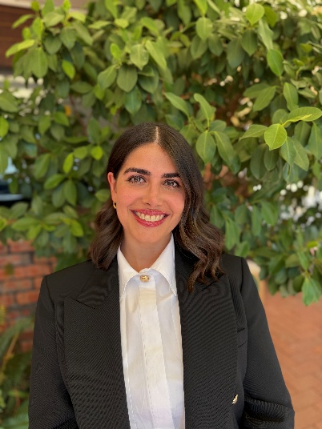 | Olga Pandos  LLB(Hons) (Adelaide), BSc (Biochemistry & Genetics) (Adelaide), PhD (Law) (Adelaide), Barrister and Solicitor in the Supreme Court of South Australia  Dr Olga Pandos is a Lecturer in Law at Deakin Law School. She is also the Deputy Director of the Law, Health and Society Research Unit at the Deakin Law School. Since 2023, Olga has been a Lecturer in Law at the University of Adelaide, Adelaide Law School. In 2020, she was admitted as a Barrister and Solicitor in the Supreme Court of South Australia. Using her background in Law and Science (Biochemistry and Genetics), her research expertise focusses on health law, ethics and emerging technologies. Olga’s doctoral thesis focussed on Clustered Regularly Interspaced Short Palindromic Repeats (‘CRISPR Technology’). The thesis examined the ethical and regulatory implications of Heritable Human Genome Editing.  Olga’s research traverses beyond genome editing and genomics, with a specific focus on decision-making capacity, consent, access to justice for vulnerable populations and reform. Within her research, she has consulted widely with a variety of stakeholders, including Aboriginal and Torres Strait Islander communities, persons with a disability and culturally and linguistically diverse communities. The intersection of health, medicine and law are fundamental themes within her research. Her research has been published in leading peer review law and interdisciplinary journals.  Olga has extensive experience working within policy, law reform and consultation. She has been a lead researcher and project manager at the South Australian Law Reform Institute for 4 years. She has been an author of 6 reports to the South Australian State Government. Most recently, Olga led and was lead author of the statutory independent review of the Mental Health Act in South Australia. Prior to her work at the South Australian Law Reform Institute, Olga worked as a policy officer for the Royal Commission into Aged Care Quality and Safety.
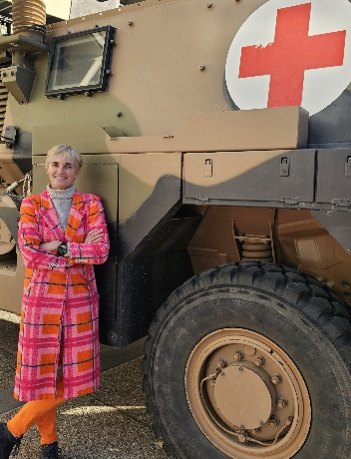 | Tegwen Howell  M Economic Studies. (Queensland)  Tegwen has over 30 years’ experience in health and medical research; including managing large complex multi-site projects; ethics and governance administration processes; and clinical trials in both Australia and Canada. She is passionate about rural and remote health care and research, with interests in aged care and mental health. Tegwen has experience in Indigenous research ethics governance, working with communities to inform research ethics review processes. She is currently a committee member with an NHMRC registered Human Research Ethics Committee.
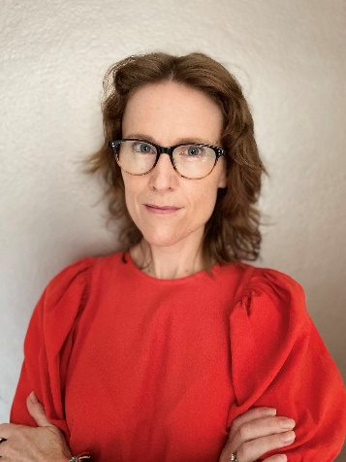 | Ainsley Newson, AHEC cross member  BSc(Hons) (University of Melbourne), LLB(Hons) (University of Melbourne), PhD – Bioethics (University of Melbourne).  Ainsley Newson (she/her) is Professor of Bioethics with Sydney Health Ethics, Faculty of Medicine and Health, University of Sydney. Professor Newson has worked in bioethics for over 25 years, and has held continuing teaching/research positions in Australia and the United Kingdom.  Ainsley has been interested in the ethical implications of genetics since adolescence. A formative experience was attending the National Science Summer School (now the National Youth Science Forum), where she first learned about the policy and political relevance of genetic modification. An MP – she can no longer remember who! – gave her a copy of the 1992 House of Representatives Standing Committee on Industry, Science and Technology Report Genetic Manipulation – The Threat or the Glory?  Her studies and career ever since have been oriented towards the ethical, legal and social implications of human genetic, genomic and reproductive technologies. A key driver in Ainsley’s work is her ability to engage with experts across disciplines.  She has researched and published on a wide range of issues, including synthetic biology, gene editing, mitochondrial donation and population genetic screening. Her research has attracted more than $90m of research funding and she has published over 230 outputs for professional and lay readership.  Ainsley is a member of the Australian Health Ethics Committee and the Board of the International Association of Bioethics, and she is also active in the Regulatory and Ethics Working Group of the Global Alliance on Genomics and Health.
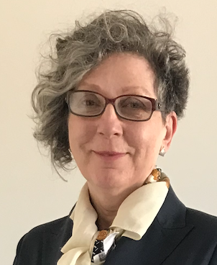 | Rachel Nowak  BSc (Hons) (University of Leeds), MA (Johns Hopkins University), PhD (University of Leeds), GAICD (Graduate Australian Institute of Company Directors)  Dr Nowak is a consultant, an advisor, a scientist and a journalist. She has worked on or in every step of the research, innovation and commercialisation pathway in the UK, Germany, USA, and Australia. Her specialities include biotech, agricultural science, brain tech, higher ed and media.  What motivates her is getting scientific knowledge and insight into the right hands, be it NGOs, companies, government departments or a single person. That way it can be used to benefit people and the world we live in. She is also motivated by getting different types of people involved in R&D.  Rachel has built new capabilities for some of Australia’s largest research organisations. Raised the profile of Australian research on the global stage. And founded a social-good brain tech start-up.  She is an award-winning US journalist, known for influential reports that changed R&D practice, and research law and policy around the world. She immigrated to Australia, which is now home, under the Distinguished Talent visa program. This is for people with an international record of outstanding achievement.  She is the recipient of an Alexander von Humboldt Fellowship to conduct agricultural research in Hanover, Germany. A Queen Elizabeth II Fellowship to research at Monash University in Australia. And a scholarship to study writing alongside poets and novelists at Johns Hopkins University in the US.
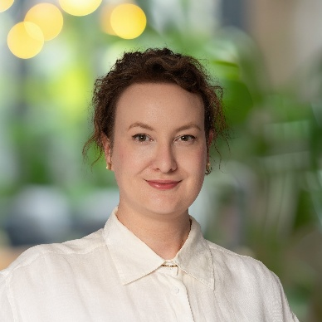 | Hilary Bowen-Smart  PhD (University of Melbourne); MPH (University of Newcastle); BSc(Hons) (Monash University); BA (Monash University); Dip. Lang. (Monash University)  Hilary Bowman-Smart is a Research Fellow in the College of Health at Adelaide University. Hilary works within empirical bioethics and philosophy, with a focus on reproductive ethics, genomics, technology and diagnosis. She was awarded her PhD by the University of Melbourne in 2022. She has an interdisciplinary background and training in genetics, philosophy, classics, and public health. Her research approach involves ethical analysis that is informed by various types of empirical research, such as surveys, data linkage, and qualitative interview studies.  Prior to her role at Adelaide University, she held a position as Researcher in the Ethics of Prenatal Genetics and Genomics at the University of Oxford between 2021 and 2023. In this role, she worked on a project comparing the implementation of non-invasive prenatal testing (NIPT) in England, France and Germany, with her research conducted in both English and German. She has also been a visiting fellow at the University of Augsburg and holds honorary positions at the Murdoch Children's Research Institute and Monash University. She is currently an Empirical Bioethics stream lead for the Australasian Association of Bioethics and Health Law.
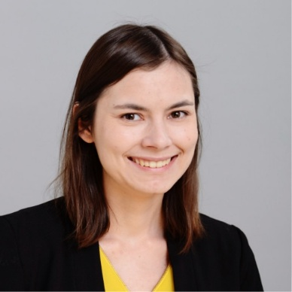 | Claire Finfer  BHlthSci (Sydney), MBEth (Sydney)  Claire Finfer holds a Bachelor of Health Science, with majors in health science and sociology, and a Master of Bioethics. She has experience in both clinical and research ethics and governance, currently serving as Clinical Ethics Consultant for the Central Adelaide Local Health Network. Claire previously was Research Development Manager (Ethics and Governance) at Northern Sydney Local Health District, where she oversees ethical review processes, Institutional Biosafety Committee and compliance with national frameworks, including Gene Technology. She has also served as a member of the NSLHD Human Research Ethics Committee. Claire is an Associate Fellow of the Australasian College of Health Service Management.  Her research and professional interests span bioethics and governance. She brings a strong understanding of NHMRC requirements, and the practical as well as broader societal implications of scientific innovation.  She is committed to strengthening public trust in research and supporting transparent, ethically grounded approaches to gene technology, informed by her interdisciplinary training and experience across health systems.
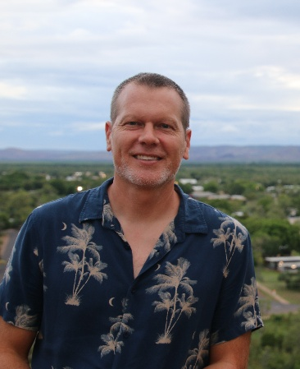 | Daniel Robinson  BSc(Adv Sc – Environmental, Hons, from UNSW), Grad Dip Env Law (Sydney), PhD Human Geography (Sydney).  Daniel Robinson is Professor in the Environment and Society Group at the University of New South Wales (UNSW), Sydney. He is also Associate Dean, Research Quality and Culture in the faculty of Arts, Design and Architecture (ADA), UNSW. He has 20+ years’ experience working on regulations, policy and ethics relating to genetic resources, access and benefit-sharing (ABS), Indigenous/traditional knowledge, and related intellectual property issues. He often works collaboratively on projects towards fair and equitable biological resource value chains with Indigenous bush foods and medicines producers, as well as government, industry (mostly SMEs), and researchers. He has provided policy advice on genetic resources, ABS and traditional knowledge, and implementation of the Convention on Biological Diversity (CBD) and Nagoya Protocol to Australian governments, regional organisations in SE Asia and the Pacific, and UN agencies (e.g. WIPO). Over several years, he has previously run teaching programs including the Master of Environmental Management, and the Master of Environmental Law and Policy.
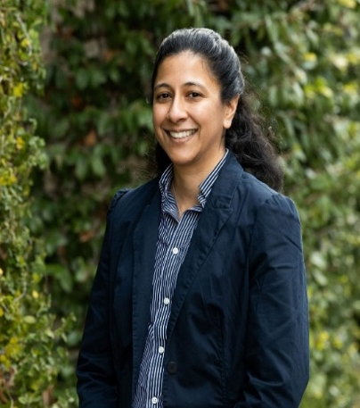 | Adj. Prof. Aanandini Ganesalingam  BSc (1st Class Hons) & Bec (W Australia), PhD (W Australia), GAICD  Adj Prof Aanandini (Dini) Ganesalingam is an agrifood research and development expert with experience spanning plant breeding, applied statistics, data governance and Research, Development & Extension (RD&E) investment strategy. She has led and advised on national and international research portfolios across industry, government and publicly funded research organisations, with a strong focus on risk governance and evidence-based decision-making.  Dr Ganesalingam has held multiple advisory and board roles supporting strategic oversight of agricultural innovation and technology translation.  Aanandini currently serves on the AgriFutures Rice RD&E Panel, and Emerging Industries Technical Advisory Group. She has recently been appointed Director of the Australasian Plant Breeding Association Board.
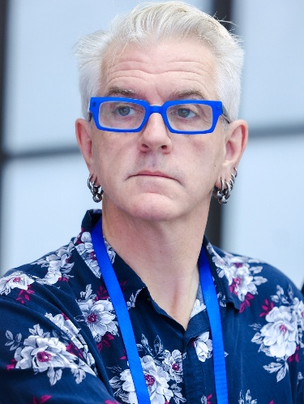 | Professor Robert Sparrow  BA (Hons) (Melbourne), PhD (ANU)  Rob Sparrow is a Professor in the Philosophy Program, and an Associate Investigator in the Australian Research Council Centre of Excellence for Automated Decision Making and Society, at Monash University, where he works on ethical issues raised by new technologies. He completed an ARC Future Fellowship on “A new ethics for the development and application of genetic technologies in a pluralist society.” He has been a Japanese Society for the Promotion of Science Visiting Fellow at Kyoto University, a Visiting Fellow in the CUHK Centre for Bioethics at the Chinese University of Hong Kong, a Visiting Fellow at Carnegie Mellon, and a Visiting Fellow at the Centre for Biomedical Ethics at the National University of Singapore. He has published widely on the ethics of genome editing as well as the ethics of AI and robotics.

