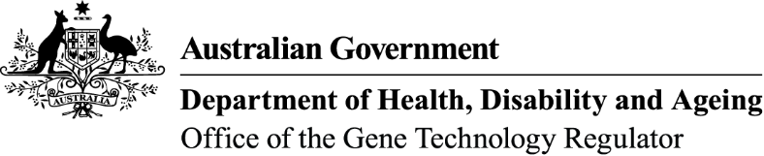 August 2026
Questions & Answers on licence application DIR 227 – Commercial release of wheat genetically modified for increased nicotianamine
What is this application for?
The University of Melbourne is seeking approval from the Gene Technology Regulator for the commercial release of a genetically modified (GM) wheat. The purpose of the application is to allow cultivation of the GM wheat Australia-wide. The release would be subject to restrictions in some Australian States and Territories for marketing or trade reasons.
What is the purpose of the GM wheat?
The GM wheat is intended to produce grain with increased levels of bioavailable iron and zinc. The primary intended use of the GM wheat is as animal feed.
Could the GM wheat also be sold as food?
The GM wheat can only be sold as food for human consumption if this is authorised by Food Standards Australia New Zealand (FSANZ). FSANZ also sets the requirements for GM food labelling in Australia. FSANZ is currently assessing the safety of the GM wheat and its products as food for human consumption under a separate application, A1356.
An explanation of which government agencies regulate GM wheat is available as an infographic.
How is the GM wheat different from non-GM wheat?
The GM wheat has been modified to produce a higher level of nicotianamine than non-GM wheat. The main introduced gene in the GM wheat, OsNAS2, is a nicotianamine biosynthesis gene from rice.
The GM wheat also contains two antibiotic resistance marker genes which were used in its initial development.
What is nicotianamine?
Nicotianamine is a metal-binding molecule that is naturally present in most plants, including all crop plants. Nicotianamine helps plants to take up micronutrients such as iron and zinc from soil and to transport these metals within the plants. Nicotianamine can also make iron and zinc more bioavailable (easier to digest and absorb) for animals or humans that eat the plants.
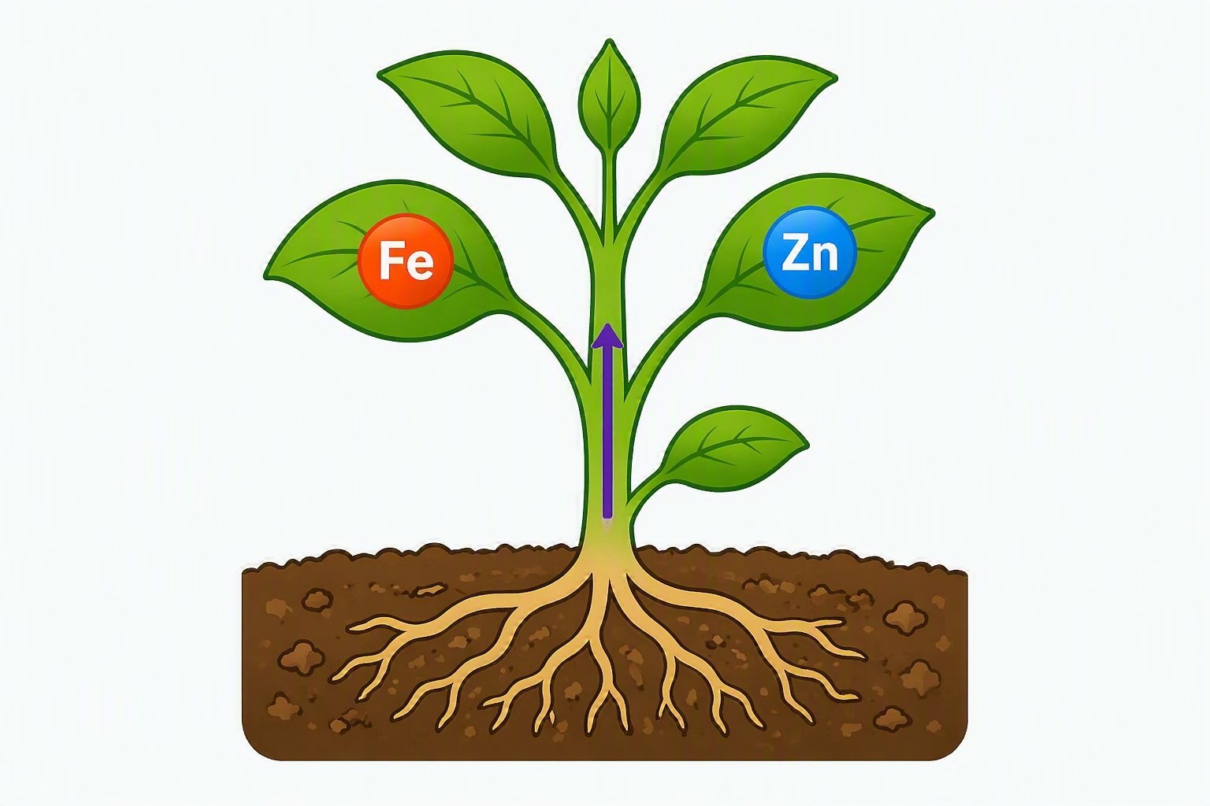
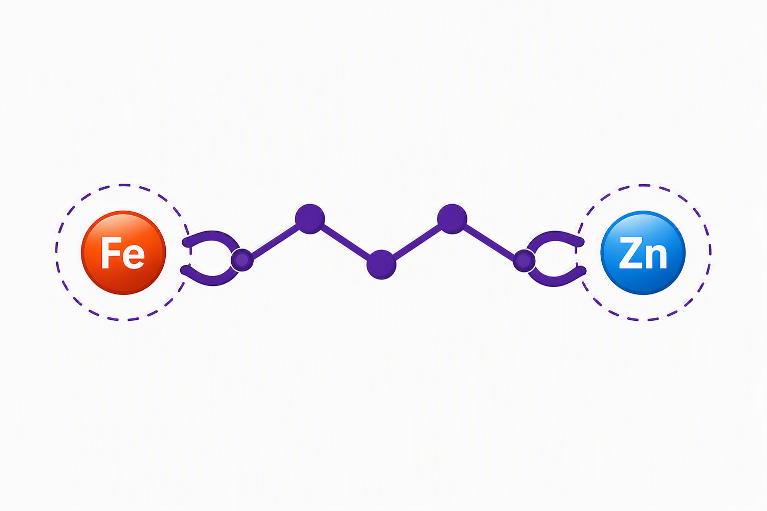
Nicotianamine is not related to nicotine (the addictive molecule in tobacco products) or nicotinamide (vitamin B3).
Plant
Nicotianamine
Metal-binding molecule
Iron
Zinc
What is the process for considering this application?
Scientists at the Office of the Gene Technology Regulator (OGTR), which is a specialised Australian government agency, will prepare a detailed risk analysis for the licence application. The analysis will consider whether there are any potential risks to human health and safety or the environment from the proposed release of GM wheat.
The OGTR will consult with a wide range of experts and the public prior to finalising the risk analysis. A timeline of the OGTR’s assessment process is available as an infographic.
When can I comment on this application?
Public consultation is expected to start in December 2026.
We will notify subscribers to OGTR News of the consultation and advertise it in newspapers and on our website. The consultation will be open for written submissions for about 2 months.
Where can I find more information?
For a summary of this licence application, please search for DIR 227 on our website. We will provide more detailed information for this application when we start the public consultation.
You can also request a copy of the licence application from the OGTR using the contact details below. Please quote our identifier DIR 227 in any communications with us about this application.

