OGTR News and Updates Issue 13

OGTR News and Announcements

- Committee appointments - The gene technology legislation establishes two committees that advise the Regulator and the Gene Technology Ministers’ Meeting; the Gene Technology Community Consultative Committee (GTECCC) and the Gene Technology Technical Advisory Committee (GTTAC). The membership of these committees expired on 31 January 2026 and the Regulator and her office thank the committee members for their service and for the excellent advice provided over the last three years. We would also like to acknowledge the work of the outgoing GTTAC chair Professor John Rasko AO who has provided thoughtful advice and long-term leadership for the committee.

- On 19 December 2025, the Minister responsible for gene technology, the Hon Rebecca White MP, appointed new membership of GTECCC and GTTAC for the next triennium. Both committees have a combination of new and ongoing members and provide a wide range of expertise. The Regulator and her office welcome the new committee membership and look forward to working with them for the next three years. More information about the committees and their work is on the committees section of our website.


- Happy 25th anniversary to the OGTR! - This past June we celebrated a significant milestone, marking 25 years of operation and our ongoing commitment to the safe regulation of gene technology in Australia. We extend our thanks to everyone who has contributed to the OGTR over the past 25 years and look forward to continuing our work together.


Please join us at the 2026 IBC Forum – an opportunity for representatives of accredited organisations and IBCs to connect, discuss key issues in gene technology regulation, hear the latest updates and engage with the OGTR.
If you have a topic suggestion or a case study to share, email ogtr@health.gov.au with “IBC Forum” in the subject line.
Attendance is free, with program and registration details to be provided 6–8 weeks before the event.
Save the Date: The 11th National Institutional Biosafety Committee Forum

The National Museum of Australia, Canberra
14 – 15 October 2026
Are your organisations contact details up to date and do you need portal access
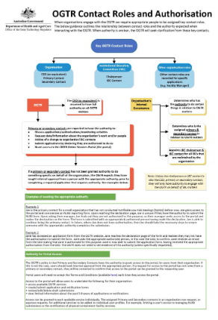
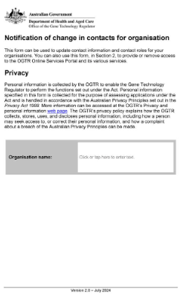
It is important that we have correct contact details for your organisation. The Notification of change in contacts and portal access for an organisation form can be used to update contact details for key personnel.

We have a guidance document explaining the authority of key contact roles with specific examples to help you in your selection. Please contact ogtr.applications@health.gov.au if you need assistance.

If a member of your organisation requires access to the OGTR Portal, please complete the Notification of change in contacts and portal access for an organisation form.


Use of AI in OGTR
OGTR is committed to the safe, ethical, responsible and legal use of AI. OGTR has access to M365 Copilot Chat to assist in our day-to-day work. We are aligned to the Australian Government Department of Health, Disability and Ageing and whole of government approach to use of AI, with our use cases limited to:
- Documentation summarisation and analysis,

- Content creation and editing,
- Meeting and task management,
- Data insights and visualisation,
- Information extraction and background research, and
- Image generation.
OGTR does not use AI meeting transcription services and does not use AI to evaluate or make decisions on applications ensuring delegate accountability for decisions. Application data, sensitive information, and any potential CCI is not used with AI tools.
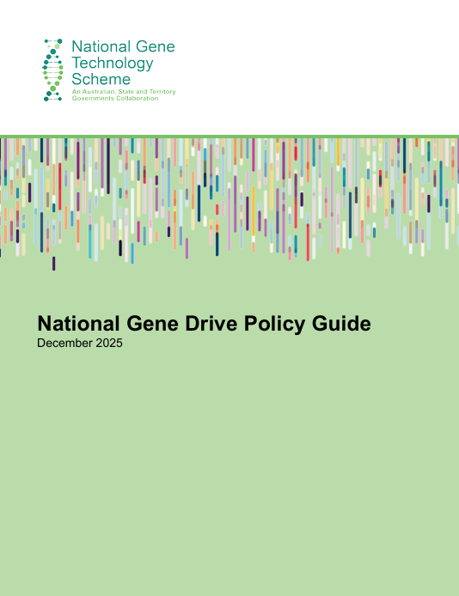
Gene Drives Policy Guide

The National Gene Drive Policy Guide has been published on the gene technology scheme website. The guide was developed in consultation with all Australian government, and experts from research and industry.

The guide will help proponents of gene drive technology understand:
- how gene drive technology and organisms are regulated in Australia
- what to consider before applying for gene drive technology research or environmental release.

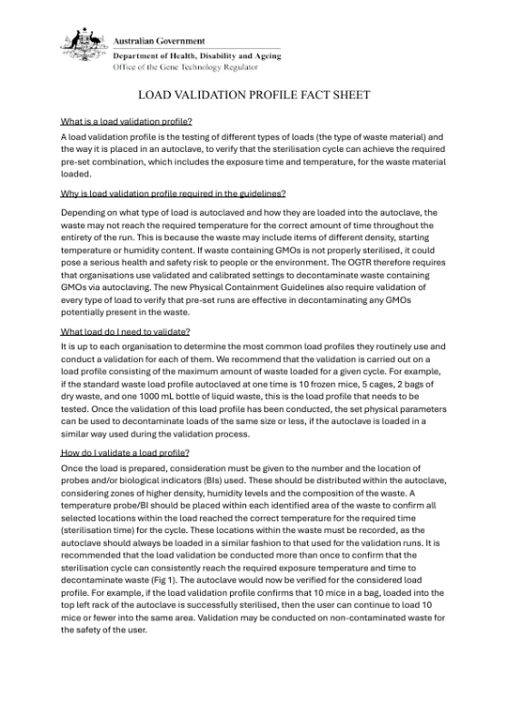
New factsheet (autoclave validation) Load validation profile of autoclave

The Guidelines for Certification of a Physical Containment Level 3 Facility, implemented on 1 December 2022, include a condition clarifying that autoclaves must be validated. Validation must demonstrate that specified physical parameters are consistently achieved for each load type. This ensures effective decontamination of any live GMOs.

This condition will apply for autoclaves used in the destruction of GMOs across all facility levels and to the Guidelines for Transport, Storage and Disposal of GMOs,. To support this, the Office has developed a guidance document explaining the expectations for validating load profiles and why this process is critical for GMO containment. The document is available on the OGTR website. - Load Validation Profile Fact Sheet | Office of the Gene Technology Regulator

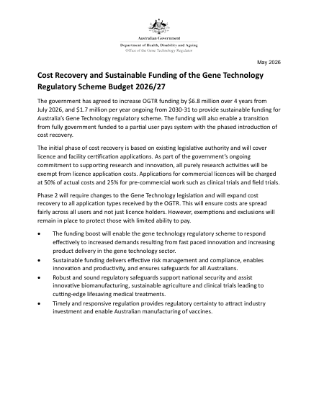

OGTR moving to cost recovery in a phased approach

The government has committed to transition the OGTR from being fully government funded, to a partial user pays system with the phased introduction of cost recovery.

Read more at: Cost Recovery and Sustainable Funding of the GT Regulatory Scheme


- CDES@health.gov.au Contact the Evaluation Section to ask questions about preparing DIR/DNIR licence applications (including variations, transfers and surrenders), certification applications including variations, transfers and surrenders) and classification of GMO dealings.
- OGTR.M&C@health.gov.au Contact the Monitoring and Compliance inbox for incident reporting, inspection planning, and other enquiries after a licence is issued.

If you need to contact OGTR, please use one of our group inboxes. If you only contact an individual OGTR staff member, your email may be missed.
An enquiry to any of our inboxes will be redirected if needed to ensure an appropriate response.
- OGTR@health.gov.au If unsure who you should contact, use this general OGTR email address, and it will be forwarded to the appropriate Section.
- OGTR.applications@health.gov.au Contact the Applications inbox for all application submissions, NLRDs, accreditation, and other general enquiries.

Who to talk to?

