LOAD VALIDATION PROFILE FACT SHEET

What is a load validation profile?
A load validation profile is the testing of different types of loads (the type of waste material) and the way it is placed in an autoclave, to verify that the sterilisation cycle can achieve the required pre-set combination, which includes the exposure time and temperature, for the waste material loaded.
Why is load validation profile required in the guidelines?
Depending on what type of load is autoclaved and how they are loaded into the autoclave, the waste may not reach the required temperature for the correct amount of time throughout the entirety of the run. This is because the waste may include items of different density, starting temperature or humidity content. If waste containing GMOs is not properly sterilised, it could pose a serious health and safety risk to people or the environment. The OGTR therefore requires that organisations use validated and calibrated settings to decontaminate waste containing GMOs via autoclaving. The new Physical Containment Guidelines also require validation of every type of load to verify that pre-set runs are effective in decontaminating any GMOs potentially present in the waste.
What load do I need to validate?
It is up to each organisation to determine the most common load profiles they routinely use and conduct a validation for each of them. We recommend that the validation is carried out on a load profile consisting of the maximum amount of waste loaded for a given cycle. For example, if the standard waste load profile autoclaved at one time is 10 frozen mice, 5 cages, 2 bags of dry waste, and one 1000 mL bottle of liquid waste, this is the load profile that needs to be tested. Once the validation of this load profile has been conducted, the set physical parameters can be used to decontaminate loads of the same size or less, if the autoclave is loaded in a similar way used during the validation process.
How do I validate a load profile?
Once the load is prepared, consideration must be given to the number and the location of probes and/or biological indicators (BIs) used. These should be distributed within the autoclave, considering zones of higher density, humidity levels and the composition of the waste. A temperature probe/BI should be placed within each identified area of the waste to confirm all selected locations within the load reached the correct temperature for the required time (sterilisation time) for the cycle. These locations within the waste must be recorded, as the autoclave should always be loaded in a similar fashion to that used for the validation runs. It is recommended that the load validation be conducted more than once to confirm that the sterilisation cycle can consistently reach the required exposure temperature and time to decontaminate waste (Fig 1). The autoclave would now be verified for the considered load profile. For example, if the load validation profile confirms that 10 mice in a bag, loaded into the top left rack of the autoclave is successfully sterilised, then the user can continue to load 10 mice or fewer into the same area. Validation may be conducted on non-contaminated waste for the safety of the user.
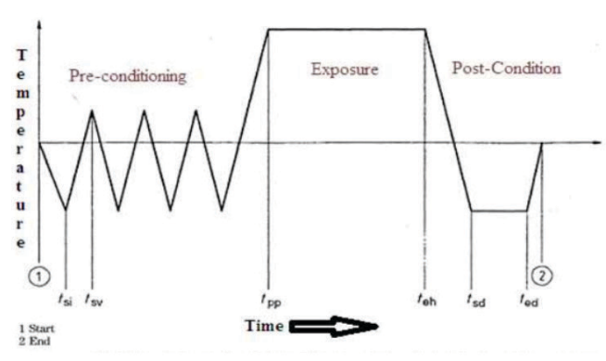

Fig 1. Autoclave cycle temperature guide, with identification of exposure time. Ensuring the right temperature is reached at the plateau, for the correct time validates the load. (Talekar and Pise, 2023)
Where do I need to put the probes/BI?
The best approach is to place probes/BIs in the areas most insulated from steam produced by the autoclave. For example, when testing a 1000 mL container of liquid, place the probe inside the bottle, to the midway point of the liquid.
Simply placing a probe or a BI on the surface of the load or randomly in the inside of an autoclave bag is not sufficient, as it may not accurately reflect the actual temperature reached by the waste and could result in false results. For example, a test done on frozen mice shows clear differences in temperature profile and the time taken to reach the required temperature when the probe is placed inside frozen animals, compared to those in the waste bag containing the mice (Fig 2).
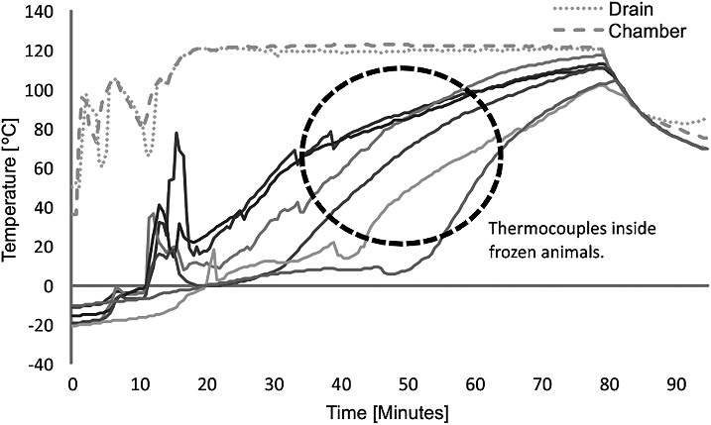
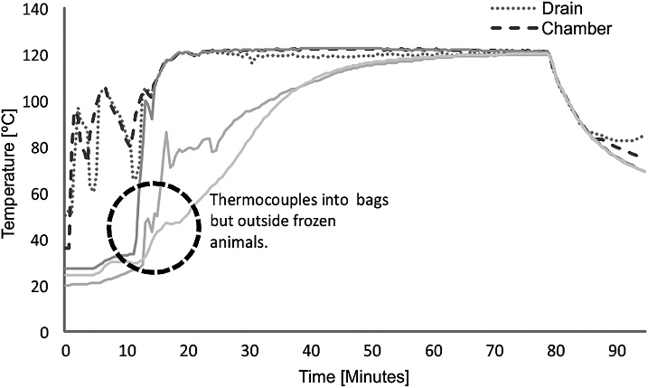
Fig 2. Temperatures recorded by probes when placed inside frozen animals, and when placed inside bag but outside frozen animals during autoclave run. (Cascardo et al., 2020)
Who needs to do this?
Any person/organisation that is carrying out dealings with GMOs and intends to decontaminate their waste using an autoclave. Some organisations opt to use external providers to conduct these tests, however this is not a requirement from the OGTR. Validation of the load profile for each type of load used in a facility can be done using external providers or internally if a record of the method used and the outcome of the validation is kept.

When do I need to do this?
This is a once off process before commencing any dealings with GMOs where an autoclave is used for decontamination purposes. As this is a new condition in the PC3 Guidelines and is about to be implemented in the revised PC2 guidelines, the OGTR will not expect organisations to conduct load validation profiles immediately. However, organisations should perform these tests as soon as practicable. If a new autoclave is installed in a facility or a new type of load is used, this process must be conducted prior to using the autoclave for decontamination.
FAQs
- If I don’t use autoclaves to decontaminate GMOs, then do I still need to validate?
- Depending on the type of facility, and licensed dealings conducted within, an autoclave may not be used for decontamination of GMOs, and therefore a load validation profile would not be required.
- Do I need to re-validate if I start autoclaving different loads?
- Yes. If the load parameters have changed, the previously validated cycle may not be sufficient to decontaminate the waste. Therefore, the cycle needs to be re-validated.
- How many probes do I need to use for each given waste type?
- The number of probes is dependent on the load type. As a guide, a few probes for each container of waste, to measure different thermal locations, should be used, particularly when the waste consists of different density and humidity “zones”.
- Which location do I need to pick for each probe?
- Waste containers can have different thermal profile depending on the size and type of waste enclosed within and where the container is loaded in the autoclave. Placing multiple probes around the container, including in the most insulated spot is sufficient.
- Can I use the built-in probes in an autoclave (if present)?
- Yes, if they have been calibrated. However, note that most autoclaves only have 1-2 probes and more may be required to correctly validate the autoclave.
- Can I use biological indicators instead of temperature probes?
- Yes, provided their placement and the number of BIs required are considered.
- Do I still need to validate the load if it is incinerated afterwards?
- It depends on the GMOs used within the facility. In PC3 and PC4 facilities, the complete decontamination of any GMOs is required before any disposal, including incineration.
- What do I do after validating a load?
- Ensure that the autoclave is loaded the same way, with the same distribution of waste as during validation runs and with the same amount (or less) of the waste. Having a document or an SOP for autoclave users in the facility to inform them of this may be helpful. In the case of a PC3 facility, the way an autoclave must be loaded is recommended to be included in the facility manual.
References
Cascardo E, Goenaga S, Fossa S, Bottale A, Levis S, Riera L. Development and Validation of Waste Decontamination Cycle in a Biosafety Level 3 Laboratory. Appl Biosaf. 2020 Dec 1;25(4):225-231. doi: 10.1177/1535676020933714.
Talekar AR, Pise AG. Systematic Approach of autoclave Qualification: A Review. International Journal of Medical & Pharmaceutical Sciences. 2023 Sep;13(9):1-6. doi: 10.31782/IJMPS.2023.13901

