Dr Jason Smythe
BSc (Hons), PhD, Grad.Cert.Mgmt. FIML, FAICD, GTTAC Chair


Dr Jason Smythe has over 35 years R&D and senior management experience the fields of gene therapeutics development and clinical applications in in Australia and USA. He holds a B.Sc. (Hons) degree in Immunology from Monash University, a Ph.D. from The Walter and Eliza Hall Institute for Medical Research and performed his postdoctoral studies in HIV-virology and therapeutics as an NHMRC C.J. Martin Fellow at the National Institutes of Health in Bethesda, Maryland (USA). Dr Smythe has held senior R&D Management positions at Johnson & Johnson; CSIRO; Monash University: The University of Melbourne and as Chief Scientific Officer at the Australian Tissue Engineering Centre Limited; Benitec Limited, and Horizon Science Pty Ltd.

He was founding Head of the Gene Therapy Research Unit at the Children's Medical Research Institute, has published over 30 research manuscripts and numerous professional reports, been granted 5 patents and awarded 4 International Research Fellowships. He was an Editor of the Journal Expert Opinion on Biological Therapy for over 10 years and a member of numerous NHMRC Grants Review Panels for over 20 years. Dr Smythe also holds a Graduate Certificate in Change Management (Grad.Cert.Mgmt) from the University of Sydney, and a Company Directors' Diploma from The Australian Institute of Company Directors (AICD). He is a Fellow of the Australian Institute of Company Directors (FAICD), a Fellow of the Australian Institute of Management (FIML Aust & NZ) and has been a Director of several successful Biotechnology Companies and Professional Associations. He was a Member of GMAC and then appointed an inaugural Member of the GTTAC in 2001.
Professor Stacey Edwards
BSc (Hons), PhD (Biochemistry)
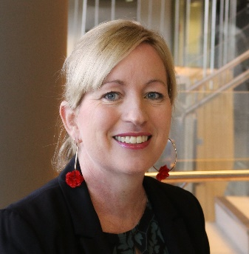
Professor Stacey Edwards is an NHMRC Leadership Fellow and Head of the Functional Cancer Genomics Laboratory at QIMR Berghofer. She received her PhD in Biochemistry at the University of Queensland (UQ). Her postdoctoral training was carried out at UQ and the Breast Cancer Now Toby Robins Research Centre in London, funded by an NHMRC CJ Martin Fellowship. She was recruited to QIMR Berghofer in 2013, where her research uses advanced molecular approaches to identify and characterise novel cancer genes. She has led international efforts to translate breast and ovarian cancer genetic data, identifying key risk variants and linking them to their target protein-coding genes and noncoding RNAs to reveal how they drive cancer. She also leads projects investigating how noncoding RNAs contribute to therapy resistance. Her work combines genetics, genomics, chromatin and transcriptome profiling with computational and molecular biology, to accelerate the path from genetic discovery to biological insight. Through this integrated approach, her lab is uncovering the biological mechanisms underlying cancer risk and therapy response, ultimately guiding the development of more targeted and effective treatments.

Adj. Prof. Aanandini Ganesalingam
BSc (1st Class Hons) & BEc, PhD, GAICD

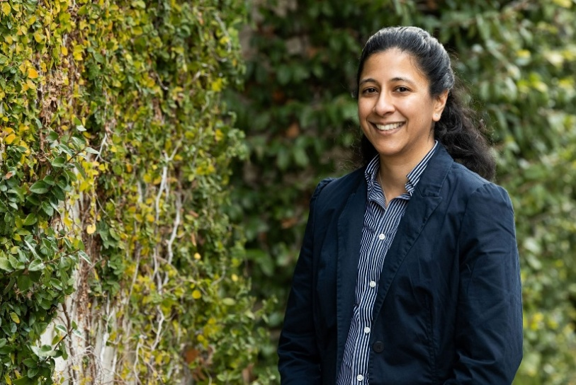
Adj Prof Aanandini (Dini) Ganesalingam is an agrifood research and development expert with experience spanning plant breeding, applied statistics, data governance and RD&E investment strategy. She has led and advised on national and international research portfolios across industry, government and publicly funded research organisations, with a strong focus on risk governance and evidence-based decision-making.

Dr Ganesalingam has held multiple advisory and board roles supporting strategic oversight of agricultural innovation and technology translation.
Aanandini currently serves on the AgriFutures Rice RD&E Panel, and Emerging Industries Technical Advisory Group. She has recently been appointed Director of the Australasian Plant Breeding Association Board.
Professor David Tscharke
BSc(hons), PhD (Adelaide), FASM, FAVS

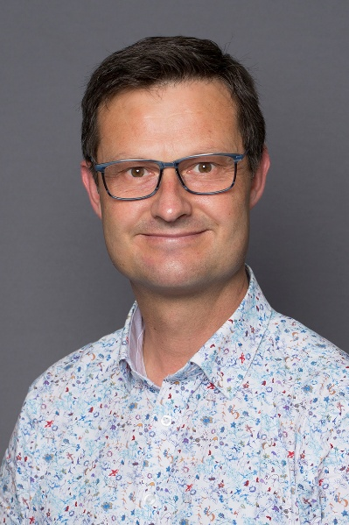
Prof David Tscharke is a biomedical scientist in the John Curtin School of Medical Research at the Australian National University (ANU). He completed undergraduate degrees (1990) and PhD (1997) at the University of Adelaide and followed this with postdoctoral positions at the University of Oxford and Imperial College, London, UK, the US National Institutes of Health, Bethesda, MD before returning to Australia in 2003. This was first to QIMR in Brisbane and then to an independent position at ANU in 2006. Since then, he has had several positions with varying responsibility for research and teaching across the ANU, including Head of Immunology and Infectious Diseases at JCSMR. His research spans a range from molecular virology to immunology and pathogenesis, often focussed at the intersection of these disciplines, and typically using molecular biology and recombinant DNA technologies as key enabling tools. He was member of the Expert Advisor Panel for the 2017 Review of the National Gene Technology Scheme and has had over a decade of service, including being Chair, of the ANU recombinant DNA Advisory Committee.

Eugenia Hong
BPharm, BSc, GradDipRepSc, DipDemC, MSHP, AMACTA, FANZCAP (ClinTrials, Lead&Mgmt)

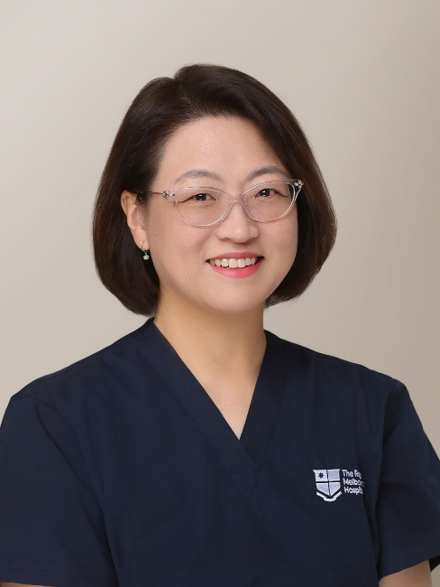
Eugenia (Genie) Hong is the Clinical Trials Pharmacy Manager at The Royal Melbourne Hospital and a nationally recognised leader in investigational medicines and clinical trials pharmacy practice.
Genie served as a committee member of the Specialty Practice in Investigational Drugs with The Society of Hospital Pharmacists of Australia (SHPA) for over 15 years and has been involved in the development of the Standard of Practice for Pharmacy Investigational Drugs Services in Australia for over 20 years. She has facilitated and presented at numerous clinical trials seminars and international conferences and previously tutored in the CRA Development Program at IQVIA.
Genie has a longstanding professional interest in GMO medicines in clinical research. She developed the Standard Operating Procedures for investigational GMO medicines at The Royal Melbourne Hospital and coordinated national training programs on GMO medicines for pharmacists through SHPA. She has over 10 years of hands-on experience with GMO medicines in clinical trial practice and co-published a review on GMO medicines and hospital pharmacy practice in the Journal of Pharmacy Practice and Research.
She currently serves as a member of the Clinical Trials Leadership Committee of Advanced Pharmacy Australia (AdPha), is an Affiliate Professional Member of the Australian Clinical Trials Alliance (ACTA), and a member of The Royal Melbourne Hospital Human Research Ethics Committee.
Genie holds a Pharmacist Consultant Fellowship (FANZCAP) of the Australian and New Zealand College of Advanced Pharmacy, recognised in the specialties of clinical trials and leadership and management.
Professor Johnson Mak

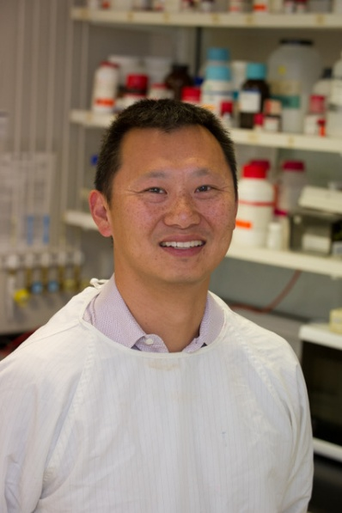
A native of Hong Kong (as well as a Canadian and an Australian) who undertook his undergraduate and post-graduate training at McGill University, Montreal, Canada. During his PhD, Johnson worked with Professor Lawrence Kleiman at the McGill AIDS Centre studying packaging of primer tRNA into HIV. He subsequently moved to Melbourne, Australia to continue work on HIV assembly at the Burnet Institute. Johnson also held appointments with Monash University, Deakin University and CSIRO AAHL. Johnson is currently a Professor at the Institute for Biomedicine & Glycomics, Griffith University, Gold Coast. Johnson has a broad research portfolio in HIV having studied primer tRNAs in retroviruses, genomic RNA packaging and dimerization, cholesterol and lipids in HIV, viral-host interactions, imaging of HIV and analysis of recombination and mutation in HIV using next generation sequencing. His team pioneered the production of full-length recombinant HIV Gag for biochemical and biophysical analyses of HIV assembly. Recently Johnson and his team have described a pre-entry priming process for HIV, as well as revealing a novel glycan-glycan biology of HIV that function as molecular Velcro during infection. Other works include the contributions of a cellular process (calcium sparks) to the polarized trafficking of HIV to enable virological synapse formation.

Dr Zlatibor Veličković

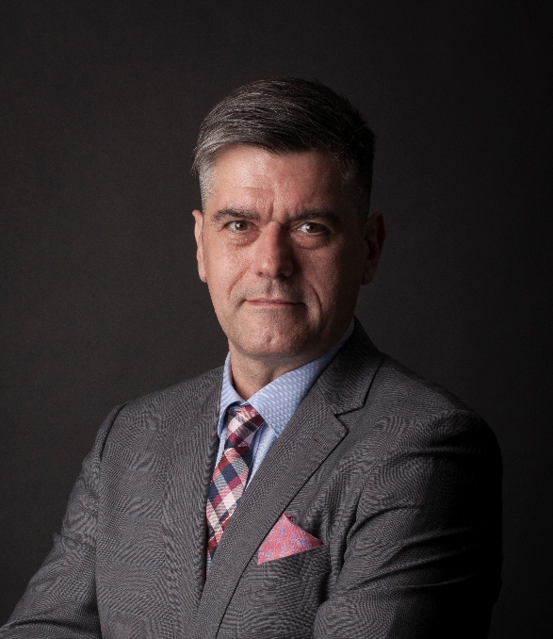
Dr. Veličković is the Facility Director of Cell & Tissue Therapies Western Australia (CTTWA) at the Centre for Advanced Therapies (CAT), Royal Perth Hospital, a position he has held since January 2022. In this role, he oversees Western Australia's only public TGA-licensed facility for manufacturing clinical-grade cellular therapies, including CAR T-cells, TILs, MSCs, and emerging programs in bacteriophage therapy and other advanced therapeutics.
Prior to his current appointment, Dr. Veličković served as Production Manager at the Department of Cell & Molecular Therapies at Royal Prince Alfred Hospital in Sydney, where he played a pivotal role in establishing CAR T-cell programs. Earlier in his career, he spent a decade as a Senior Scientist in molecular genetics at the Australian Red Cross Blood Service.
Dr. Veličković holds a PhD in Immunogenetics from the University of Otago, New Zealand, and a Bachelor of Science with First Class Honours in Molecular Biology and Physiology from the University of Belgrade, Serbia. He is an Adjunct Associate Professor at the School of Biomedical Sciences, University of Western Australia, where he teaches advanced therapies and regenerative medicine.
An active contributor to the global cell and gene therapy community, Dr. Veličković holds numerous leadership and advisory roles. He is a current member of the Therapeutic Goods Administration (TGA) Advisory Committee on Biologicals, co-chair of the ISCT ANZ Workforce Development Subcommittee, member of the ISCT APAC Industry committee, member of the Foundation for the Accreditation of Cellular Therapy (FACT) Education Committee and serves on the National Bacteriophage Therapy Regulation Working Group and institutional biosafety and ethics committees. He is a past Vice President of ISCT ANZ (2022-24).
Dr. Veličković is a sought-after international speaker, presenting regularly at conferences globally on topics including advanced therapy manufacturing, regulatory frameworks, distributed manufacturing models, and workforce development. His published work spans cell and gene therapy manufacturing and quality assurance, regulatory navigation in the APAC region, and clinical-grade cell therapy process development. He is committed to expanding access to transformative cellular and gene therapies for patients across Australia and the broader region.

Professor Paul Verma

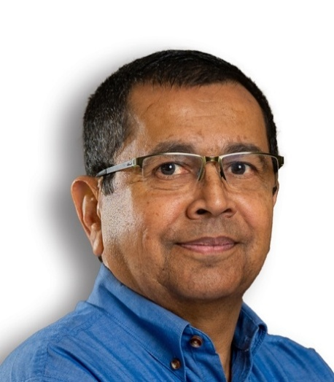
Professor Paul Verma is a Principal Scientist, Reproduction at the South Australian Research & Development Institute (SARDI), as well as an Affiliate Professor at Adelaide University. He leads the Large Animal Genome Modulation Program, pioneering the use of reproductive technologies and precise genome editing (CRISPR-Cas9) to enhance livestock production traits and develop biomedical models for animal and human diseases, engineering sheep models for Fragile X syndrome, two Alzheimer’s disease models, and a loss-of-function mutation in the neurokinin B (NKB) gene to study reproductive function, as well pig models of cardiac diseases and genetic modifications for improving livestock production traits. With nearly four decades of experience in genetic manipulation across multiple species—including fish, rodents, sheep, and pigs—he has also contributed to genetic modification of cell lines from cattle, endangered felids, and humans, utilizing ZFN, TALEN, and CRISPR/Cas9 technologies.
Assoc. Prof. Karen L. MacKenzie
BAppSc, Phd

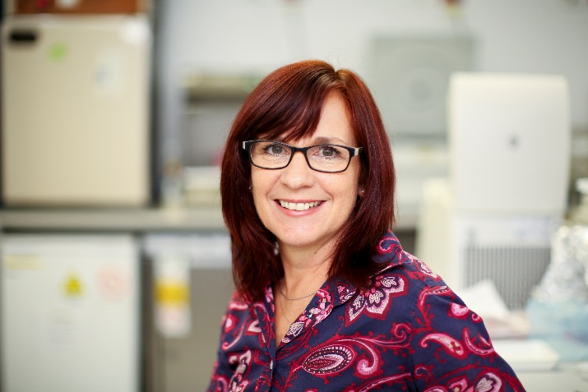
Associate Professor Karen MacKenzie is a Senior Research Fellow in the Cancer Research Unit at Children’s Medical Research Institute (CMRI) and holds a Conjoint appointment in the Faculty of Medicine and Health at the University of Sydney. She has more than 25 years’ experience in basic cancer biology, pre-clinical and translational cancer research, with expertise in cancer cell immortality, biomarker discovery, molecular targets and precision oncology.
A/Prof MacKenzie completed her PhD at UNSW and undertook postdoctoral training at Memorial Sloan-Kettering Cancer Center, New York. She subsequently established and led an independent research program at Children’s Cancer Institute before joining CMRI in 2017. Her research integrates molecular biology, proteomics and patient-derived model systems to identify diagnostic biomarkers and novel therapeutic strategies, particularly for aggressive cancers that affect children, adolescents and young adults. She has published 70 peer-reviewed papers in leading oncology and haematology journals and has been a Chief Investigator on grants totalling over $13 million.
Associate Professor MacKenzie has supervised numerous PhD and Honours students and serves on institutional scientific and advisory committees. Her research has informed precision oncology initiatives, supported regulatory approval of targeted therapies, and generated publicly available datasets that are accelerating international efforts to develop biomarker-guided treatments for aggressive cancers.

Cressida Cains

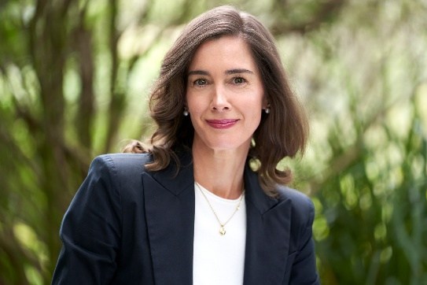
Cressida Cains is an agricultural leader and board director with experience across primary production, agri-food value chains, rural leadership and policy engagement. She is the co-founder of Pecora Dairy, a value-added sheep dairy business in New South Wales, and brings a practical understanding of how regulation and innovation intersect at farm and industry levels.
Cressida has held a range of governance and advisory roles across the agricultural sector, including President of Australian Women in Agriculture, State Chair of AgriFutures Alumni NSW/ACT, member of the Telstra Regional Council, and board director of the National Rural Women’s Coalition. She is a graduate of the Australian Rural Leadership Program and has worked extensively with government, industry and community stakeholders on complex policy and regulatory issues relevant to agriculture and regional Australia.
Rosemary Richards
B.Ag.Ec, MBA, GAICD

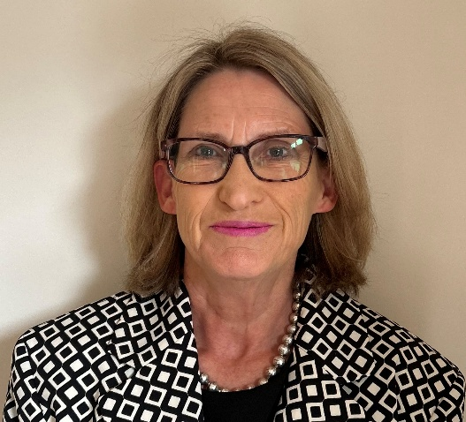
Rosemary is the principal of Bowman Richards & Associates (BR+A), a consulting firm specialising in providing strategic support to the agribusiness, food and technology sectors. Rosemary is a passionate senior executive, communicator and industry advocate. Her experience in project management, trade policy and strategic development extends across all facets of agri and food businesses and covers work with public and private companies, industry organisations and government.
Rosemary undertakes a range of strategic planning, market analysis and trade policy activities for the grains and food industry and has led work on non-tariff trade measures for both sectors. She also has extensive experience across innovation and sustainability including frameworks, impact evaluation and advocacy. Rosemary is Chair of the Australian Oilseeds Federation, Chair of Sustainable Grain Australia, and a director of Sugar Research Australia.

Professor Calum Wilson
BSc (Hons), MSc (Dist), PhD

Professor Calum Wilson is a Plant Pathologist and teaching academic working within the Tasmanian Institute of Agriculture (TIA) at the University of Tasmania. He completed his PhD in Plant Virology from the University of Western Australia in 1992. He heads a research team working to understand and combat plant diseases that impact on quantity, quality and sustainability of food production. The team's research portfolio is diverse across a range of plant pathogens and food crops. His group has contributed toward the basic studies of crop genetics, pathology, physiology and chemistry associated with disease development and host resistance, soil ecological and biological approaches to combat disease, epidemiological and molecular studies of plant viruses and their insect vector. He has served on the University of Tasmania and private industry Institutional Biosafety Committees and contributed to discussions around the Tasmanian Moratorium on release of GMOs into the Tasmanian environment.
Emeritus Professor Paul Young
B.Sc (Hons), PhD (London), FAHMS, FQA, FAVS, FASM

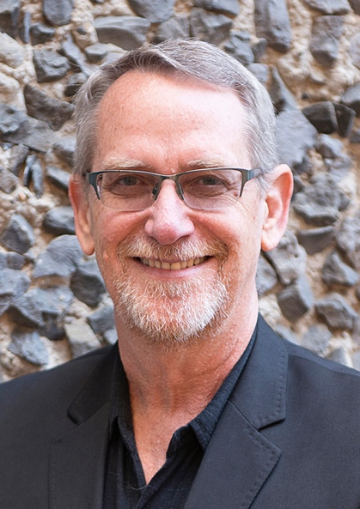
Paul Young is Emeritus Professor of Virology at The University of Queensland, Brisbane, Australia. He gained his PhD from the London School of Hygiene & Tropical Medicine and joined the University of Queensland in 1991. His group has contributed significantly in the areas of diagnostics, vaccine and antiviral development as well as towards a greater understanding of the basis of severe viral disease. With colleagues at UQ, he co-led an Australian consortium that developed a COVID-19 vaccine in early 2020, based on an innovative platform technology created at UQ, the Molecular Clamp. The vaccine candidate was taken through clinical trials and while the vaccine did not progress, the trials validated the potency of the platform technology. The platform was re-engineered and following successful clinical trials, the technology was acquired by Sanofi in 2025.
Prof Young is President-elect of the International Union of Microbiological Societies, is a Fellow of the Australian Academy of Health and Medical Sciences and the Queensland Academy of the Arts and Sciences and has been the President of the Australian Society for Microbiology (2012-2014), the Australasian Virology Society (2001-2011) and the Asia-Pacific Society for Medical Virology (2012-2015).

Dr Graham Bonnett


Dr Graham Bonnett was a research scientist with CSIRO from 1993 to 2026. Prior to that he held a post-doctoral position at the University of Melbourne after finishing a PhD (in 1989) at the University of Leeds. His last role in CSIRO was leading the Drought Resilience Mission hosted by CSIRO Agriculture and Food. His research expertise is in the physiology and development of crop plants and the science underpinning the regulation of genetically modified sugarcane cultivars. In 2009 he was awarded a Queensland-Smithsonian Fellowship and spent 5 months in Panama (Smithsonian Tropical Research Institute) researching the reproductive biology of the weedy
sugarcane relative Saccharum spontaneum. In 2013 he was appointed to the Independent Science Panel advising on the Reef Water Quality Protection Plan.
Dr Gabrielle O’Sullivan
BSc (Hons) PhD MPH (Hons)
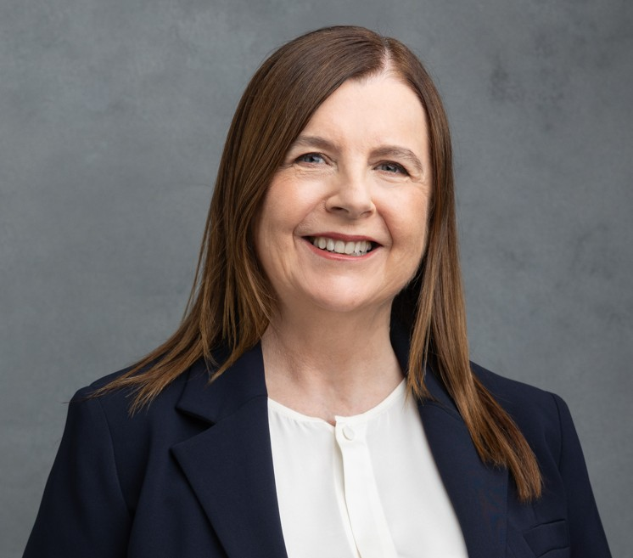
Dr Gabrielle O’Sullivan is the Executive Officer of Royal Prince Alfred Hospital Institutional Biosafety Committee. She has a BSc in microbiology (major) and chemistry (minor) from University College Dublin and a PhD in biochemistry and immunology from London School of Hygiene and Tropical Medicine. Her post-graduate work was in medical microbiology and biochemistry. Her PhD was in the area of acute phase reactants, lectins and amyloid formation. Her post–doctoral research was at the University of Sydney focusing on cellular immunology and cell migration, specifically Langerhans cells, cytokines and glycosaminoglycans. She has a Master’s degree in Public Health from the University of Sydney and has made contributions to genetics and public health education, epidemiology, public health and the ethics and biosafety of gene technology. She co-developed and co-ordinated a successful short course on genetics and public health at the University of Sydney and co-authored a book on the ethics of inheritable genetic modification. Dr O’Sullivan has extensive experience in science-based risk communication and risk assessment of gene technology, particularly in the contexts of biomedical research, clinical trials and cell and gene and molecular therapies, including CAR T-cell, oncolytic virus, viral vector, and human gene editing protocols. She has contributed to many gene technology reviews, and as Co-Chair of the Australia and New Zealand Legal and Regulatory Affairs Committee of the International Society Cell and Gene Therapy from 2014 to May 2026, and as a cross-member from the Gene Technology Technical Advisory Committee to the Gene Technology Ethics and Community Consultative Committee from 2015 to 2025.

Professor Fiona Cameron

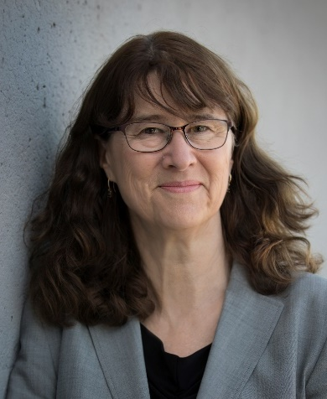
Prof. Cameron has a PhD on gene regulation from Macquarie University with a productive research career with the CSIRO of over 20 years in the areas of gene regulation, gene delivery, drug formulation and gene therapy. Prof. Cameron has also published in the field of antibiotic resistance. She worked in research management of the CSIRO Nanotechnology Emerging Science area and the CSIRO National Flagship for Food Futures, before running the Innovation and Consulting unit at the University of Western Sydney. Her subsequent role was Executive Director for Biological Sciences and Biotechnology at the Australian Research Council, where Prof. Cameron was additionally responsible for the major grants schemes (Centres of Excellence, Industrial Transformation Research Program, Special Research Initiatives). She now sits on a number of advisory boards of ARC and other research Centres. Prof. Cameron works as a consultant in the higher education sector and has completed the Australian Institute of Company Directors course.
Professor Geraldine O’Neill

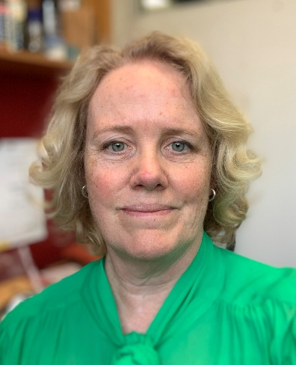
Professor Geraldine O’Neill is an internationally recognised cancer cell biologist based at The Children’s Hospital at Westmead and holds a Conjoint appointment with the University of Sydney. Her research focuses on how interactions between cancer cells and their tissue environment regulate tumour progression and therapeutic response, with particular emphasis on brain cancers and the development of advanced preclinical model systems.
Her work integrates cell and molecular biology, gene and cell engineering, and biophysical approaches to improve the evaluation and translation of emerging therapies, including cell- and gene-based interventions. She has led multidisciplinary research programs spanning fundamental discovery and translational application in paediatric oncology.
Professor O’Neill has extensive experience in research governance and biosafety oversight and previously chaired the Children’s Medical Research Institute/Children’s Hospital at Westmead Institutional Biosafety Committee.

Assoc. Prof. Grant Logan


Assoc. Prof. Grant Logan is a scientist at the Children’s Medical Research Institute, Westmead and a conjoint senior lecturer at the University of Sydney. He has over twenty-five years’ experience in the design and application of viral vector systems for gene transfer in medical research and more recently in the biotechnology therapeutics sector. Many of Assoc. Prof.Logan’s research papers reflect his strong interest in the use of gene therapy to modulate immunity or the immune system’s response to virus vector systems and how this influences gene transfer. Assoc. Prof. Logan commenced his career in diagnostic virology and public health environmental science, including the detection and monitoring of viruses and pathogens in the environment. Assoc. Prof. Logan sits on the Scientific Advisory Committee to the Human Research Ethics Committee of the Sydney Children’s Hospital Network. He also maintains an interest in beekeeping and is a member of the Amateur Beekeepers Association of NSW.
Dr Tessa Gargett

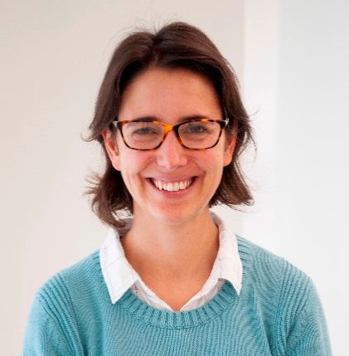
Dr Gargett is a Florey mid-career Research Fellow at the Royal Adelaide Hospital and a Senior Research Fellow at Adelaide University. She is an immunologist and cell therapy specialist with 12 years post-doctoral experience with 37 career publications and >2200 citations to date. She has extensive experience in clinical application of CAR-T therapy and a career-goal of making CAR-T therapy accessible to Australian patients. Dr Gargett is the lead scientist for three national phase 1 CAR-T therapy trials. One of these was recently completed, resulting in a high-impact report downloaded over 100 times in the first week of publication and selected as a JITC editor’s pick (Gargett et al. JITC 2024). She is currently responsible for CAR-T manufacturing and biomarker analysis for 2 open phase 1 trials for adults and children with brain cancer, with 16 patients treated to date. She also leads a program of preclinical work investigating the application of CAR-T therapy for GBM and DIPG and has ongoing collaborative research projects with A/Prof Gomez and Prof Pitson (Centre for Cancer Biology) using primary glioblastoma tissues and intracranial xenograft models (CTI, 2020; Front Immunol, 2022; JITC, 2022). Internationally she works with Prof Brenner, Baylor College of Medicine (Mol Ther, 2016), Prof Dotti, UNC Lineberger (JIT 2015, Mol Ther 2016), Prof Monje, Stanford Medicine (joint members LEVI's CATCH trial committee) to bring CAR-T therapy protocols to Australia. Dr Gargett is one of only a handful of national experts performing place-of-care manufacturing and clinical CAR-T research, and as such she contributes to the federal review of cell and gene therapies, and is the elected Treasurer for the International Cell and Gene Therapy Society regional executive (2024-2026).

Assoc. Prof. Michael Michael

Assoc. Prof. Michael is a molecular biologist working at Flinders Medical Centre in Adelaide. He also works in cancer research at Flinders Health and Medical Research Institute, Flinders University. Originally a founding scientist at one of Australia’s first biotechnology companies Calgene Pacific/Florigene Pty Ltd, Assoc. Prof. Michael now supervises the Gene Expression Lab in Flinders Centre for Innovation in Cancer, where he studies the contribution of epigenetics and RNA-mediated processes to tumour initiation and progression. His priorities are to identify biomarkers that can inform clinical decisions and to develop novel therapies. He completed both his undergraduate and Ph.D. studies in genetics at the University of Melbourne and is a long-standing contributor to the Flinders Institutional Biosafety Committee.

