

15 January 2026
NOTIFICATION OF DECISION ON APPLICATION
DIR 218 – Commercial release of tomato genetically modified for purple fruit colour from All Aussie Avocados Pty Ltd (trading as All Aussie Farmers)
The Gene Technology Regulator (the Regulator) has issued licence DIR 218 to All Aussie Avocados Pty Ltd (trading as All Aussie Farmers), authorising the commercial release of a tomato genetically modified for purple fruit colour.
The release is authorised to take place throughout Australia. The GM Purple Tomato and products derived from the GM Purple Tomato may enter general commerce, including use in human food and animal feed.
The Risk Assessment and Risk Management Plan (RARMP) and the licence were finalised taking into account input received during consultation with the public, State and Territory governments, Australian Government agencies, the Minister for the Environment, the Gene Technology Technical Advisory Committee and local councils. The Regulator thanks submitters for their contributions.
Submissions are summarised in Appendix B and Appendix C of the RARMP, together with information about how the issues raised relating to risks to human health and safety or the environment were considered in preparing and finalising the RARMP.
The finalised RARMP concludes that this commercial release poses negligible risks to people and the environment and does not require specific risk treatment measures. However, general licence conditions have been imposed to ensure ongoing oversight of the release.
Regulatory responsibilities
This GM Purple Tomato would only become available in Australia if all regulatory requirements are met, including approvals from the Gene Technology Regulator, Food Standards Australia New Zealand (FSANZ), and the Department of Agriculture, Fisheries and Forestry (DAFF).
Issues such as food safety and labelling, agricultural chemical use, benefits, and marketability and trade implications are outside the scope of assessments conducted by the Regulator.
FSANZ has considered the safety of the GM Purple Tomato and its products as food for human consumption under application A1333 and approved its use as food.
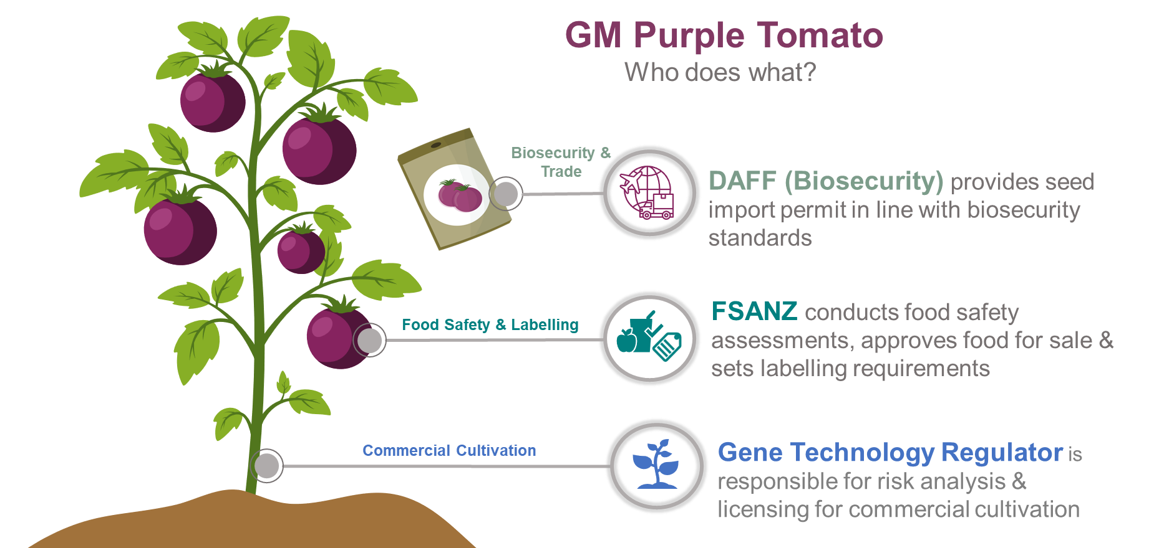

Further information
The finalised RARMP, a summary of the RARMP, the licence and Questions and Answers about this decision can be obtained online from the DIR 218 page of the Office of the Gene Technology Regulator’s (OGTR) website or requested via the contacts detailed below.
Office of the Gene Technology Regulator
MDP 54 GPO Box 9848 CANBERRA ACT 2601 Tel: 1800 181 030 E-mail: ogtr@health.gov.au
OGTR website

