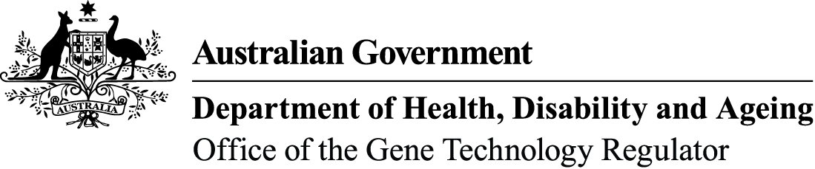

Snapshot of genetically modified (GM)

wheat trials
- Wheat is one of several GM crops that have been approved for experimental field planting in Australia.
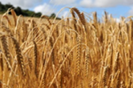
- There have been trials of GM wheat that sought to improve salt tolerance, drought resistance, disease resistance, yield, grain quality, grain nutrients and nutrient use efficiency.
- GM wheat is not grown commercially in Australia and is not licensed for commercial release.
- The Gene Technology Regulator (the Regulator) carries out science-based risk analysis before approving field trials of GM wheat.
- Any work with GM wheat in Australia must be licensed by the Regulator. Criminal charges can apply for unauthorised dealings with GM plants of any kind.
Since 2005, the Regulator has issued 25 licences for small-field, early-stage research trials of GM wheat. Five of these field trial licences are still current. For further details, see the table on the next page.
There has been no commercial release of GM wheat in Australia, and to date the Regulator has not received any licence applications for the commercial release of GM wheat.
Each field trial is limited in its size and duration. For example, DIR 165 allows up to 5 hectares (ha) per site per year over 6 years. This is limited to 2 sites of 2 ha in the first year and 10 sites of 2 ha per year in the next 4 years and 4 sites of up 5 ha in the final year. The trials are subject to strict containment conditions to manage the potential for spread and persistence of the GM wheat and its introduced genes into the wider environment.
The OGTR actively inspects trials to make sure they are compliant with licence conditions. There have been no breaches of containment with any of these field trials.
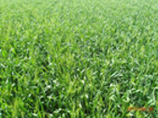
GM wheat from these trials is not permitted to enter commercial human food or animal feed supplies. CSIRO researchers are developing wheat and wheat products that might improve nutritional properties such as glycaemic index. The Regulator has authorised CSIRO to conduct trials involving feeding foods containing GM wheat to animals and people under some licences. These studies are also subject to approval by ethics committees who consider animal and human ethical issues.
Some of these trials are ongoing, while some have concluded. For full details on each trial visit the GMO record.
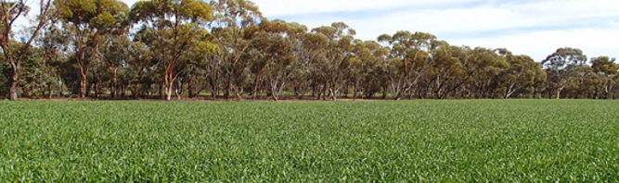

Current licences for limited and controlled releases (field trials) of GM wheat (as of December 2025)
Licence No | Licence holder | Modified Trait | Issued
DIR 204 | Trigall Australia Pty Ltd | Abiotic stress tolerance | August 2024
DIR 201 | The University of Adelaide | Enhanced yield | April 2024
DIR 186 | The University of Adelaide | Enhanced yield, abiotic stress tolerance | February 2022
DIR 165 | The University of Melbourne | Composition – food (human nutrition) | April 2019
DIR 162 | CSIRO | Disease resistance | July 2018

