

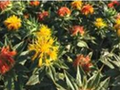
Snapshot of Genetically Modified (GM) Crops in Australia
Overview
GM crops are genetically modified organisms (GMOs).
This factsheet is an introduction to the regulation of GM crops in Australia. It is supported by a suite of factsheets with more detailed information for anyone with an interest in or concerns about GM crops.
All GM crops grown in Australia (commercial and experimental) or imported GM grains or flowers are approved by the Regulator only if they are safe for people and the environment. GM crops may be used as stockfeed if the Regulator has authorised it.
You can look up the risk analyses and other documents for each licence on the GMO Record on our website.
We monitor the scientific literature for any new information relevant to the risk of GM crops. Also, licence holders must report any adverse effects to the Regulator who can vary, suspend, cancel or transfer licences, if there is a risk to people or the environment.
Commercially, only 5 GM crops are authorised to be grown by farmers in Australia: canola, Indian mustard, cotton, banana and safflower. Some types of GM blue carnation may also be grown on a commercial scale, and some GM cut flowers can be imported and sold in Australia.
Field trials of several other GM crops have also been authorised.
Food Standards Australia and New Zealand assess GM foods which can be sold only if safe.

Commercial GM crops authorised to be grown in Australia
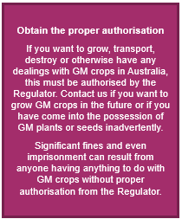
Commercial licences are usually issued to companies but give permission for all people in Australia to grow the GM crop.
The ACT, Tasmania and parts of South Australia have restrictions on growing GM crops due to marketing issues.
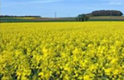
GM Canola
Canola is grown for its seed, which is crushed for the oil used in margarine, cooking oils, salad oils and edible oil blends. After the oil is extracted, the by-product is a protein-rich meal, which is used to feed livestock. Canola is grown around Australia and is easily recognised by its vivid yellow flowers.
As of 2024, about46% of the national canola crop was genetically modified.
The types of GM canola licensed to be grown commercially in Australia are tolerant to glyphosate and/or glufosinate herbicides or can produce Omega-3 oil.
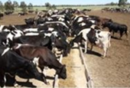
GM Indian mustard
Indian mustard is a minor crop grown in Australia as a condiment (mustard), an oilseed or a vegetable. Commercial production is on a small scale, located mainly in central New South Wales and western Victoria. The GM Indian mustard tolerant to herbicides containing glufosinate has been approved for growing in Australia but to date, no planting has commenced.
GM cotton
Cotton is grown commercially in several inland regions of New South Wales and Victoria as well as central and southern Queensland. Almost all cotton grown in Australia is genetically modified to be resistant to pest insect attack and to tolerate certain herbicides.
While cotton is grown primarily for textiles, cottonseed oil is also used in a wide range of foods including spreads and oils. Cottonseed is also used to feed to livestock.
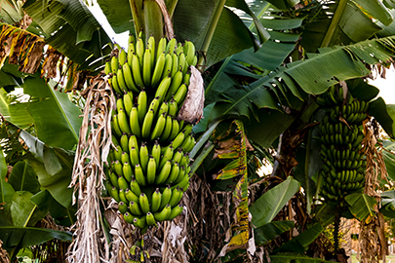
GM Banana
Bananas are grown mainly in northern Queensland, with smaller areas of commercial production in northern New South Wales and Western Australia. Cavendish bananas are the predominant commercial banana cultivar. Bananas are produced mainly for fresh fruit for the domestic market.
The GM bananas authorised for commercial cultivation are modified for resistance to Panama disease. This disease affects Cavendish bananas.
GM Safflower
Safflower is a minor crop grown in Australia for the edible and industrial oil markets. Commercial safflower production occurs mainly in New South Wales, Victoria and South Australia.
After oil is extracted from the seed, the remaining meal can be used as stockfeed. Whole safflower seeds are also used for birdseed.
Commercial GM safflower with increased levels of oleic acid in their seed oil was released in Australia from 2018. The seed oil extracted from the GM safflowers is intended for use in industrial oil production and animal feed but not for human consumption (although authorised). High purity oleic acid has applications in industry as a replacement for petroleum-based precursors in the manufacture of plastics, lubricants or cosmetics.
Field trials of GM crops
There are current field trials of GM banana, cotton, canola, Indian mustard, wheat, barley, ryegrass, sorghum and clover. In the past, there have also been trials of other GM plants.
GM flowers

Seven types of GM blue carnation are grown or imported as cut flowers and sold in Australia. The Regulator has determined that these carnations are of such low risk that they were included on the GMO Register.
Five types of GM chrysanthemum are also licensed for import as cut flowers and sale in Australia. Growing these GM chrysanthemums in Australia was not assessed for safety and therefore is not permitted.

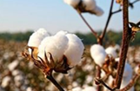
GM crops around the world
While only few crops are approved for commercial release in Australia, there are approximately 80 different types of GM crops grown worldwide. By volume most of these GM crops are modified canola, soybean, maize and cotton.
Other commercially released crops include apple, papaya, potato, squash and tomato. Australia has strict quarantine rules to restrict the import of plant materials. Additional safeguards apply to GM crops. See our factsheets on unintentional release and on stockfeed imports
GM products in food
The safe use of GM products in food is the responsibility of Food Standards Australia New Zealand (FSANZ). All GM foods must undergo a safety assessment and be approved before they can be sold in Australia and New Zealand. Read more about FSANZ and their role in assessing the safety of GM foods on the FSANZ website.
GM grain imports for use in human food or animal feed
Some grains are imported into Australia for processing into food or feed.
Approved Australian-grown GM crops and approved imports of GM grain may be processed into human food or fed to livestock.
Examples of grains imported for processing into human food include maize to make starch, syrup and flour, and canola to make oil. These uses are regulated by FSANZ. By-products of these processes may also be used as stockfeed.
Some GM grains, such as canola, maize and soy, are occasionally imported into Australia for use as stockfeed but are not licensed to be grown here. The GM grains must be devitalised before being distributed to farmers and fed to livestock to ensure they cannot persist in the Australian environment.
Livestock may not be fed material from GM crop trials unless this is specifically authorised in the respective licence.
GM and non-GM grain imports must be approved by the Australian agriculture department, and all viable GM seed imports must in addition be authorised by the Regulator. The latter includes canola, cotton, or other seed for food or stockfeed containing GM grain.

