

Snapshot of Genetically Modified (GM) Canola in Australia
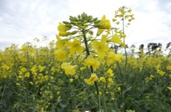
Canola is grown for its seed which is crushed for the oil used in margarine, cooking oils, salad oils and edible oil blends. After the oil is extracted, the by-product is a protein-rich meal used to feed livestock. Canola is grown around Australia and is easily recognised by its vivid yellow flowers.
As of 2024, about 46% of canola produced in Australia is GM. The Australian Capital Territory, Kangaroo Island (South Australia) and Tasmania have legislation banning farming of GM canola due to marketing concerns.
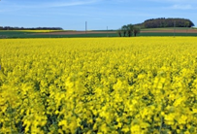
Safety of GM canola
The Office of the Gene Technology Regulator (OGTR) carried out scientific evaluations of GM canola and the Regulator authorised the first commercial releases of 2 herbicide-tolerant types in 2003. The OGTR risk analysis found that these types of GM canola posed no more risk to human health and the environment than non-GM canola.
The Regulator has issued a total of 10 licences for the commercial release of GM canola. This includes one commercial licence for GM Indian mustard (which is closely related to canola). These allow the approved GM canola to be grown throughout Australia.
Currently, commercially grown GM canola in Australia is glyphosate or glufosinate tolerant canola with a hybrid breeding system.
Other types of GM canola have been approved for commercial release in Australia including canola tolerant to both glyphosate and glufosinate and canola producing long chain omega-3 oil. However, these are not currently being grown commercially.
The commercial approvals of GM canola to date are listed in the table above. The latest information on commercial approvals is available online as part of the GMO Record.

GM canola currently grown in Australia is tolerant to glyphosate or glufosinate herbicides. This offers farmers potential economic and environmental gains.
All GM canola grown in Australia (commercial and experimental) are approved by the Gene Technology Regulator (the Regulator) only if they are safe for people and the environment. You can find the risk analyses and other documents for each licence on the GMO Record on our website.
Some state governments have further restrictions on growing GM canola.
There are additional guidelines for use of GM canola in stockfeed and for dealing with GM canola growing on the roadside (volunteer plants).
Criminal charges can apply for non-authorised dealings with GM crops of any kind.
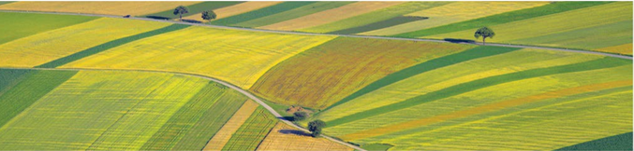

Licence number | Trade name | Modified trait/s | Licence holder | Licence issue date
DIR-190 | InVigor™ canola | Herbicide tolerance; hybrid breeding system | BASF Australia Ltd | 13 Oct 2022
DIR-178 | - | Herbicide tolerance; hybrid breeding system | BASF Australia Ltd | 16 Sep 2021
DIR-175 | - | Herbicide tolerance; hybrid breeding system | BASF Australia Ltd | 12 May 2021
DIR-155 | DHA canola | Omega-3 oil content | Nuseed Pty Ltd | 13 Feb 2018
DIR-139 | OptimumTM GLY canola | Herbicide tolerance | Pioneer Hi-Bred Australia Pty Ltd | 29 Mar 2016
DIR-138 | InVigor® x TruFlex™ Roundup Ready® canola | Herbicide tolerance; hybrid breeding system | BASF Australia Ltd | 22 Mar 2016
DIR-127 | TruFlex™ Roundup Ready® canola (MON 88302) | Herbicide tolerance | Monsanto Australia Ltd | 21 Nov 2014
DIR-108 | InVigor® x Roundup Ready® canola | Herbicide tolerance; hybrid breeding system | BASF Australia Ltd | 2 Dec 2011
DIR 021/2002 | InVigor® canola | Herbicide tolerance; hybrid breeding system | BASF Australia Ltd | 25 Jul 2003
DIR 020/2002 | Roundup Ready® canola | Herbicide tolerance | Monsanto Australia Ltd | 19 Dec 2003

Ongoing oversight by the Regulator
The OGTR monitors scientific and other literature for any new information relevant to GM crops and evaluates that information in relation to existing licences. The Regulator also maintains oversight of commercially grown GM canola, to ensure it remains safe.
If something changes, and a GM crop can no longer be considered safe, the Regulator has the power to revoke existing licences to grow the crop. To date, no information has arisen in Australia or internationally to indicate that GM canola commercially grown in Australia is no longer safe, or that licences issued since 2003 should be suspended.
You can read the risk assessment and risk management plan for each application and other details of the licences. These documents are available on the GMO Record.
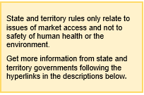
Restrictions on cultivation of GM canola
Each state and territory may ban cultivation of GM crops temporarily or indefinitely for trade or marketing reasons on a case-by-case basis.
GM canola is grown in many states in Australia. Canola is generally not grown in the Northern Territory. The Australian Capital Territory, South Australia and Tasmanian governments have a range of restrictions.
After the Regulator approved GM canola commercial releases in 2003, most states and territories passed laws to delay the commercial release of GM crops (including GM canola), allowing them to investigate issues such as marketability and trade before the first commercial plantings of GM canola.
Some states and territories have since allowed GM crops such as canola, while some moratoria (bans) remain in place.
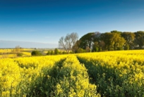
The Australian Capital Territory’s moratorium remains in force.
New South Wales allowed its moratorium on commercial cultivation of GM food crops to lapse at the end of June 2021. GM canola restrictions were lifted prior to this in 2008.
The Northern Territory allows GM canola to be grown. Canola is currently not cultivated.
Queensland has allowed GM canola to be commercially cultivated since 2003.
In late 2020, South Australia has allowed commercial cultivation of GM canola in all areas except Kangaroo Island.
Tasmania has extended its GM crop and animal moratorium until 2029.
Victoria allowed its moratorium order on commercial production of GM canola to lapse in 2008.
Western Australia granted an exemption in 2010 allowing commercial cultivation of GM canola and revoked its moratorium legislation in 2016.
Other regulators
The safety of GM products for sale as food is assessed by Food Standards Australia New Zealand (FSANZ). Read more on the FSANZ website.
The use of herbicides on GM herbicide-tolerant canola varieties is regulated by the Australian Pesticides and Veterinary Medicines Authority, which applies conditions to ensure responsible use of herbicides, and to minimise the development of weeds with herbicide resistance.

