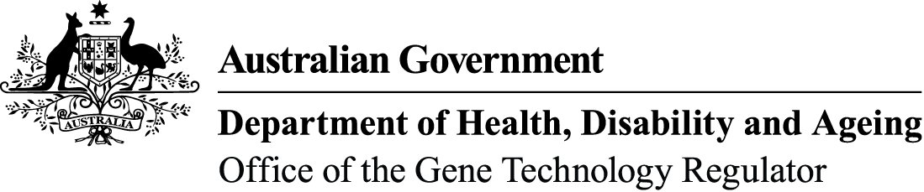

Genetically modified organisms in Australia
Gene technology is widely used in Australia: in agriculture, in research, in health and medicine, in education, and in industry.

When gene technology is used to create a genetically modified plant, animal or other living thing (an organism), the use of this genetically modified organism (GMO), for example growing genetically modified (GM) canola, is regulated by the Gene Technology Regulator to protect people and the environment.
You may not create, use or import a GMO in Australia unless you have the appropriate approval.
The Gene Technology Regulator (the Regulator) is appointed by the Governor General of Australia to administer the national regulatory system for gene technology. The Regulator is assisted by the Office of the Gene Technology Regulator (OGTR).
OGTR factsheets explain what GMOs are, how they’re used in Australia, how to get permission to import or use them, and how the regulatory system works to protect Australia.

Using GMOs in Australia

The current uses of GM organisms in Australia include the following.
- Four GM crops are grown in Australia: canola, cotton, safflower and banana. Other crops are undergoing field trials. Read more about GM crops in agriculture.
- GM carnations and GM chrysanthemums are grown in Australia and/or imported from overseas
- Researchers use GM bacteria, plants, animals and other organisms in their research. They use a range of techniques including adding, modifying or turning off genes to study what the genes do.
- Genetic modification is widely used to make medicines such as insulin and vaccines such as Gardasil. A small clinical trial of an oral cholera vaccine was held in Australia.
- Genetic modification is also used to make medicines and vaccines for animals, such as the Hendra vaccine for horses.
- Schools use GMOs in biology classes.
- Individuals are starting to use GMOs for personal research.

Importing GMOs

Internationally, GMOs are more widely used than in Australia. For example, about 80 GM crops are grown around the world.
You may not import any live GM plants, animals, and other organisms unless you have
approval under the relevant biosecurity and gene technology legislation. For example, you need permission from the Gene Technology Regulator to import GM grain and you may also require an import permit from the Department of Agriculture and Water Resources. You will also need permission from the Regulator to import GM bacteria for research, or GM ‘glow in the dark’ aquarium fish. Some approvals are delegated to institutional biosafety committees and are then reported to the Regulator.

Regulating GM products
Food Standards Australia New Zealand is responsible for the safety assessment of GM foods. The use of GM products as human therapeutics is regulated by the Therapeutic Goods Administration. The Australian Pesticides and Veterinary Medicines Authority regulates the use of GM products as pesticides or animal medicines.


