

Genetically modified (GM) cotton in Australia

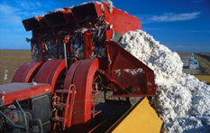
Cotton crops
Cotton is the leading plant fibre crop worldwide; however, many parts of the plant are used.
After the cotton is harvested, the fluffy white fibre, called the lint, is separated from the seed and processed to produce yarn, which is knitted or woven into fabrics.
The seed is processed into oil, meal and hulls. The oil is used for human consumption and the production of soaps and cosmetics. The meal and hulls are used for livestock feed.

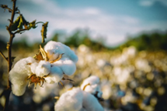
GM cotton in Australia
GM cotton was first grown in Australia in 1996. Over 99.5% of cotton grown in Australia now is genetically modified. The GM cotton plants are either herbicide tolerant, resistant to major insect pests, such as bollworm, or both.
These traits assist farmers with pest and weed management and may reduce the environmental impacts of farming when compared with conventional (non-GM) cotton.
GM cotton can only be grown with the approval of the Gene Technology Regulator (the Regulator). Criminal charges can apply for unauthorised activity with GM crops of any kind.
Farmers may grow commercially authorised GM cotton anywhere in Australia, subject to any moratoria imposed by States and Territories for marketing purposes.
Commercial cotton production mainly occurs in New South Wales, southern and central Queensland, and northern Victoria, as the climate is suitable for cotton cultivation.

Risk analysis of GM cotton
The Regulator has authorised commercial release of a number of different types of GM cotton. The Regulator has also authorised confined field trials for GM cotton with new traits, such as enhanced fibre yield or resistance to a wider range of insect pests.
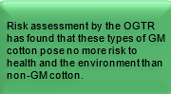
Prior to deciding whether to authorise a new type of GM cotton, the Office of the Gene Technology Regulator (OGTR) prepares a comprehensive Risk Assessment and Risk Management Plan (RARMP). RARMPs consider the risk of harm to the health and safety of people and the environment from activities with GMOs.
They include a thorough review of relevant national and international scientific literature, as well as critical assessment of data supplied by the applicant. Advice is also taken from experts, agencies, authorities, and the public.
The current commercially approved GM cottons are listed below. You can read the RARMP, the licences and other supporting information for all cotton applications through the GMO Record on the OGTR website.

Oversight of GM cotton
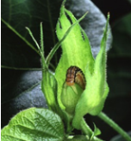
The Regulator maintains oversight of commercially grown GM cotton, to ensure it remains safe.
For example, the OGTR monitors scientific and other literature for any new information relevant to GM crops and assesses that information in relation to existing licences.
If something changes, and a GM crop can no longer be considered safe, the Regulator has the power to revoke existing licences to grow the crop.
To date, no information has arisen in Australia or internationally to indicate that GM cotton commercially grown in Australia is no longer safe, or that any licences issued should be revoked.
Licence number | Trade name | Modified trait/s | Issued
DIR 062/2005 | LibertyLink® and LibertyLink® x Roundup Ready® | Glufosinate and glyphosate herbicide tolerance | 08 Aug 2006
DIR 066/2006 | Bollgard II®, Roundup Ready®, Roundup Ready Flex®, Bollgard II® x Roundup Ready® and Bollgard II® x Roundup Ready Flex® | Glyphosate herbicide tolerance; insect resistance | 26 Oct 2006
DIR 091 | Widestrike™ | Insect resistance; glufosinate herbicide tolerance | 25 Nov 2009
DIR 118 | Pima cotton⁽¹⁾ Roundup Ready Flex® | Glyphosate herbicide tolerance | 16 Aug 2013
DIR 124 | Bollgard® 3 and Bollgard® 3 x Roundup Ready Flex® | Glyphosate herbicide tolerance, insect resistance | 19 Jun 2014
DIR 143 | GlyTol® and GlyTol® x TwinLink Plus® | Insect resistance;  glufosinate and glyphosate herbicide tolerance | 08 Dec 2016
DIR 145 | Xtendflex® and Bollgard® 3 x Xtendflex® | Insect resistance;  glufosinate, dicamba and glyphosate herbicide tolerance | 20 Dec 2016
DIR 157 | VIPCOT™ Cotton | Insect resistance | 14 Feb 2018
DIR 173 | Event: MON 87701 | Dicamba and glufosinate herbicide tolerance | 15 Oct 2020
DIR 216 | Bollgard® 3 ThryvOn™ cotton with XtendFlex® Technology | Insect resistance;  glufosinate, dicamba and glyphosate herbicide tolerance | 07 Oct 2025

(1) Also called Egyptian cotton. All other approvals are for upland cotton.

Other regulators
The OGTR does not regulate the use of GM products in food or regulate issues relating to agricultural chemicals.
Food Standards Australia New Zealand (FSANZ) is responsible for the regulation and assessment of food safety. All GM foods and ingredients must undergo a safety assessment and be approved before they can be sold in Australia and New Zealand.
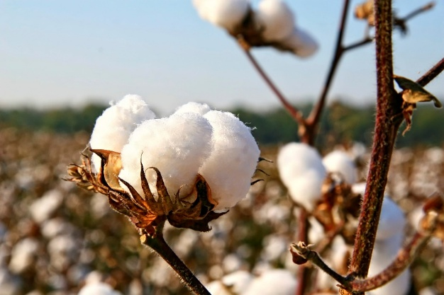
The use of herbicides on GM herbicide-tolerant cotton varieties is regulated by the Australian Pesticides and Veterinary Medicines Authority (AVPMA). The APVMA consider risks to human health and the environment when assessing any application for the use of herbicides on GM crops. They set conditions to ensure responsible use of herbicides, and to minimise the development of weeds with herbicide resistance. GM crops with insecticidal properties must also be registered with the APVMA as they have the same function as agricultural chemicals.

