

Biohacking and community science

There is a growing community of individuals in Australia who are conducting do-it-yourself biology which is also sometimes known as biohacking or community science.
Community science or biohacking covers a wide range of possible experiments and activities, some of which may involve genetically modified organisms (GMOs).
In Australia, there are strict laws to regulate activities involving GMOs. The laws are in place to make sure any risks to human health, safety and the environment are managed appropriately. Significant fines, and even jail time, can result from non-compliance.

Before you start
If you are planning to use GMOs in do-it-yourself biological research in Australia, your first port of call should be the Office of the Gene Technology (OGTR) website to find out your obligations.
There are also community science groups around Australia who can assist you.

What are the rules?
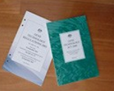
If you are considering working with or creating GMOs in Australia, you need to understand your obligations under the legislation.
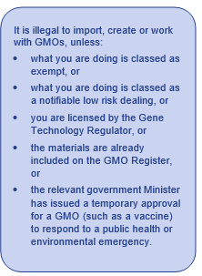
Some work involving GMOs in Australia is classified as exempt dealings. The legislation includes scientific descriptions of GMO work which is exempt. If you’re using a kit such as those used in Australian schools which enable you to insert a fluorescent colour into a harmless laboratory strain of bacterium, then there’s a good chance that your work is exempt provided you follow good laboratory practice and don’t release your GMO into the environment.

The next level is Notifiable low risk dealings (NLRD). This mostly covers research in universities and other research organisations that poses minimal risk to health and safety of people and the environment provided they meet specified conditions. The work must be conducted in certified containment facilities and assessed by an Institutional Biosafety Committee (IBC) before work commences. NLRDs must be reported to the OGTR annually.
Some universities are providing support to community groups to enable them to conduct work at this level.
If you want to import, use, or create GMOs in other ways then you must apply to the OGTR for a licence. You can read more about all the classifications of GMO dealings at Who needs to apply to import or use (deal with) a GMO?

Keeping GMOs in the lab
The OGTR has developed notes on how to avoid releasing a GMO into the environment: containment of exempt dealings.
These cover exempt dealings – the lowest risk category. Working at higher levels requires certified facilities and/or a licence from the OGTR.
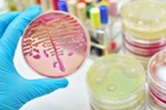
The guidance notes do not provide comprehensive guidance for laboratory safety, good laboratory practice or broader occupational health and safety issues. You should seek additional guidance on these matters

