OGTR News and Updates Issue 12
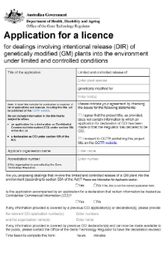
OGTR News and Announcements
- Most DNIR and DIR application forms have been updated to include a new question about Commercial Confidential Information (CCI). These forms can be found on our website. Please ensure these new forms are used when applying for a new licence, old forms will not be accepted after 31 December 2025.
- A note to all stakeholders that organisation names will no longer be included in PC1 or PC2 certified facility titles. Exceptions are made for specific circumstances and can be requested by your organisation. This will be a gradual change, assessed as variations for certifications are evaluated. No action is required at this time.

Use of AI by OGTR
The OGTR is committed to transparency and the responsible use of AI across government and with our regulated stakeholders. With the increased usage of AI to record or transcribe meetings, the OGTR will not electronically record or transcribe any meeting using Microsoft Copilot or any other AI software.
Unless expressly agreed to by all meeting parties, OGTR staff do not consent to the electronic recording or transcribing of any meeting by such AI software.




Handling an Unintentional or Low-Level Presence of GM crops

The probability of unapproved GMOs gaining entry to Australia is low. However, due to the international trade of grains, trace amounts of GM grains could be present in shipments, leading to the unintended presence of unapproved GMOs in Australia. A 6-step strategy is in place to minimise the chance of GM crops being imported into Australia, which involves oversight and diligence by both Government and industry.

For more information on the strategy, what you can do to minimise the risk of importing GMO seed stock, and what to do in the event of detecting an unintended presence, see our factsheet.

A reference for all GM plants authorised for release into the environment is available on our website.

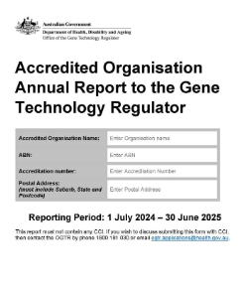
Annual Reports for Accreditations

The OGTR is following up outstanding annual reports from accredited entities, where these have not been received by the 30 September 2025 due date. If you are required to submit an annual report to the OGTR for your accreditation, and have not yet done so, please send it as soon as possible. If your annual report is not received, the Regulator may suspend or cancel your accreditation. The template for providing your annual report can be found on our website.

If you have any questions regarding the submission of your annual report, please contact the Applications team on 1800 181 030 or email OGTR.applications@health.gov.au.

If you intend to surrender your accreditation, you can request to surrender through the same contact points above. Note that an accreditation that was active at any time during the 2024/25 year will require an annual report to be submitted.


DIR Updates:
- Licence issued for the commercial release of cotton genetically modified for insect and herbicide tolerance (DIR 216).
- Licence issued for the commercial supply of a genetically modified therapeutic for bladder cancer treatment (DIR 217).

Staff movements
Since our last newsletter there have been a few long-term staff that have departed the office.

Dr Louisa Matthew (Director, Regulatory Practice), joined OGTR in Evaluation in 2008.
Dr Andrea Robold (Assistant Director, Plant Evaluation), joined OGTR in Evaluation in 2006, with time spent in Regulatory Practice and FSANZ.
Dr Heidi Mitchell (Director, Contained Dealings), joined OGTR in Evaluation in 2006, with time spent in Regulatory Practice.

As well as the following retirements:
- Andrew Short (Monitoring & Compliance, commenced 2016),

- Diana Hall (Regulatory Practice, commenced 2018)

Feature: The Asilomar Conference 50 years on

In the early 1970s a laboratory in the United States, run by Paul Berg, proposed to clone DNA of a virus that can cause cancer (SV40) into infectious (Escherichia coli) bacteria. The implications concerned him, and others, enough to ask the US National Academy of Science to consider the safety of this new recombinant DNA (rDNA) technology amid the risk of infection spreading to laboratory workers and others.

These concerns gave rise to the voluntary moratorium on rDNA experiments proposed by the US Committee on Recombinant DNA Molecules in July 1974 and the Asilomar conference where 400 scientists met at the Asilomar Conference Centre in California from 24-27 February 1975.
Entrance to the Asilomar State Park and Conference Centre where the conference was held in 1975

This year marks 50 years since that meeting. Many journals and institutions are marking this ‘golden jubilee’ and its pivotal role in the oversight of biotechnology. There are too many to list but a Google search will yield many worthy of consideration. The final report of the Asilomar organising committee is available online (but is also a reminder of the time before word processors).

Three Australians attended Asilomar - James Pittard (University of Melbourne), James Peacock (CSIRO) and Bruce Holloway (Monash University).

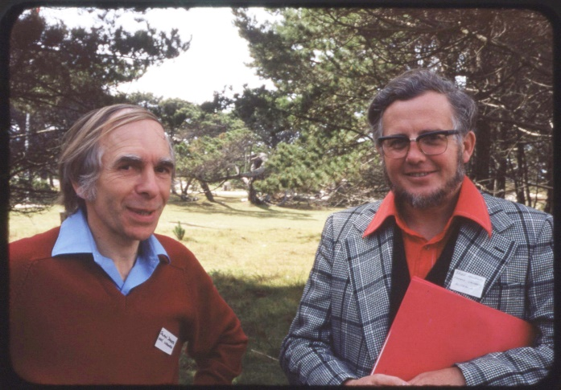
- In 1975, Australia established a system of voluntary oversight of rDNA experiments overseen by the Academy of Science Committee on Recombinant DNA (ASCORD).
- In 1981, the Australian Government established the Recombinant DNA Monitoring Committee (RDMC).
- In 1987, the Australian Government established the Genetic Manipulation Advisory Committee (GMAC). This voluntary oversight was ultimately succeeded by the Gene Technology Act 2000, administered by the Gene Technology Regulator (the Regulator) and supported by the Office of the Gene Technology Regulator.
Australian attendee at Asilomar 1975 Prof Bruce Holloway (Monash University) on the right.
- Professor Pittard served on ASCORD, RDMC, GMAC voluntary oversight committees, and then on the Gene Technology Technical Advisory Committee (a key advisory body for the Regulator).
In 1976, the US National Institutes of Health (NIH) published the Recombinant DNA Research Guidelines, including the role of institutional biosafety committees (IBCs).

Prompted somewhat by the Asilomar outcomes but also by advances in rDNA research, the OECD formed a
Group of National Experts (GNE) in 1983 to develop guidance. The work of the GNE led to the 1986 OECD

Council Recommendation Concerning Safety Considerations for Applications of Recombinant DNA Organisms in Industry, Agriculture and the Environment and the seminal Recombinant DNA Safety Considerations (the ‘Blue Book’). An update of the Recommendation was approved by Council in September 2024.
Safety of laboratory workers is a role that IBCs play an important part in overseeing

The NIH guidelines have been continuously updated, most recently in 2024. The concepts of physical and biological containment and risk assessment articulated by Asilomar and the original NIH Guidelines remain relevant today.

The recommendations contained in the Summary Statement of the Asilomar Conference on Recombinant DNA Molecules are considered to be the origin for the international, national and institutional governance of gene technology.

Fifty years after Asilomar, the IBC remains an important part of the oversight of gene technology to ensure the safety of laboratory workers and the community.
Reminder: Accredited Organisations
It is a condition of your Instrument of Accreditation that you notify the OGTR of certain changes to your organisation within 30 days of the change occurring. Notification is required for the below changes:
- Organisation name or ownership.
- Primary contact, or their contact details.
- CEO (or equivalent), or their contact details.
- IBC contact, or their contact details (where the IBC is established by the organisation).
- IBC chair, or their contact details (where the IBC is established by the organisation).
In addition, notification is also required for changes to the IBC’s you access or own, convictions of certain offences, and the loss of an authorisation under a law of the Commonwealth, a State or a foreign country relating to the health and safety of people or the environment.
Reminder: PC1 and PC2 Certified Facilities
If you have a PC1 or PC2 OGTR certified facility but are not working with GMOs you can suspend the certification until you need to work with GMOs again, or if you no longer need the facility you can surrender it.
Use the OGTR online services portal or the links below:
- Application for the Suspension of a Certification of a Physical Containment Facility | Office of the Gene Technology Regulator
- Application for the Surrender of a Certification of a Physical Containment Facility | Office of the Gene Technology Regulator

As a courtesy, the OGTR sends reminders to owners of certified facilities to alert them when their facility certifications are due to expire. It is however your responsibility to keep track of the certification status of your facilities. This is easy to see on the OGTR online services portal. To ensure your facility certification does not expire, applications to extend must be received at least 20 working days prior to the expiry.

