# Logo of the Office of the Gene Technology Regulator

# INVITATION TO COMMENT

## DIR 218 – Commercial release of tomato genetically modified for purple fruit colour from

## All Aussie Avocados Pty Ltd (trading as All Aussie Farmers)

The Gene Technology Regulator (the Regulator) has received a licence application (DIR 218) from All Aussie Avocados Pty Ltd (trading as All Aussie Farmers) for the commercial cultivation of genetically modified (GM) tomatoes. The GM tomato has been genetically modified for purple fruit colour. At this stage, the GM Purple Tomato is intended to be grown commercially in greenhouses in Australia, subject to restrictions in some Australian States and Territories for marketing or biosecurity reasons. The GM Purple Tomato and its products would enter general commerce, including use in food.

The Regulator has prepared a Risk Assessment and Risk Management Plan (RARMP) for this application and is inviting written submissions relating to risks to human health and safety and the environment prior to deciding on whether to issue the licence. You can obtain the consultation RARMP and related information via the department’s [consultation hub](https://consultations.health.gov.au/ogtr/dir-218-consultation), the [OGTR website](https://www.ogtr.gov.au/gmo-dealings/dealings-involving-intentional-release/dir-218) or from the contacts below.

**You can make a written submission via the** [**consultation hub**](https://consultations.health.gov.au/ogtr/dir-218-consultation)**, or via email or letter by 3 November 2025 (please reference DIR 218).**

***Regulatory responsibilities***

This GM Purple Tomato would only become available in Australia if all regulatory requirements are met, including approvals from the Gene Technology Regulator, Food Standards Australia New Zealand ([FSANZ](https://www.foodstandards.gov.au/)), and the Department of Agriculture, Fisheries and Forestry ([DAFF](https://www.agriculture.gov.au/about/contact)).

Issues such as **food safety and labelling, agricultural chemical use, benefits,** and **marketability and trade** **implications** do **NOT** fall within the scope of the evaluations conducted under the Act as these are the responsibility of state and territory governments, industry bodies or other agencies and authorities.

FSANZ is currently assessing the safety of the GM Purple Tomato and its products as food for human consumption under application [A1333](https://www.foodstandards.gov.au/food-standards-code/applications/a1333-food-derived-purple-tomato-lines-containing-event-delros1-n?mc_cid=c081b9e40d&mc_eid=0f37df4f4b).

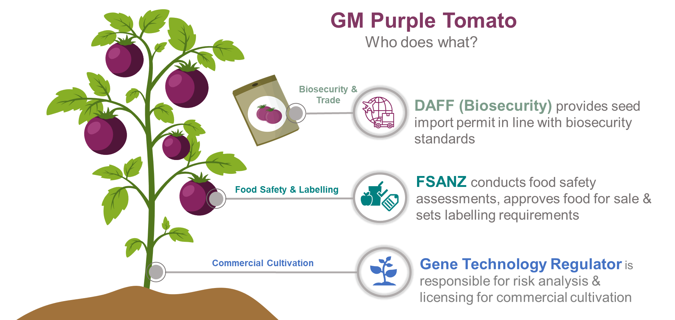

***Decision-making process for commercial cultivation of the GM Purple Tomato plants***

The Gene Technology Regulator must undertake the following steps:

1. *(Completed) Notification of receipt of application.* No public consultation occurs at this early stage. However, advice on this application will be sought from a broad range of experts, agencies and authorities, and from local councils.
2. *(Completed) Preparation of the* *Risk Assessment and Risk Management Plan (RARMP)*. The OGTR will prepare a consultation version of the RARMP, considering the advice received in Step 1.
3. *Public consultation*. **Consultation with the public** as well as the stakeholders in Step 1 on the consultation RARMP.
4. *Finalisation of the RARMP*. After consultation, all submissions and advice received will be considered and the RARMP finalised.
5. *The Regulator makes a decision.* A decision on whether or not to issue a licence will be made by the Regulator.

The decision will be publicly notified, including to [subscribers](https://www.ogtr.gov.au/about-ogtr/contact-and-subscribe/subscribe-ogtr-news) and all people who made a submission. We will post the decision, final RARMP, licence (if approved) and associated documents on our [website](http://www.ogtr.gov.au/).

***Further information***

More information is available from the [OGTR website](http://www.ogtr.gov.au/) on:

* this application, including the RARMP (search for **DIR 218**)
* how to [subscribe](https://www.ogtr.gov.au/about-ogtr/contact-and-subscribe/subscribe-ogtr-news) to our client list
* [genetic modification methods for plants](https://www.ogtr.gov.au/sites/default/files/files/2021-06/risk_assessment_reference_-_methods_of_plant_genetic_modification.pdf) and [selectable marker genes](https://www.ogtr.gov.au/sites/default/files/2024-02/risk_assessment_reference_marker_genes_in_gm_plants.pdf)
* [Australia’s national scheme for regulation of gene technology](https://www.ogtr.gov.au/about-ogtr/australias-gene-technology-regulatory-system) and
* the [approval process](https://www.ogtr.gov.au/work-gmos/about-approval-process).

Raj Bhula

Gene Technology Regulator

8 September 2025

**Office of the Gene Technology Regulator  
E-mail:** [**ogtr@health.gov.au**](mailto:ogtr@health.gov.au)

[OGTR Website](https://www.ogtr.gov.au/)  Telephone: 1800 181 030

MDP 54 GPO Box 9848 CANBERRA ACT 2601