# NOTIFICATION OF RECEIPT OF APPLICATION

## DIR-218 – Commercial release of tomato genetically modified for purple fruit colour from

## All Aussie Avocados Pty Ltd (trading as All Aussie Farmers)

The Office of the Gene Technology Regulator (OGTR) has received a licence application (DIR 218) from All Aussie Avocados Pty Ltd (trading as All Aussie Farmers) for the commercial cultivation of genetically modified (GM) tomatoes. The GM tomato has been genetically modified for purple fruit colour. At this stage, the GM Purple Tomato is intended to be grown commercially in greenhouses in Australia, subject to restrictions in some Australian States and Territories for marketing or biosecurity reasons. The GM Purple Tomato and its products would enter general commerce, including use in human food.

***Regulatory responsibilities***

This GM Purple Tomato would only become available in Australia if all regulatory requirements are met, including approvals from the Gene Technology Regulator, Food Standards Australia New Zealand ([FSANZ](https://www.foodstandards.gov.au/)), and the Department of Agriculture, Fisheries and Forestry ([DAFF](https://www.agriculture.gov.au/about/contact)). FSANZ is currently assessing the safety of the GM Purple Tomato and its products as food for human consumption under application [A1333](https://www.foodstandards.gov.au/food-standards-code/applications/a1333-food-derived-purple-tomato-lines-containing-event-delros1-n?mc_cid=c081b9e40d&mc_eid=0f37df4f4b).

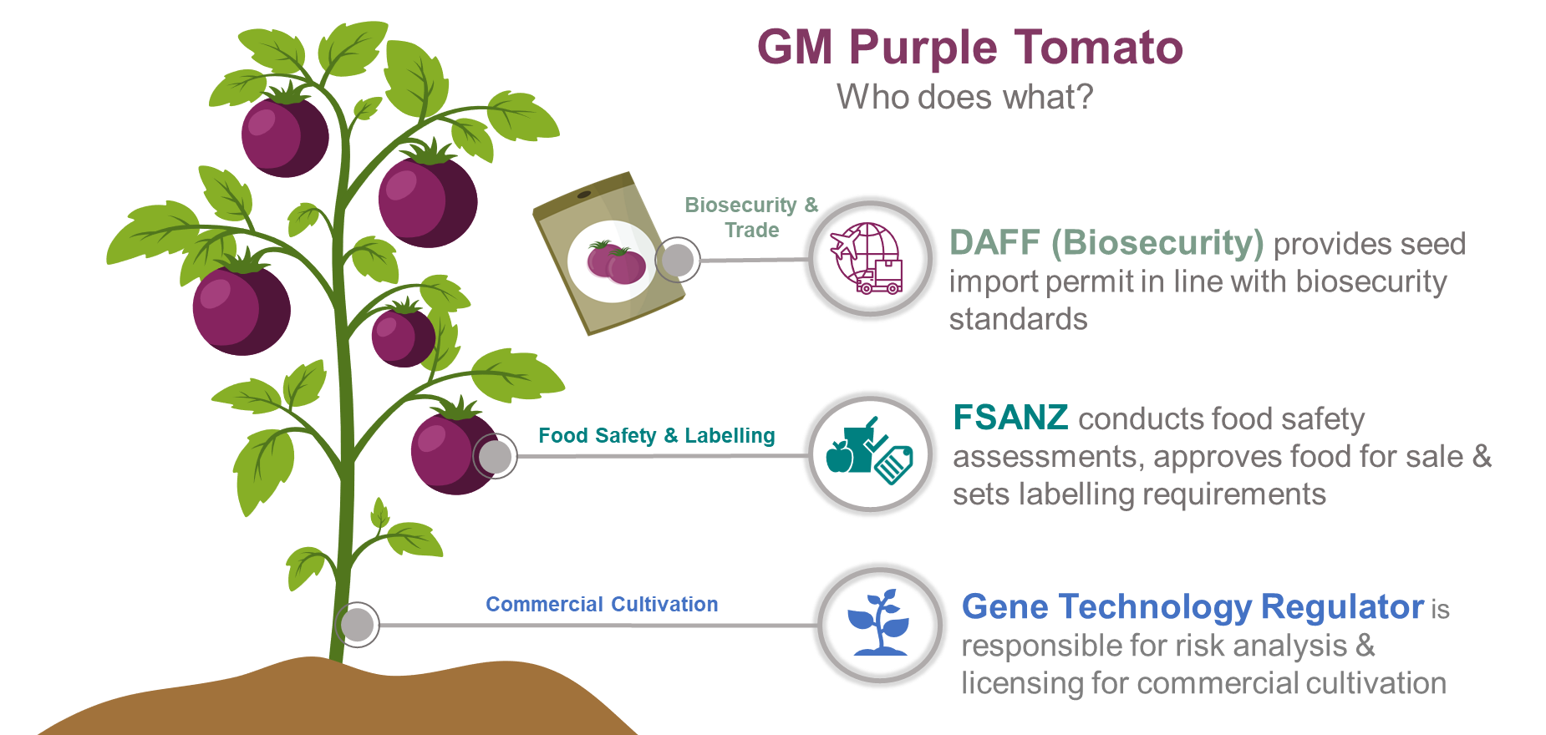

***Decision-making process for commercial cultivation of the GM Purple Tomato plants***

The Gene Technology Regulator must undertake the following steps:

1. *(Completed) Notification of receipt of application.* No public consultation occurs at this early stage. However, advice on this application will be sought from a broad range of experts, agencies and authorities, and from local councils.
2. ***(Current step) Preparation of the* *Risk Assessment and Risk Management Plan (RARMP)*. The OGTR will prepare a consultation version of the RARMP, considering the advice received in Step 1.**
3. *Public consultation*. **Consultation with the public** as well as the stakeholders in Step 1 on the consultation RARMP. It is expected that the consultation RARMP and other information will be available **in September 2025**.

[Subscribers](https://www.ogtr.gov.au/about-ogtr/contact-and-subscribe/subscribe-ogtr-news) will be notified of the consultation and it will be advertised in newspapers and on the OGTR [website](http://www.ogtr.gov.au/). The consultation period will be for at least 30 days.

1. *Finalisation of the RARMP*. After consultation, all submissions and advice received will be considered and the RARMP finalised.
2. *The Regulator makes a decision.* A decision on whether or not to issue a licence will be made by the Regulator.

The decision will be publicly notified, including to [subscribers](https://www.ogtr.gov.au/about-ogtr/contact-and-subscribe/subscribe-ogtr-news) and all people who made a submission. The decision, final RARMP, licence (if approved) and associated documents will be posted on the OGTR [website](http://www.ogtr.gov.au/).

***Further information***

More information is available from the [OGTR website](http://www.ogtr.gov.au/) on:

* this application (search for **DIR-218**)
* how to [subscribe](https://www.ogtr.gov.au/about-ogtr/contact-and-subscribe/subscribe-ogtr-news) to our client list
* [genetic modification methods for plants](https://www.ogtr.gov.au/sites/default/files/files/2021-06/risk_assessment_reference_-_methods_of_plant_genetic_modification.pdf) and [selectable marker genes](https://www.ogtr.gov.au/sites/default/files/2024-02/risk_assessment_reference_marker_genes_in_gm_plants.pdf)
* [Australia’s national scheme for regulation of gene technology](https://www.ogtr.gov.au/about-ogtr/australias-gene-technology-regulatory-system) and
* the [approval process](https://www.ogtr.gov.au/work-gmos/about-approval-process).

Please email [ogtr@health.gov.au](mailto:ogtr@health.gov.au) or phone 1800 181 030 if you would like a copy of the application (refer to OGTR identifier DIR 218). The OGTR mail address is *The Office of the Gene Technology Regulator, MDP 54, GPO Box 9848, Canberra ACT 2601*.

Raj Bhula

Gene Technology Regulator

23 May 2025 (updated July 2025)