May 2025

Summary of Licence Application DIR 218

All Aussie Avocados Pty Ltd (trading as All Aussie Farmers) has made an application under the *Gene Technology Act 2000* (the Act) for Dealings involving the Intentional Release (DIR) of genetically modified organisms (GMOs) into the Australian environment.

|  |  |
| --- | --- |
| *Project Title* | Commercial release of tomato genetically modified for purple fruit colour[1] |
| *Parent organism* | Tomato (*Solanum lycopersicum*) |
| ***Genetic modifications*** | |
| Introduced genes | Introduced genes conferring purple fruit colour, sourced from garden snapdragon (*Antirrhinum majus*):   * *Delila* gene * *Rosea1* gene   These 2 genes switch on production of natural blue pigments, anthocyanins, in the ripening fruit (see *Further information on the genetic modification* below this table).  Introduced marker gene:   * *nptII* gene – gene from the bacterium *Escherichia coli* conferring resistance to the antibiotic kanamycin and structurally-related antibiotics |
| Genetic modification method | *Agrobacterium*-mediated transformation |
| Identifier | Developer’s line name: Del/Ros1-N  Commercial name: The Purple TomatoTM  OECD Unique Identifier: NPS-01201-8 |
| *Principal purpose* | Commercial cultivation of the GM Purple Tomato in greenhouses |
| *Previous releases* | **Australia**  The GM Purple Tomato has not been previously grown in Australia.  **United States (US)**  The US Department of Agriculture Animal and Plant Health Inspection Service deemed the GM Purple Tomato not a regulated article. Seed has been sold to home gardeners since 2024.  The US Food and Drug Administration authorised the GM Purple Tomato as food in 2023. In 2024, commercially produced fruit was sold in grocery stores. |

A separate application will need to be made to Food Standards Australia New Zealand to seek approval for fruit from the GM Purple Tomato to be sold as food.

### Further information on the genetic modification

The GM Purple Tomato differs from non-GM red tomatoes:

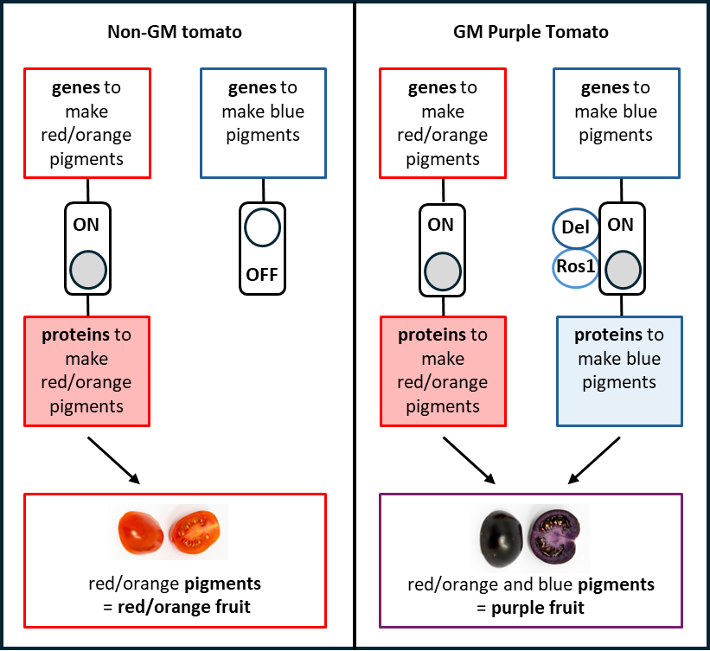

### Difference to non-GM purple tomatoes

While many non-GM tomatoes have red/orange fruit, some varieties have been conventionally bred to have fruit with blue pigments. The ripe fruit from these non-GM purple tomato varieties have a purple skin and may have a slight darker tinge in parts of the flesh, but not all purple flesh.

This makes it easy to distinguish the ripe fruit of purple non-GM tomato varieties from those of the GM Purple Tomato.

### Consultation on this licence application

**Public consultation** is expected in **September 2025**. We will notify subscribers to [OGTR News](https://www.ogtr.gov.au/about-ogtr/contact-and-subscribe/subscribe-ogtr-news) of the consultation and advertise it in newspapers and on our [website](http://www.ogtr.gov.au). The consultation will be open for written submissions for at least 30 days.

### More information is available from the [OGTR website](http://www.ogtr.gov.au/) on:

* this application (search for **DIR-218**)
* how to [subscribe](https://www.ogtr.gov.au/about-ogtr/contact-and-subscribe/subscribe-ogtr-news) to our client list
* [genetic modification methods for plants](https://www.ogtr.gov.au/sites/default/files/files/2021-06/risk_assessment_reference_-_methods_of_plant_genetic_modification.pdf) and [selectable marker genes](https://www.ogtr.gov.au/sites/default/files/2024-02/risk_assessment_reference_marker_genes_in_gm_plants.pdf)
* [Australia’s national scheme for regulation of gene technology](https://www.ogtr.gov.au/about-ogtr/australias-gene-technology-regulatory-system) and
* the [approval process](https://www.ogtr.gov.au/work-gmos/about-approval-process).

1. The original title for the application was *Commercial release of Lycopersicon esculentum genetically modified for purple anthocyanin pigment in ripe fruit*.