
Licence for dealings involving an intentional release of a GMO into the environment
Licence No.: DIR 176
Licence Holder: Grasslanz Technology Australia Pty Limited
Limited and controlled release of white clover genetically modified for increased condensed tannins
Issued: 31 March 2021
Transferred: 2 June 2022
Varied: 29 April 2025

Gene Technology Regulation in Australia
Australia’s gene technology regulatory system operates as part of an integrated legislative framework. The Gene Technology Act 2000 (Cth) and corresponding state and territory legislation form part of a nationally consistent regulatory system controlling activities involving genetically modified (GM) organisms.
This licence is issued by the Gene Technology Regulator (the Regulator), in accordance with the Gene Technology Act 2000 and, as applicable, corresponding State law.
The Regulator is required to consult with, and take into account advice from, a range of key stakeholders, including other regulatory authorities, on risks to human health and safety and to the environment in assessing applications for dealings involving the intentional release of GM organisms into the Australian environment.
Other agencies that also regulate GM organisms or GM products include Food Standards Australia New Zealand, Australian Pesticides and Veterinary Medicines Authority, Therapeutic Goods Administration, Australian Industrial Chemicals Introduction Scheme and the Department of Agriculture, Water and the Environment. Dealings conducted under any licence issued by the Regulator may also be subject to regulation by one or more of these agencies. It is recommended that the licence holder consult the relevant agency (or agencies) about their regulatory requirements.
Dealings permitted by this licence may also be subject to the operation of State legislation recognising areas as designated for the purpose of preserving the identity of GM crops, non-GM crops, or both GM crops and non-GM crops, for marketing purposes.
Further information on Licence DIR 176
More information about the decision to issue this licence is contained in the Risk Assessment and Risk Management Plan prepared in connection with the assessment of the application for the licence. This document can be obtained from the Office of the Gene Technology Regulator website or by telephoning the Office on 1800 181 030.
Information about where the GMOs have been planted pursuant to this licence can be accessed on the OGTR website.

Interpretations and Definitions
- In this licence:
  - unless defined otherwise, words and phrases used in this licence have the same meaning as they do in the Act and the Regulations;
  - words denoting a gender include any other gender;
  - words in the singular include the plural and words in the plural include the singular;
  - words denoting persons include a partnership and a body whether corporate or otherwise;
  - references to any statute or other legislation (whether primary or subordinate) are a reference to a statute or other legislation of the Commonwealth of Australia as amended or replaced from time to time and equivalent provisions, if any, in corresponding State law, unless the contrary intention appears;
  - where any word or phrase is given a defined meaning, any other part of speech or other grammatical form in respect of that word has a corresponding meaning;
  - specific conditions prevail over general conditions to the extent of any inconsistency.
- In this licence:
‘Act’ means the Gene Technology Act 2000 (Commonwealth) or the corresponding State law under which this licence is issued.
‘Bees’ means cultivated honeybees of the species Apis mellifera.
‘Birdsfoot Trefoil’ means plants of the species Lotus corniculatus L.
‘Burial Site’ means a place where the GMOs are Destroyed by burial.
‘Clean’ means, as the case requires:
  - in relation to Equipment or a facility, remove and/or Destroy the GMOs; or
  - in relation to an area of land specified in this licence as requiring Cleaning:
    - destroy White Clover plants, if present, to the reasonable satisfaction of the Regulator, and
    - remove White Clover seeds from the soil surface to the reasonable satisfaction of the Regulator;
    - destroy all plants in the Planting Area.
Note: The intent of removing seeds from the soil surface is to minimise seed dispersal. One method of removing seeds from the soil surface is Tillage, which moves seeds to under the soil. Tillage must be in accordance with condition 45.
‘Contingency Plan’ means a written plan detailing measures to be taken in the event of the unintended presence of the GMOs outside an area that must be inspected. A Contingency Plan must include procedures to:
        - ensure the Regulator is notified immediately if the licence holder becomes aware of the event; and
  - recover and/or Destroy the GMOs to the reasonable satisfaction of the Regulator; and
  - inspect for and Destroy any Volunteers that may exist as a result of the event to the reasonable satisfaction of the Regulator.
‘Destroy’, (or ‘Destruction’) means, as the case requires, kill by one or more of the following methods:
        - uprooting;
        - root cutting and shredding/mulching;
        - Tillage, but only in accordance with condition 45;
        - treatment with herbicide;
        - burning/incineration;
        - autoclaving;
        - burial, but only in accordance with condition (burial condition);
        - a method approved in writing by the Regulator.
Note: ‘As the case requires’ has the effect that, depending on the circumstances, one or more of these techniques may not be appropriate. For example, treatment with herbicide would not successfully kill GM seeds.
‘Equipment’ includes, but is not limited to, seeders, harvesters, tents, storage equipment, transport equipment (e.g. bags, containers, trucks), clothing, footwear and tools.
‘Extreme Weather’ includes, but is not limited to, fires, flooding, cyclones or torrential rain, that could disperse GMOs or affect the licence holder’s ability to comply with licence conditions.
‘Flowering’ is taken to begin when any plant of the class of plants referred to in a particular condition first has an open flower, and is taken to end when all plants in the class of plants no longer have flowers.
‘GM’ means genetically modified.
‘GMOs’ means the genetically modified organisms that are the subject of the dealings authorised by this licence. GMOs include live plants, root stock that is able to grow into live plants and viable seed.
‘Inner Pollen Trap’ means an area of land extending outwards at least 1 metre from the outer edge of a Planting Area, where only Pollen Trap Plants are grown, as shown in Figures 1B and 1C.
‘Insect-proof’ means sufficient to prevent the entry of insects that commonly pollinate White Clover flowers.
‘Isolation Zone’ means an area of land extending at least 90 m in all directions from the outer edge of the Monitoring Zone as shown in Figure 1A; or means an area of land extending at least 463 m in all directions from the outer edge of the outer pollen trap as shown in Figures 1B and 1C.
‘Logbook’ means a written or electronic record containing information required to be collected and maintained by this licence and which is able to be presented to the Regulator on request.
‘Lucerne’ means plants of the species Medicago sativa L.
‘Monitoring Zone’ means an area of land extending outwards at least 10 m from the outer edge of the insect-proof tent, as shown in Figure 1A; or any area of land within the Inner Pollen Trap that is not a Planting Area, as shown in Figure 1B and Figure 1C.
‘OGTR’ means the Office of the Gene Technology Regulator.
‘Personal Information’ means information or an opinion about an identified individual, or an individual who is reasonably identifiable:
  - whether the information or opinion is true or not; and
  - whether the information or opinion is recorded in a material form or not.
‘Planting Area’ means an area of land where the GMOs and non-GM white clover, Perennial Ryegrass and Birdsfoot Trefoil are intentionally planted and grown pursuant to this licence, but does not include the Pollen Trap.
‘Plant Material’ means any part of the GM or non-GM white clover plants grown at a Planting Area or Pollen Trap, whether viable or not, or any product of these plants.
‘Pollen Buffer’ means an area of land extending outwards at least 35 metres from the outer edge of an Inner Pollen Trap, where only Pollen Buffer Plants are grown, as shown in Figures 1B and 1C.
‘Pollen Trap Plants’ means non-GM White Clover grown in a Pollen Trap.
‘Pollen Buffer Plants’ means non-GM Lucerne grown in a Pollen Buffer.
‘Outer Pollen Trap’ means an area of land extending outwards at least 1 metre from the outer edge of a Pollen Buffer, where only Pollen Trap Plants are grown, as shown in Figures 1B and 1C.
‘Regulations’ means the Gene Technology Regulations 2001 (Commonwealth) or the corresponding State law under which this licence is issued.
‘Regulator’ means the Gene Technology Regulator.
‘Sign off’ means a notice in writing from the Regulator, in respect of an area, that post-Cleaning obligations no longer apply to that area.
‘Site’ means an area of land containing one Planting Area and its Monitoring Zone, as shown in Figure 1A; or an area of land containing one or more Planting Areas and Inner Pollen Trap, Pollen Buffer and Outer Pollen trap as shown in Figures 1B and 1C.
‘Tillage’ means the use of any technique to disturb the soil.
Note: Tillage must be in accordance with condition 45.
‘Volunteers’ means GM or non-GM White Clover plants which have not been intentionally grown.
White Clover means plants of the species Trifolium repens L.

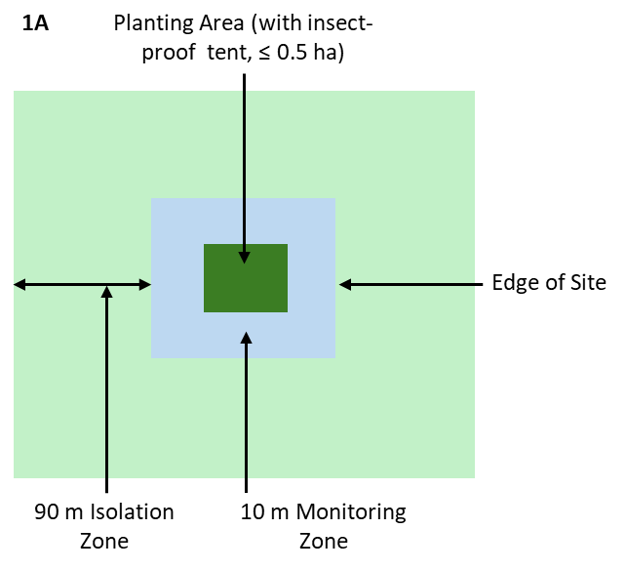

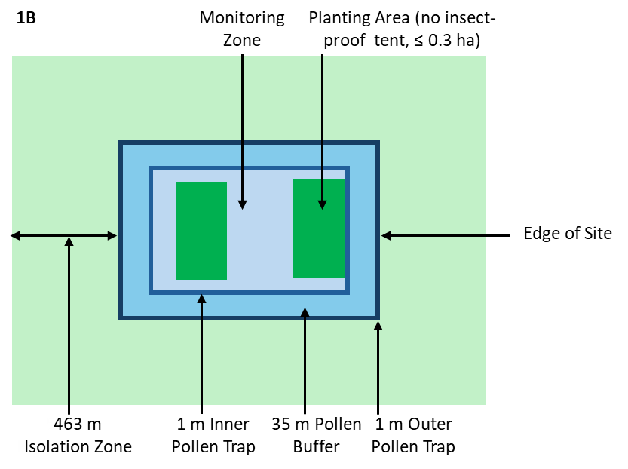

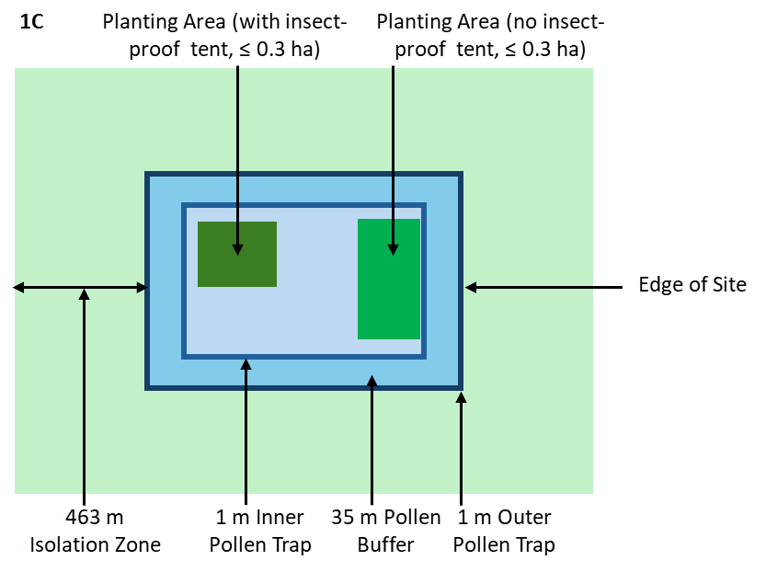
Figure 1. Diagrams (not to scale) showing the relationships between Planting Area, Pollen Trap, Monitoring Zone and Isolation Zone.
Layout (A) with Insect-proof tent, (B) with Pollen Traps and Pollen Buffer and (C) with tented and non-tented Planting Areas, Pollen Traps and Pollen Buffer.

General conditions and obligations
- This licence does not authorise dealings with the GMOs that are otherwise prohibited as a result of the operation of State legislation recognising an area as designated for the purpose of preserving the identity of GM crops, non-GM crops, or both GM crops and non-GM crops, for marketing purposes.
- This licence remains in force until it is suspended, cancelled or surrendered. No dealings with the GMOs are authorised during any period of suspension.
Note: Although this licence has no expiry date, the period when GMOs may be grown is restricted in accordance with Condition 18.
- The licence holder is Grasslanz Technology Australia Pty Limited.
- The persons covered by this licence are the licence holder and employees, agents or contractors of the licence holder and other persons who are, or have been, engaged or otherwise authorised by the licence holder to undertake any activity in connection with the dealings authorised by this licence.
- The GMOs with which dealings are authorised by this licence are GM White Clover containing the TaMYB14-1 gene, as listed at Attachment A.
- The dealings authorised by this licence are to:
        - conduct experiments with the GMOs;
        - breed the GMOs;
        - propagate the GMOs;
        - grow the GMOs;
        - import the GMOs;
        - transport the GMOs;
        - dispose of the GMOs;
and the possession, supply or use of the GMOs in the course of any of these dealings.
- This licence does not apply to dealings with the GMOs conducted as a Notifiable Low Risk Dealing (NLRD) or pursuant to another authorisation under the Act.
Note: Dealings conducted as an NLRD must be assessed by an Institutional Biosafety Committee (IBC) before commencement and must comply with the requirements of the Regulations.

General obligations of the licence holder
- The licence holder must, at all times, remain an accredited organisation in accordance with the Act and must comply with its instrument of accreditation.
- The licence holder must be able to access and control all Planting Areas, Pollen Traps, Pollen Buffers, Monitoring Zones, Isolation Zones and approved facilities to the extent necessary to comply with this licence.
Note: Arrangements to access and control these areas must be notified to the Regulator as part of each planting notification (Condition 54.a.iii).
- The licence holder must inform any person covered by this licence, to whom a particular condition of the licence applies, of the following:
        - the particular condition, including any variations of it;
  - the cancellation or suspension of the licence;
  - the surrender of the licence.
- The licence holder must not permit a person covered by this licence to conduct any dealing with the GMOs unless:
        - the person has been informed of any applicable licence conditions, including any variation of them; and
        - the licence holder has obtained from the person a signed and dated statement that the person:
    - has been informed by the licence holder of the licence conditions including any variation of them; and
    - has understood and agreed to be bound by the licence conditions, or variation.
- The licence holder must inform the persons covered by this licence that any Personal Information relevant to the administration and/or enforcement of the licence may be released to the Regulator.

General Obligations of persons covered by the licence
- If a person is authorised by this licence to deal with the GMOs and a particular condition of the licence applies to the dealing by the person, the person must allow the Regulator, or a person authorised by the Regulator, to enter premises where the dealing is being undertaken, for the purposes of auditing or monitoring the dealing.
Note: Under the Act, the definition of premises includes a building, area of land or vehicle.

Limits and Control Measures

Limits on the release
The following licence conditions impose limits on where and when the GMOs may be grown.
- The only plants that may be intentionally grown at a Planting Area are:
        - the GMOs covered by this licence; and
        - non-GM White Clover, non-GM Perennial Ryegrass and non-GM Birdsfoot Trefoil; and
        - plants approved in writing by the Regulator.
- Non-GM White Clover, non-GM Perennial Ryegrass and non-GM Birdsfoot Trefoil plants grown in a Planting Area and Pollen Traps must be handled as if they were GMOs.
- Planting and growing of the GMOs may only occur within the following limits:
Area and duration
Period | Maximum number of Sites per year | Maximum combined size of Planting Areas per year | Maximum size of an individual Planting Area
From issue of licence until December 2026 | 2 | 1.0 ha | - 0.5 ha, but only if gene flow measures are employed in accordance with condition 24.a and the layout is as in Figure 1A.  - 0.3 ha if gene flow measures are employed in accordance with either condition 24.b. or 24.c.
Note: More than one Planting Area per year may be established at a Site if grown in accordance with condition 24.b or 24.c, within the overall maximum size per Planting Area and Maximum combined size of Planting Areas per year (see Figures 1B and 1C).
Local Government Areas in which Planting Areas may be located
New South Wales | Victoria | Western Australia | Queensland
Armidale¹ | Ballarat⁴ | Albany⁷ | Gympie Regional¹
Bathurst¹ | Bass Coast² | Augusta-Margaret River⁶ | Ipswich⁴
Bega Valley² | Baw Baw² | Bridgetown-Greenbushes⁶ | Lockyer Valley¹
Bellingen² | Benalla⁵ | Busselton⁶ | Logan⁴
Berrigan² | Campaspe² | Capel⁶ | Moreton Bay¹
Blayney² | Cardinia² | Dardanup⁶ | Scenic Rim¹
Byron² | Casey⁴ | Denmark⁶ | Somerset¹
Cabonne² | Colac-Otway² | Harvey⁶ | South Burnett¹
Central Coast³ | Corangamite² | Manjimup⁶ | Southern Downs¹
Cessnock⁴ | East Gippsland² | Murray⁶ | Tablelands¹
Lake Macquarie⁴ | French Island⁸ | Nannup⁶ | Toowoomba¹
City of Lithgow³ | Gannawarra² | Nedlands⁷
Clarence Valley³ | Glenelg² | Serpentine-Jarrahdale⁶
Coffs Harbour⁴ | Golden Plains² | Subiaco⁷
Cootamundra-Gundagai¹ | Greater Shepparton⁴ | Swan⁷
Cowra² | Hepburn² | Waroona⁶
Dubbo¹ | Indigo²
Dungog² | Latrobe⁴
Glenn Innes Severn³ | Loddon²
Goulburn Mulwaree³ | Macedon Ranges²
Gwydir² | Mitchell²
Hawkesbury⁴ | Moira²
Hilltops³ | Moorabool²
Inverell² | Mornington Peninsula²
Kempsey² | Moyne²
Kyogle³ | Pyrenees²
Lismore⁴ | South Gippsland²
Liverpool Plains² | Southern Grampians²
Maitland⁴ | Surf Coast²
MidCoast³ | Towong²
Mid-Western¹ | Wangaratta⁵
Muswellbrook² | Warnambool⁴
Nambucca² | Wellington²
Narrabri² | Wodonga⁴
Oberon³ | Yarra Ranges²
Orange⁴
Port Macquarie-Hastings³
Port Stephens³
Queanbeyan-Palerang¹
Richmond Valley³
Shoalhaven⁴
Singleton²
Snowy Monaro¹
Snowy Valleys³
Tamworth¹
Tenterfield²
Tweed²
Upper Hunter²
Upper Lachlan²
Uralla²
Wagga Wagga⁴
Walcha³
Walgett²
Warrumbungle²
Wingecarribee²
As different states have different titles for LGAs, these are identified in the table as: ¹ Regional Council; ² Shire Council; ³ Council; ⁴ City Council; ⁵ Rural City Council; ⁶ Shire of; ⁷ City of; ⁸ Unincorporated area

Control measures
The following licence conditions restrict the spread or persistence of the GMOs and their genetic material in the environment.

GMOs must not enter food or feed
- Plant Material must not be used, sold or otherwise disposed of for any purpose which would involve or result in its use as food for humans or feed for animals.
- A livestock-proof fence must be located around the Site, and a rabbit-proof fence must be located around the Planting Area while GMOs are being grown and until the Planting Areas are Cleaned.
- While a fence is required under the preceding condition, the fence must be inspected for damage at least once every 35 days and after any Extreme Weather event, and if damage is found, must be repaired as soon as practicable.
Note: Details of any inspection activity must be recorded in a Logbook (Condition 55) and reported to the Regulator (Condition g).
- If Beehives containing Bees are utilised, they may only be situated at a Site for pollination while the GMOs, Pollen Traps and Pollen Buffer plants are Flowering.
- Once pollination is complete, the Bees, honey and pollen in the beehive must be destroyed.

Conditions to restrict pollen flow
- For each Planting Area, one of the following measures to limit gene flow must be adopted:
        - cover all GMOs with an insect-proof tent from at least seven days prior to Flowering and until all GMOs have completed Flowering, and surround the Planting Area with a Monitoring Zone of at least 10 metres, and surround the Monitoring Zone with an Isolation Zone of at least 90 metres (as shown in Figure 1A); or
  - surround the Planting Area with an Inner Pollen Trap of at least 1 metre, surround the Inner Pollen Trap with a Pollen Buffer of at least 35 metres, surround the Pollen Buffer with an Outer Pollen trap of at least 1 metre, and surround the Outer Pollen trap with an Isolation Zone of at least 463 metres (as shown in Figure 1B).
  - if GMOs are grown both with and without an insect-proof tent in Planting Areas at a Site, the Planting Areas must comply with the requirements of Planting Areas managed under 24 (b) (as shown in Figure 1C).
- Prior to planting the GMOs, the licence holder must notify the Regulator which of the measures, as detailed in Condition 24, proposed to be used for the Planting Area(s) for each Site.
- When a Monitoring Zone is used in accordance with Condition 24, it must be maintained in a manner appropriate to allow the identification and Destruction of White Clover while the GMOs are growing in the Planting Area(s).
Note: Measures to achieve this could include maintaining the area free of vegetation and/or keeping vegetation mown to a height of less than 10 centimetres. Condition 54 requires details of current land use and recent land management practices to be recorded upon inspection of the Monitoring Zone.
- If insect-proof tents are used, a Monitoring Zone and an Isolation Zone must be used in accordance with condition 24:
        - the GMOs must not be planted in a Planting Area if any White Clover is present in the Monitoring Zone; and
  - the associated areas and insect-proof tents must be inspected by people trained to recognise White Clover, and actions must be taken as follows:
Area | Period of inspection | Inspection frequency | Inspect for | Action
Monitoring Zone | From 14 days prior to the expected commencement of Flowering of any GMOs*  until all GMOs have been harvested or Destroyed | At least once every 28 days | White Clover | Destroy before Flowering
Insect-proof tents | While tents are in place | At least once every 14 days and after any Extreme Weather event | Damage that may render tents not Insect-proof | Repair any damage or replace if repair not possible
Isolation Zone | From 14 days prior to the expected commencement of Flowering of any GMOs*  until all GMOs have finished Flowering | At least once every 28 days | White Clover | Destroy before Flowering; alternatively, Destroy the GMOs before Flowering
*Condition a requires the licence holder to provide information to the Regulator on the expected Flowering period, however the inspection period should be based on the observed development of the GMOs, so that inspections commence prior to any GMOs Flowering.
Note: Details of any inspection activity must be recorded in a Logbook (Condition 5554) and reported to the Regulator (Condition 54).
- When beehives are used in the insect-proof tent, the applicant must ensure that bees from the hive remain within the insect-proof tent. Once pollination is complete, the requirements of Conditions 22 and 23 must be satisfied in a manner that ensures bees are not released from the insect-proof tent.
- If Pollen Traps and Pollen Buffer are used in accordance with condition 24:
        - the GMOs must not be planted in a Planting Area if any White Clover is present in the Monitoring Zone (if used); and
        - the Monitoring Zone (if used), Inner Pollen Trap, Pollen Buffer, Outer Pollen Trap and Isolation Zones must be inspected by people trained to recognise White Clover, and actions must be taken as follows:
Area | Period of inspection | Inspection frequency | Inspect for | Action
Monitoring Zone (if used) | From 14 days prior to the expected commencement of Flowering of any GMOs*  until all GMOs have been harvested or Destroyed | At least once every 28 days | White Clover | Destroy before Flowering
Pollen Buffer | From 14 days prior to the expected commencement of Flowering of any GMOs*  until all GMOs have been harvested or Destroyed | At least once every 28 days | White Clover | Destroy before Flowering
Isolation Zone | From 14 days prior to the expected commencement of Flowering of any GMOs*  until all GMOs have finished Flowering | At least once every 28 days | White Clover | Destroy before Flowering; alternatively, Destroy the GMOs before Flowering
*Condition a requires the licence holder to provide information to the Regulator on the expected Flowering period, however the inspection period should be based on the observed development of the GMOs, so that inspections commence prior to any GMOs Flowering.
Note: Details of any inspection activity must be recorded in a Logbook (Condition 55) and reported to the Regulator (Condition 54).
- If Pollen Traps and Pollen Buffer are used in accordance with condition 24:
        - Pollen Trap and Pollen Buffer Plants must have a reasonably dense and vigorous growth; and
  - Pollen Trap and Pollen Buffer Plants must be Flowering at the same time as the GMOs and at a sufficient rate to significantly reduce pollen flow; and
Note: a flowering rate of 25% or more in the pollen traps and pollen buffer may be considered as suitable to reduce pollen flow.
  - Pollen Trap and Pollen Buffer Plants must form a continuous barrier at least 37 metres wide around the Planting Area while the GMOs are Flowering, although one path of up to 2 metres in width is allowed in order to access the Planting Area; and
Note: To comply with Condition 17, Pollen Trap plants must be treated as if they were GMOs.
  - the Inner Pollen Trap, Pollen Buffer and Outer Pollen Trap must be inspected:
Area | Period of inspection | Inspection frequency | Inspect for | Action
Inner Pollen Trap, Pollen Buffer, Outer Pollen Trap | From 14 days prior to the expected commencement of Flowering of any GMOs*  until all GMOs have finished Flowering | At least once every 28 days | Dense, vigorous growth; concurrent flowering; and a continuous barrier of at least 37 m. | If conditions 30a, b and c not met, GM White Clover plants in the Planting Area prevented from Flowering; or Destroyed
*Condition a requires the licence holder to provide information to the Regulator on the expected Flowering period, however the inspection period should be based on the observed development of the GMOs, so that inspections commence prior to any GMOs Flowering.
Note: Details of any inspection activity must be recorded in a Logbook (Condition 55) and reported to the Regulator (Condition 54).
- If the GMOs in the planting area are prevented from Flowering to comply with Condition 30, inspections of the GMOs in the Planting Area for flower buds must be conducted every 14 days.
- If a Site includes both Planting Area(s) surrounded by an insect-proof tent and Planting Area(s) without insect-proof tents (as shown in Figure 1C), inspection requirements detailed in Conditions 27, 29, 30 and 31 must be fulfilled and any Monitoring Zone must be managed in accordance with Condition 26.
- Pollen Trap Plants and Pollen Buffer Plants must be Destroyed after the end of each Flowering season.

Conditions to restrict seed dispersal
- Equipment used in connection with the GMOs must be Cleaned as soon as practicable after use with the GMOs and before use for any other purpose.
- Planting Areas and Pollen Traps must be at least 50 metres away from any permanent natural watercourses or manmade drainage features that flow into natural watercourses.
Note: This includes irrigation channels or storm water drains that flow into a natural watercourse.
- Planting Areas and Pollen Traps must not be located in flood prone areas.
- Measures must be implemented to control rodents within each Planting Area while GMOs are being grown and until the Planting Area is Cleaned.
Note: Measures for rodent control may include, but are not limited to, traps and/or poison baits within and/or surrounding the Planting Area.

Conditions relating to harvesting
- If all GMOs in a Planting Area have been Destroyed, then for the purposes of this licence:
        - the GMOs are taken to have been harvested; and
  - the Planting Area is taken to have been Cleaned.
Note: Cleaning activities must be reported to the Regulator (Condition e). Areas of land that have been Cleaned are subject to inspections (Condition 43).
- GMOs must be harvested by hand or with a dedicated mower, in a manner that minimises dispersal of GMOs outside the Planting Area.
- The GMOs must be harvested and threshed separately from any other crop.
- Harvested GM seed or Plant Material not required for experimentation or future planting must be Destroyed as soon as practicable.

Conditions to restrict persistence of GMOs on trial sites
- Areas of land used in connection with the GMOs must be Cleaned as follows:
Areas of land to be Cleaned | When
- Planting Area  - Inner Pollen Trap, Pollen Buffer, Outer Pollen Trap (if used)  - Monitoring Zone (if used) | Within 14 days after harvest of the GMOs
Any other area used to Clean any Equipment used in connection with the GMOs | As soon as practicable
Any other area where the GMOs have dispersed, e.g. during planting, growing, harvesting or Destruction | As soon as practicable
Note: Cleaning activities must be reported to the Regulator (Condition e). Areas of land that have been Cleaned are subject to inspections (Condition 43).
- After Cleaning, areas of land must be inspected by people trained to recognise White Clover. Inspections must cover the entirety of areas to be inspected. Actions must be taken as follows:
Area | Period of inspection | Inspection frequency | Inspect for | Action
- Planting Area  - Inner Pollen Trap, Pollen Buffer, Outer Pollen Trap (if used)  - Monitoring Zone (if used)  iv. other areas of land that were Cleaned in accordance with Condition 42 | From the day of Cleaning, until:  - the area is planted as a new Planting Area in accordance with condition 16; or  - the Regulator has issued a Sign off for the area | At least once every 28 days | Volunteers | Destroy before Flowering
Note: In the 12 months prior to submitting a request to Sign off a site, any volunteers found during inspection must be tested as outlined in Condition 52.d.
- While post-Cleaning inspection requirements apply to an area:
        - the area must be maintained in a manner appropriate to allow identification of Volunteers; and
        - no plants may intentionally be grown in the area unless:
    - the area is planted as a new Planting Area in accordance with condition 16; or
    - the plants are agreed to in writing by the Regulator; and
        - the area must not be used for grazing livestock; and
        - after harvest, the Planting Area and the area where the Inner Pollen Trap plants were grown must be Tilled each Spring and each Autumn until submission of the Sign off application;
        - if soil moisture at the time of Tilling is not sufficient to promote germination of Volunteers, the area must receive a watering event as described in Attachment B.
- Any Tillage of the Planting Area and the Inner Pollen Trap must be to a depth no greater than the original planting.

Destruction by burial
- If Destruction of GMOs occurs by burial:
        - the GMOs must be buried in a pit deep enough to allow covering of Plant Material with one metre of soil as required in 46(e);
        - only vegetative material may be destroyed by burial. The licence holder must ensure that any other Plant Material included in the burial pit is destroyed prior to burial by another suitable method;
        - at the time of burial:
    - Plant Material must be compacted and completely covered by a layer of soil at the time of burial; and
    - Plant Material must be wet when buried to encourage decomposition; and
    - the burial pit must be completely covered, with overlap at each edge to ensure no gap, by a solid sheet of marine ply, capable of holding a person’s weight; and
  - until the burial pit is covered with a 1 m layer of soil as detailed in Condition 46(e):
    - the burial pit must be inspected at least every 28 days to ensure that it is not disturbed and that there are no volunteers at the burial site; and
    - the cover over the burial site must only be removed to allow burial of further GM Plant Material;
  - when all disposal of Plant Material at the burial site is complete, or as soon as practicable once the site has been Cleaned (whichever comes first), the licence holder must:
- ensure that Plant Material is covered with a layer of soil at least one metre in depth, the top of which is no higher than the surrounding soil surface; and
- must take measures to ensure that the burial site is not disturbed for a period of at least two years from the date of burial; and
- during that period, the burial pit must be inspected at least every 28 days to ensure that it is not disturbed and that there are no volunteers at the burial site.
Note: If GMOs are dispersed on the soil surface during the process of burial, the burial site becomes an area of land that requires Cleaning under Condition 42, and is subject to post-Cleaning requirements.
Note: The date and location of burial, and measures used to ensure that the burial site is not disturbed, must be reported to the Regulator (Condition f).

Processing or experimentation with the GMOs
- Treatment, threshing or processing of GM seed or experimentation or analysis with the GMOs may only be undertaken within:
        - a Planting Area before Cleaning; or
  - a Pollen Trap/Monitoring Zone before Cleaning; or
  - a facility approved in writing by the Regulator.
Note: This condition does not apply to dealings conducted as an NLRD (see Condition 9).
- Within a facility approved in writing by the Regulator in accordance with Condition 47(c), any area that is used for treatment, threshing, processing, experimentation or analysis of the GMOs must be Cleaned as soon as practicable and before use for any other purpose.

Transport or storage of the GMOs
- Transport or storage of the GMOs must:
        - only occur to the extent necessary to conduct the dealings permitted by this licence or other valid authorisation under the Act, or to the extent necessary to enable export of the GMOs; and
        - be in accordance with the Regulator’s Guidelines for the Transport, Storage and Disposal of GMOs for PC2 GM plants as current at the time of transportation or storage; and
        - comply with all other conditions of this licence.

Note: Activities with the GMOs within a Site prior to Cleaning are not regarded as transport or storage.

Note: Condition 13 requires signed statements for persons transporting the GMOs.

Note: This condition does not apply to dealings conducted as an NLRD (see Condition 9).
- Methods and procedures used to transport GMOs must be recorded, and must be provided to the Regulator, if requested.
Note: The Contingency Plan must be implemented if the GMOs are detected outside areas under inspection (Condition 51).

Contingency plan
- If any unintentional presence of the GMOs is detected outside the areas requiring Cleaning, the Contingency Plan must be implemented.

Sign off
- The licence holder may make written application to the Regulator that planting restrictions and inspection conditions no longer apply to the Planting Area and other areas requiring Cleaning if:
        - post-Cleaning inspection activities have been conducted for at least 36 months on the area; and
        - conditions have been conducive for germination and detection of Volunteers; and
        - no Volunteers have been detected in the area during the twelve months prior to the Sign off request; or
        - inspection records for that Site and molecular analysis for each Volunteer Plant found show that no GM white clover plants have been observed in the most recent twelve (12) month inspection period.
Note: The Planting Area, Pollen Traps and Pollen Buffer require Tillage and watering events prior to a Sign off application (Condition 44).

Note: The Regulator will take into account the management and inspection history for the Planting Area and other areas requiring Cleaning, including post-harvest crops planted (if any), Tillage, irrigation, rainfall, application of herbicide and occurrence of Volunteers, in deciding whether or not further inspections are required to manage persistence of the GMOs.

Reporting and documentation
The following licence conditions are imposed to demonstrate compliance with other conditions and facilitate monitoring of compliance by staff of the OGTR.
- General notifications must be sent to the Regulator as follows:
Note: please send all correspondence related to the licence to OGTR.M&C@health.gov.au.
Notice | Content of notice | Timeframe
- Changes to contact details | Changes to any of the contact details of the project supervisor that were notified in the licence application or subsequently | As soon as practicable
- Ongoing suitability to hold a licence | - any relevant conviction of the licence holder; or  - any revocation or suspension of a licence or permit held by the licence holder under a law of the Australian Government, a State or a foreign country, being a law relating to the health and safety of people or the environment; or  - any event or circumstances that would affect the capacity of the licence holder to meet the conditions of the licence; and | As soon as practicable after any of these events occur
- Ongoing suitability to hold a licence | - any information related to the licence holder's ongoing suitability to hold a licence, that is requested by the Regulator | Within the timeframe stipulated by the Regulator
- People covered by the licence | - names of all organisations and persons, or functions or positions of the persons, who will be covered by the licence, with a description of their responsibilities; and  Note: Examples of functions or positions are ‘project supervisor’, ‘site manager’, ‘farm labourer’ etc.  - detail of how the persons covered by the licence will be informed of licence conditions | At least 14 days prior to conducting any dealings with the GMOs (to be updated within 14 days if the notified details change)
- Testing methodology | A written methodology to reliably detect the genetic modifications described in this licence. The detection method/s must be capable of identifying each GM White Clover line planted under this licence | At least 14 days prior to conducting any dealings with the GMOs (to be updated within 14 days if the notified details change)
- Contingency plan | A Contingency Plan to respond to inadvertent presence of the GMOs outside an area that must be inspected | At least 14 days prior to conducting any dealings with the GMOs (to be updated within 14 days if the notified details change)
- Training records | Copies of the signed and dated statements referred to in condition 13, if requested by the Regulator | Within the timeframe stipulated by the Regulator
- Additional information required by the Act | - additional information as to any risks to the health and safety of people, or to the environment, associated with the dealings authorised by the licence; or  - any contraventions of the licence by a person covered by the licence; or  - any unintended effects of the dealings authorised by the licence  Note: The Act requires, for the purposes of the condition 53.g, that:  - the licence holder will be taken to have become aware of additional information of a kind mentioned in Condition 53.g if he or she was reckless as to whether such information existed; and  - the licence holder will be taken to have become aware of contraventions, or unintended effects, of a kind mentioned in Condition 53.g, if he or she was reckless as to whether such contraventions had occurred, or such unintended effects existed  Note: Contraventions of the licence may occur through the action or inaction of a person. | Without delay after becoming aware of any new information  Note: An example of notification without delay is contact made within a day of a contravention of the licence via the OGTR free call phone number 1800 181 030, which provides emergency numbers for incidents that occur out of business hours. Notification without delay will allow the OGTR to conduct a risk assessment on the incident and attend the location, if required
- Further details regarding additional information | Any further details requested by the Regulator in relation to information provided under condition 53.g | Within the timeframe stipulated by the Regulator
- Notifications relating to each trial site must be sent to the Regulator as follows:
Note: please send all correspondence related to the licence to OGTR.M&C@health.gov.au.
Notice | Content of notice | Timeframe
- Intention to plant | - Details of the Planting Area including size, the local government area, GPS coordinates, a street address, a diagrammatical representation of the Site (e.g. Google Maps) and any other descriptions  - For each Planting Area at each Site, whether an Insect-proof tent or Pollen Traps and Pollen Buffer will be used  - Detail of how the licence holder will access and control the Planting Area and the associated Pollen Traps, Pollen Buffer, Monitoring Zone and Isolation Zone, in accordance with condition 11  Note: this should include a description of any contracts, agreements, or other enforceable arrangements.  - Identity of the GMOs to be planted at the Planting Area (e.g. lines or construct details)  - Date on which the GMOs will be planted  - Period when the GMOs are expected to Flower  - Period when harvesting is expected to commence  - How all areas requiring post-Cleaning inspections are intended to be used until Sign off, including proposed post-harvest crops (if any)  - Details of how inspection activities will be managed, including strategies for the detection and Destruction of Volunteers, molecular analysis of volunteers as required  - History of how the Site has been used for the previous two years | At least 7 days prior to each planting (to be updated as soon as practicable if the notified details change)
- Planting | - Actual date(s) of planting the GMOs  - Any changes to the details provided under part (a) of this condition | Within 7 days of any planting
- Extreme Weather | Any Extreme Weather event that is expected to affect or has already affected an area where the GMOs are or may be present.  Note: The Contingency Plan must be implemented if the GMOs are detected outside areas requiring Cleaning (Condition 51). | As soon as practicable
- Harvest | Actual date(s) of harvesting the GMOs | Within 7 days of commencement of any harvesting
- Cleaning | - Date(s) on which required Cleaning was performed on any areas of land  - Method(s) of Cleaning | Within 7 days of completion of Cleaning
- Destruction by burial | - Location of burial including GPS coordinates  - Date when material is first buried at the burial site  - Details of measures used to ensure that buried material will not be disturbed between date of burial and final filling of burial site as required by Condition 46.e  - Date of final filling of burial site as required in Condition 46.e  - Details of measures used to ensure that the burial site will not be disturbed for the period required by Condition 46.e | Within 7 days of burial of any GMOs
- Inspection activities | Information recorded in a Logbook as per the inspection requirements (Conditions 21, 27, 29, 30 and 46) | Within 35 days of inspection
Note: Additional records must be provided to the Regulator, if requested, in accordance with condition 55.
- Details of any inspection activity must be recorded in a Logbook and must include:
        - date of the inspections; and
        - name of the person(s) conducting the inspections; and
        - details of the experience, training or qualification that enables the person(s) to recognise White Clover, if not already recorded in the Logbook; and
        - details of areas inspected including current land use (including any post-harvest crops) and recent management practices applied; and
Note: management practices include Tillage events, spraying or maintenance measures used to facilitate inspections.
        - details of the developmental stage of the GMOs while they are being grown; and
        - details of any post-Cleaning rainfall events including measurements at or near the area, or any irrigation events; and
        - details of any White Clover plants observed during required inspections or during land-management activities, including number, developmental stage and approximate position of the White Clover plants within each area required to be inspected†; and
        - date(s) and method(s) of Destruction of or preventing Flowering of any White Clover plants found during inspections, including destruction of White Clover plants during land-management activities; and
        - details of any damage and any repairs to the fence surrounding the Site, while the fence is required; and
        - details of any damage and any repairs to the Insect-proof tents, while Insect-proof tents are required; and
        - details of inspections of Pollen Traps and Pollen Buffers observed during required inspections or during land-management activities, including any actions required in response to low density and vigour of growth; insufficient concurrent flowering; absence of a continuous barrier; and
        - details of rodent control methods used and any evidence of rodent activity, while rodent control methods are required.
† Examples of acceptable ways to record the positional information for Volunteers in the Logbook include:
- descriptive text
- marking on a diagram
- indicating grid references on a corresponding map/sketch.
Note: Details of inspection activities must be provided to the Regulator (Condition 54). The Regulator has developed a standardised proforma for recording inspection activities. This can be made available on request.

ATTACHMENT A
DIR No: 176
Full Title: Limited and controlled release of white clover genetically modified for increased condensed tannins
Organisation Details
Organisation name: Grasslanz Technology Australia Pty Limited
IBC Details
IBC Name: PTM Solutions Australia
GMO Description
GMOs covered by this licence
White clover plants genetically modified by introduction of only the genes and genetic elements listed below.
Parent Organism
Common Name: White Clover
Scientific Name: Trifolium repens L.
Modified traits
Category: Altered composition – animal nutrition
Description: White clover plants have been modified for increased concentrations of condensed tannins in leaves. The plants have been modified by the insertion of a gene from another clover species – Trifolium arvense L. (hare’s foot clover) - expressing a transcription factor involved in the proanthocyanidin (PA) pathway. The genes and regulatory elements inserted are listed in the table below.
Genetic element | Source | Description | Function
TaMYB14-1 | Trifolium arvense L. | Allelic variant of TaMYB14 | R2R3-MYB Transcription factor, regulation of proanthocyanindin (PA) biosynthesis in legumes
35S | Cauliflower mosaic virus | Promoter from CaMVª | Promoter for TaMyb14-1 gene
pNos | Agrobacterium tumefaciens | Promoter | Promoter for nptII gene
nptII | Escherichia coli | Plasmid selectable marker - kanamycin resistance | Selectable marker gene
OCS | Agrobacterium tumefaciens | 3’-untranslated sequence of the octopine synthase gene | Terminator sequence for TaMYB14-1 gene
nos | Agrobacterium tumefaciens | Nopaline synthase gene from A. tumefaciens Ti plasmid | Terminator sequence for nptII gene
ª Cauliflower Mosaic Virus
Purpose of the dealings with the GMO
The purpose of the release is to evaluate the characteristics of GM white clover lines under field conditions. The GM white clover is not permitted to be used for human food or animal feed.

ATTACHMENT B

A watering event is irrigation or natural rainfall that provides sufficient soil moisture to promote germination of white clover seeds on a trial site.

Examples of acceptable watering events are:
        - At least 26 millimetres of rainfall over one day; or
        - At least 28 millimetres of rainfall over two days; or
        - At least 30 millimetres of rainfall over three days; or
        - At least 32 millimetres of rainfall over four days; or
        - Irrigation that provides equivalent levels of soil moisture to one of the examples of rainfall above.

Rainfall measurements must be taken on the site or within 3 km of the site. An irrigation or natural rainfall that matches one of the examples listed above, and occurs during the time period specified for a watering event in Condition 43 of the licence, is considered a valid watering event. The licence holder should keep records of the date/s and amount of water applied during the watering event, and provide this information when requesting Sign off of the relevant site.

If an irrigation or natural rainfall does not match one of the examples listed above, the licence holder may submit a request to the Regulator for it to be considered a watering event. The request should provide:
        - evidence of amount of water applied, such as rainfall measurements on the site or within 3 km of the site, and
        - evidence that resultant soil moisture is suitable for germination, such as photos of germinating plants on the site.
It is recommended that any requests that an irrigation or natural rainfall be considered a watering event be submitted at the time of the event, to minimise potential delays to Sign off of the site.

