UPDATED CCI APPLICATION FORM
The OGTR has updated the form “Application for Declaration that specified information is confidential commercial information (CCI)” – more often known as the ‘CCI application form’. You can find the new Form on the OGTR website. You can also find new guidance documents with Examples and Information to help you complete the form. While CCI applications submitted using the old form are still currently being accepted, from 1 January 2024 all CCI applications must be submitted using the updated form.

We encourage you to seek your own legal advice before sending a CCI application. As always don’t hesitate to contact us (ogtr.applications@health.gov.au or 1800 181 030) if you have questions about a CCI application, or about the updated form and guidance material.
Reminder: If you send confidential information to the OGTR via the Symantec secure email system, please also alert us of your Symantec submission with a standard email.

OGTR ONLINE SERVICES PORTAL
Frequently asked OGTR Portal Questions
What should I do if my portal invitation link is not working?
Firstly, check if you received the invitation more than 72 hours ago as the link may have expired. Secondly, your invitation is a one-time link for the initial registration process. After you have registered you need to log into the portal via the OGTR Website. If you require another invitation, please contact to the OGTR.
Can I save a draft NLRD submission and come back to submit later?
Yes, if at any point you do not wish to continue entering details about an NLRD, you may select [Save and close]. You can see saved reports on the ‘Draft submissions’ dashboard.
The OGTR Online Services Portal is live! Many of our stakeholders have used the portal to report their NLRDs. You can use the OGTR Online Services Portal to report NLRDs anytime throughout the year to stay ahead of the end of financial year rush. The portal will also provide you with your NLRD Identifier immediately upon submission.

We are in the process of providing more services to you such as new certified facility applications and dashboards displaying your current certifications, draft submissions, application status, and important information such as certification expiration dates and instrument status.

In early 2024 we will be running User Acceptance Testing (UAT) for the next phase of our portal. Your participation in UAT is greatly appreciated and plays a key role in the finalisation of our online services. Please email the Application Entry Point at ogtr.applications@health.gov.au if you are interested in participating.

To help with registration, we have an instructional video that takes you through the process.
Registering for the OGTR Online Services Portal – Instructional Video

UPDATE TO NOTIFICATION OF MINOR WORKS
If your organisation intends to conduct maintenance work (minor works) in a low-level certified facility (PC1 and PC2, excluding PC2 Large Scale) you may not need to suspend the facility certification. Depending on the type of maintenance work it may require no notification, notification of minor works or an application to request changes to certification. To help you identify which process you should follow, we have created a Factsheet and Decision Tree. Links to these resources can be found below.

Fact Sheet: Construction, repair, and maintenance work in a low- level certified facility

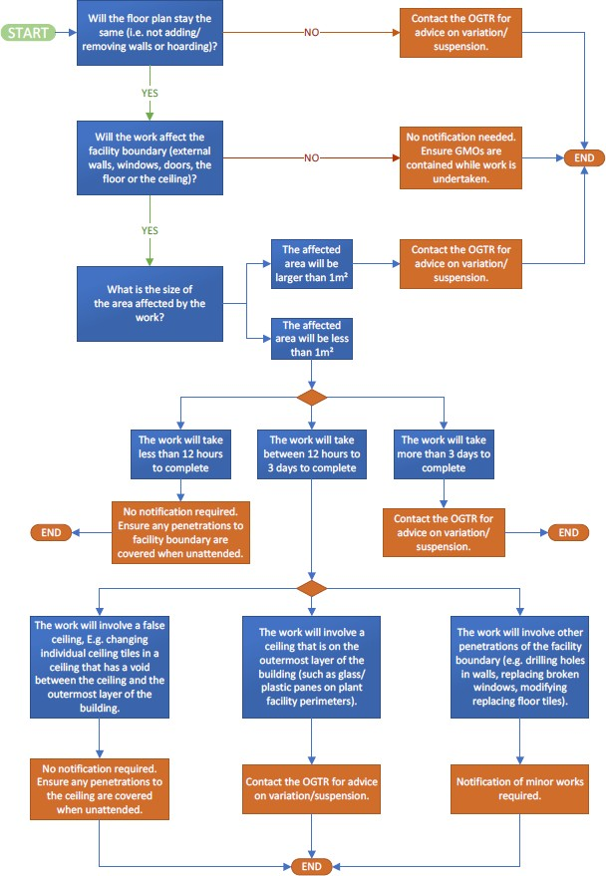
This fact sheet aims to clarify what level of notification and advance warning is required for low-level (PC1 and PC2, excluding PC2 Large Scale) certified facilities that undergo maintenance work.

Decision Tree: Construction, rep air, and maintenance work in a low-level certified facility

This decision tree provides assistance on which type of form needs to be completed when conducting maintenance or repair work on a low-level containment facility.



MEET THE EVALUATORS - CONTAINED DEALINGS

OGTR NEWS & UPDATES
November 2023
The Contained Dealings Evaluation Section (CDES) prepares risk assessment and risk management plans in response to applications for dealings not involving intentional release of GMOs into the environment (DNIRs) – also known as ‘contained dealings’ – and applications for non-plant dealings involving intentional release (DIRs). These include clinical trials of live GMOs such

as vaccines or gene therapies. The section processes applications for certification of containment facilities, including the inspection of high-level and large scale facilities. CDES also provides advice to organisations on the classification of GMO dealings.

PLANT EVALUATION SECTION

The Plant Evaluation Section’s key role is to assess applications for dealings involving intentional release of genetically modified plants. The Section also assesses applications for other types of GMOs, both for intentional release and for work done in containment. The Section prepares risk assessment and risk management plans, and publishes reference documents to inform the risk analysis process, including comprehensive biology documents for many plant species.

