# OGTR ONLINE SERVICES PORTAL

The OGTR Online Services Portal development is well underway. Initially, the portal will allow users to draft and advise us of their Notifiable Low Risk Dealings (NLRD)s, providing a faster and more efficient way to complete this task. As the portal evolves, we will be introducing other forms that will streamline the regulatory process even further. Future development will see users able to view their certifications and contact details for their organisation, making it easier to manage regulatory requirements.

We will keep you updated on the progress of the portal and let you know when it is ready for use. In the meantime, we invite you to participate in our User Acceptance Testing (UAT). Please send an email to [ogtr.applications@health.gov.au](mailto:ogtr.applications@health.gov.au) to express your interest. We value your input and look forward to working with you to make the OGTR Online Services Portal a success.

# NLRD INTERMITTENT REPORTING

As the end of financial year approaches, we strongly encourage all organisations to notify their NLRDs as they are assessed. The new portal is expected to be released mid-year. Reporting the bulk of your NLRDs now will minimise the extra load of learning a new process during the busy end of financial year period. You can do this by [using the existing NLRD form, accessed via the OGTR website.](https://www.ogtr.gov.au/resources/publications/notifiable-low-risk-dealing-nlrds-reporting-form)

**Committee member announcement**

The Assistant Minister for Health and Aged Care, the Hon. Ged Kearney MP, has reappointed members and Chairs to the Gene Technology Technical Advisory Committee (GTTAC) and the Gene Technology Ethics and Community Consultative Committee (GTECCC) for a further three-year term from 1 February 2023 to 31 January 2026. Details of GTTAC and GTECCC members are available on the OGTR [website](https://www.ogtr.gov.au/about-ogtr/australias-gene-technology-regulatory-system#gene-technology-committees).

[Click here](https://www.ogtr.gov.au/sites/default/files/2023-03/gene-technology-technical-advisory-committee-gttac.pdf) to view a short biography of all GTTAC Members.

# PC3 GUIDELINES

The new PC3 lab certification Guidelines have been in effect since 1 December 2022. New labs and those requiring recertification need to comply with these guidelines. Please find below some useful resources relating to the updates including a video.

[Guidelines for Certification of a Physical Containment Level 3 Facility](https://www.ogtr.gov.au/resources/publications/guidelines-certification-physical-containment-level-3-facility-new-guidelines-effective-1-december-2022)

[Guidance to be read with the new PC3 Guidelines](https://www.ogtr.gov.au/resources/publications/guidance-certification-physical-containment-level-3-facility-be-read-new-guidelines-effective-1-december-2022)

[PC3 Guidelines Video](https://www.youtube.com/watch?v=fFKTDPQP7TY)

# MEET THE INSPECTORS - MONITORING AND COMPLIANCE

The Monitoring & Compliance team at the OGTR are responsible for making sure GMO dealings comply with legislative obligations and are consistent with the object of the Act. The M&C team do this by conducting monitoring inspections, audits, and practice reviews to see how organisations dealing with GMOs are meeting the conditions of their licences, certifications or other authorisations. The team also investigates any reported non- compliances, whether they be self- reported or third-party reports, with the aim of bringing the situation back into compliance.

The travel interruptions, lockdowns and border restrictions over the past few years impacted the OGTR monitoring and compliance program but with the lifting of these restrictions the team is back to pre-pandemic numbers of in-person monitoring visits. See the team above sporting their brand- new uniforms. You may meet them during a monitoring visit soon!

**DID YOU KNOW WE HAVE A RANGE OF FACT SHEETS ON OUR WEBSITE?**

## [Genetically modified crops in Australia](https://www.ogtr.gov.au/resources/publications/genetically-modified-gm-crops-australia)

Four genetically modified (GM) crops have been approved for cultivation in Australia: cotton, canola, Indian mustard and safflower. GM flowers have also been approved for growing or importing into Australia.

## [Intentional](https://www.ogtr.gov.au/news/announcement/what-do-we-mean-intentional-release) [Release](https://www.ogtr.gov.au/news/announcement/what-do-we-mean-intentional-release)

Regulatory approvals for activities with GMOs include two licence types based on whether or not they involve an intentional release of the GMO into the environment. Here is an explanation of what this means.

# MEET THE AEP TEAM



The Application Entry Point (AEP) Section's day-to-day tasks include, managing and enhancing the information, business systems, and processes within the office. Receiving and acknowledging applications and responding to enquiries.

You may need to speak to AEP if you:

* are reporting a Notifiable Low Risk Dealing (NLRD) or submitting your Annual Report
* are looking to accredit a new organisation or have changes to contact details for your existing accredited organisation to report
* have any questions or queries about the technical aspects of SmartForms
* 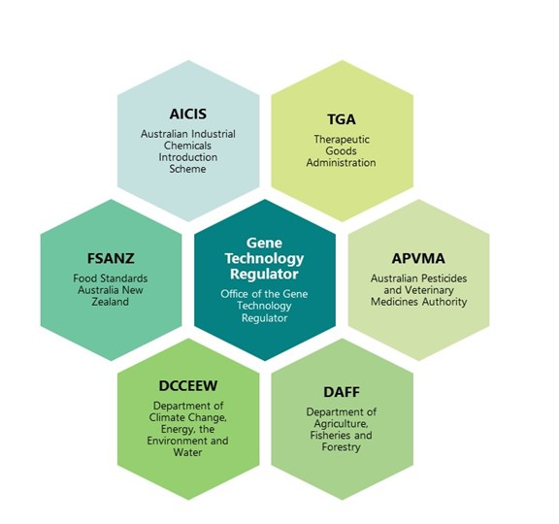are assisting with user acceptance testing (UAT) for the information management and business system improvements being undertaken by the section

Other agencies play a role in the National Gene Technology Scheme. This information can be found

on the Gene Technology Scheme [website.](https://www.genetechnology.gov.au/)

As shown in this [infographic](https://www.genetechnology.gov.au/about-the-national-scheme/how-it-works/role-other-agencies) the Gene Technology Regulator and the OGTR consult with the following agencies as needed. These agencies also consult with

the Regulator, as required.

**THE NATIONAL GENE TECHNOLOGY SCHEME**