Gene Technology Ethics and Community Consultative Committee
2020-2023
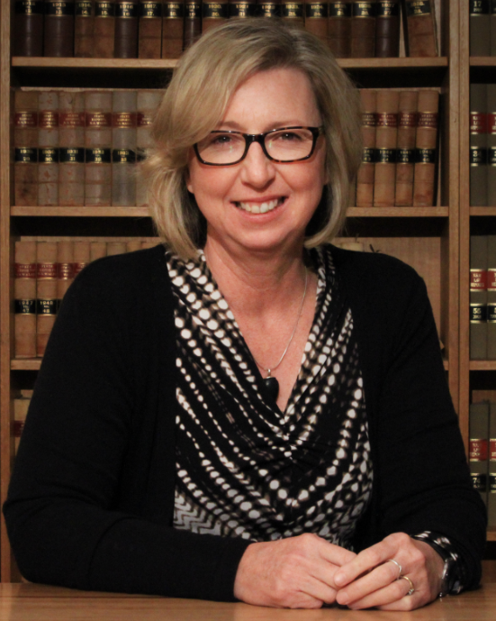 | Judith Jones, GTECCC Chair  Associate Professor BSc (Syd); LLB (NSW); DipPracLegTraining (UTS); Solicitor NSW  Judith is an Associate Professor at the ANU College of Law.  Harnessing her dual background in both science and law, Judith began her research career as an environmental and planning lawyer by focussing on uncertainty, precaution and risk assessment. This has included almost two decades of service, in different capacities, on the federal non-statutory and statutory bodies that provide advice to the Gene Technology Regulator on legal and ethical issues relating to risk assessment and the regulation of gene technology in Australia. Judith has a range of scholarly publications in the areas of environmental impact assessment, risk regulation and precaution. The emphasis in those publications is designing regulation in conditions of scientific and other uncertainty. She is also a member of the ANU Institutional Biosafety Committee.  Judith’s research also combines her environmental law research interests with her own rural background and interests in Australian legal history to examine the impact of historical and current practices on Australian soils, water and vegetation. This research focusses on the impact of colonial property law and culture on landuse practices and consequent environmental degradation. In terms of contemporary agricultural landuse, this research focusses on law and culture relevant to encouraging sustainable landuse practices in regions of high agricultural value.
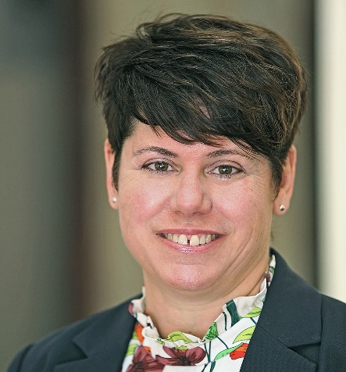 | Rachel Ankeny  Rachel A. Ankeny has a BA in Liberal Arts, MA degrees in Philosophy, Bioethics, and Gastronomy, and a PhD in the History and Philosophy of Science. She currently is Professor in History and Philosophy and the ERA 2023 Academic Lead at the University of Adelaide. She has diverse research interests in bioethics, history, and philosophy, and expertise and ongoing research on health and science policy, particularly regarding public engagement. She is currently Vice President of the Australasian Association of Bioethics and Health Law and President of the International Society for History, Philosophy and Social Studies of Biology (ISHPSSB). She previously served on the Gene Technology Ethics Committee/GTECCC between 2004 and 2014.
 | Paula Fitzgerald  Paula Fitzgerald is a senior professional with a background in stakeholder and government relations, policy development and advocacy, communication, regulatory affairs, issues management, membership engagement and capacity building.  Paula has worked across a diverse stakeholder base and has established trusted networks, both nationally and internationally, to develop and lead local and global teams, to deliver strategies and solutions, particularly across the science and agriculture sectors. She is an advocate for science-based decision making, farmer access to new tools and technologies, and agriculture engaging with the community to ensure a strong social licence.  Paula is currently a Director of Skills Impact Australia, a Director of Animal Health Australia, and the Chief Executive Officer of the Australian Fodder Industry Association (AFIA).
 | Jaden Hastings, expert adviser  BA (New York University), AM (Harvard University), MSc (University of Oxford), MFA (Central Saint Martins, UAL), PhD (University of Melbourne)  Jaden Hastings works across multiple fields as a researcher as well as an entrepreneur, from synthetic biology to machine learning and bioastronautics. As a biomedical researcher, she has worked in some of the world's leading institutions, yet has devoted substantial effort to opening up avenues for the public to engage directly in scientific research for over a decade. Since 2009, she has maintained a laboratory within her home in every country she has resided, and is frequently asked to help organise and formalise local community biology groups that wish to start their own laboratory spaces. In 2017, Hastings founded the x0.lab Initiative a not-for-profit organization that supports mission-based scientific field studies and supporting STEAM education in remote communities. Hastings has co-founded two community labs, London Biohackspace and Melbourne’s BioQuisitive—and was the first garage lab start-up in Australia to obtain PC1 certification from the OGTR. J.J.’s involvement in BioSummit began with running workshops as part the inaugural BioSummit 1.0 at MIT Media Lab, then served as part of the Organisation Committee in for BioSummit 2.0, and was part of the Leadership Committee for the Global Community Bio Fellows Programme and Organising Committee for BioSummit 3.0. She remains a central figure in the global community biology movement as well as an internationally-acclaimed artist addressing the impact of biotechnology in society.
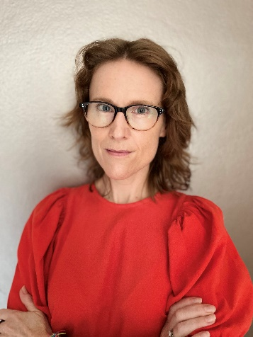 | Ainsley Newson  BSc(Hons) (University of Melbourne), LLB(Hons) (University of Melbourne), PhD – Bioethics (University of Melbourne).  Ainsley Newson (she/her) is Professor of Bioethics with Sydney Health Ethics, Faculty of Medicine and Health, University of Sydney. Professor Newson has worked in bioethics for over 20 years, and has held continuing teaching/research positions in Australia and the United Kingdom.  Ainsley has been interested in the ethical implications of genetics since adolescence. A formative experience was attending the National Science Summer School (now the National Youth Science Forum), where she first learned about the policy and political relevance of genetic modification. An MP – she can no longer remember who! – gave her a copy of the 1992 House of Representatives Standing Committee on Industry, Science and Technology Report Genetic Manipulation – The Threat or the Glory?  Her studies and career ever since have been oriented towards the ethical, legal and social implications of human genetic, genomic and reproductive technologies. She has researched and published on a wide range of issues, including synthetic biology, gene editing, mitochondrial donation and population genetic screening. Her research has attracted more than $85m of research funding and she has published over 140 outputs for professional and lay readership.  A key driver in Ainsley’s work is her ability to engage with experts across disciplines. Her work critically considers ethical issues in genomics and human reproductive technologies, specifically how they can be used well across research, clinical and population health settings.  Ainsley is a member of the Australian Health Ethics Committee and the New South Wales Health Ethics Advisory Panel, and is also active in the Regulatory and Ethics Working Group of the Global Alliance on Genomics and Health. In 2022 Ainsley founded AusGenELSI, a network to bring people together to consider ethical, legal and social issues in genomics in Australia.
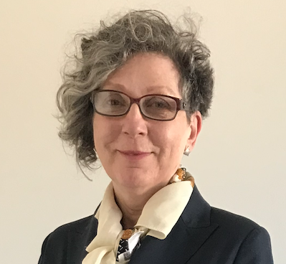 | Rachel Nowak  BSc (Hons) (University of Leeds), MA (Johns Hopkins University), PhD (University of Leeds), GAICD (Graduate Australian Institute of Company Directors)  Dr Nowak is a consultant, an advisor, a scientist and a journalist. She has worked on or in every step of the research, innovation and commercialisation pathway in the UK, Germany, USA, and Australia. Her specialities include biotech, agricultural science, brain tech, higher ed and media.  What motivates her is getting scientific knowledge and insight into the right hands, be it NGOs, companies, government departments or a single person. That way it can be used to benefit people and the world we live in. She is also motivated by getting different types of people involved in R&D.  Rachel has built new capabilities for some of Australia’s largest research organisations. Raised the profile of Australian research on the global stage. And founded a social-good brain tech start-up.  She is an award-winning US journalist, known for influential reports that changed R&D practice, and research law and policy around the world. She immigrated to Australia, which is now home, under the Distinguished Talent visa program. This is for people with an international record of outstanding achievement.  She is the recipient of an Alexander von Humboldt Fellowship to conduct agricultural research in Hanover, Germany. A Queen Elizabeth II Fellowship to research at Monash University in Australia. And a scholarship to study writing alongside poets and novelists at Johns Hopkins University in the US.
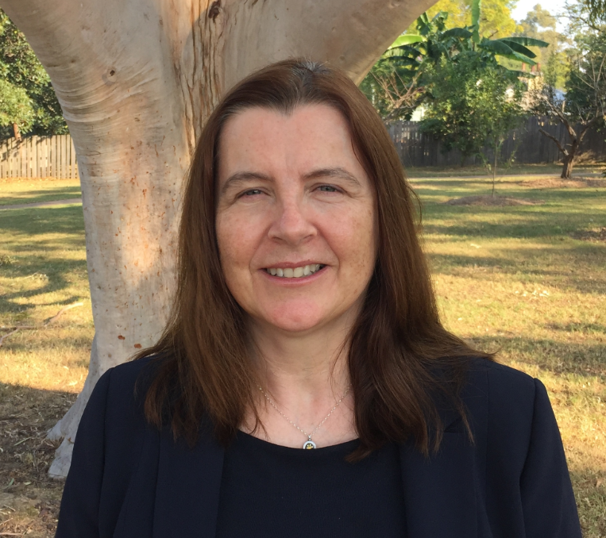 | Gabrielle O’Sullivan  BSc (Hons) PhD MPH (Hons)  Dr Gabrielle O’Sullivan is the Executive Officer of Royal Prince Alfred Hospital Institutional Biosafety Committee. She has a BSc in microbiology (major) and chemistry (minor) from University College Dublin and a PhD in biochemistry and immunology from London School of Hygiene and Tropical Medicine. Her post-graduate work was in medical microbiology, virology and biochemistry. Her PhD was in the areas of acute phase reactants, lectins, amyloid formation, biochemistry and innate immunology. Her post–doctoral research at the University of Sydney focused on cellular immunology, cell migration, Langerhans cells, cytokines and glycosaminoglycans. She has a Master’s degree in Public Health from the University of Sydney and has made contributions to genetics and public health education, epidemiology, public health and the ethics and biosafety of gene technology. She co-developed and co-ordinated a successful short course on genetics and public health at the University of Sydney and co-authored two books, one on genetic testing and another on the ethics of inheritable genetic modification. Dr O’Sullivan has extensive experience in science-based risk communication and risk assessment of gene technology, particularly in the contexts of biomedical research, clinical trials and cell, gene and molecular therapies. She has contributed to gene technology reviews and is co-chair of the Australia and New Zealand Legal and Regulatory Affairs Committee of the International Society Cell and Gene Therapy and cross-member of GTTAC and GTECCC.
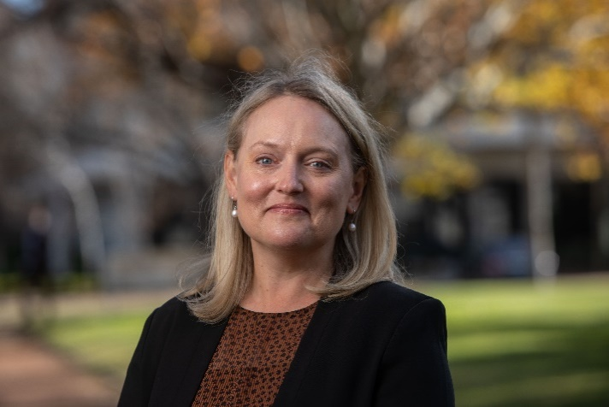 | Kelly Pearce  BSc (Hons), PhD, GAICD  Dr Kelly Pearce has worked in Agricultural Research for over 22-years and continues to coordinate many regional science and innovation projects in her role as Chief Executive Officer at The Facey Group which is a non-for-profit Agricultural Research and Development organisation based in Wickepin, WA. Kelly holds a number of industry positions including- Grower Group Alliance Director and Ministerial appointment to the Biosecurity Council of WA, the Western Australian Meat Industry Authority and the Sheep and Goat Industry Funding Scheme. Kelly is a 2012 Nuffield Scholar, Graduate of the Australian Institute of Company Directors and a Research Fellow with the Australian Farm Institute. Kelly is also a Grain and Sheep Producer from Yealering in Western Australia with her family.
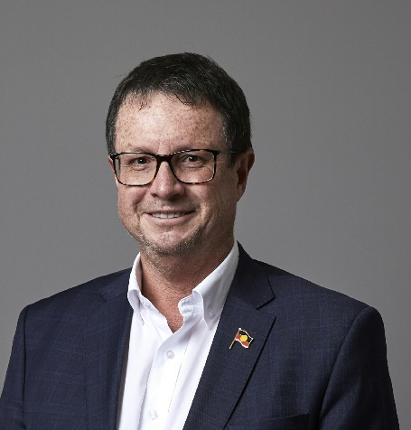 | Stephen Robson  MPH MD PhD FRANZCOG FRCOG FACOG  Professor Steve Robson is a senior obstetrician and gynaecologist and academic at the Australian National University Medical School. He is a past-president of the Royal Australian and New Zealand College of Obstetricians and Gynaecologists (RANZCOG). Steve is a member of the Embryo Research Licencing Committee of the NHMRC. He is a member of the Australian Medical Council (AMC) and a Fellow of the Royal Society of Medicine. He has a strong interest in the effects of genomics on society and is involved in research on genetic screening.
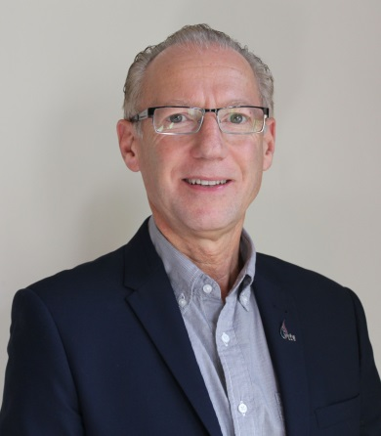 | Robert Sward AM  BSc (Hons), PhD, Member of the Order of Australia  Since 2013, Dr Robert Sward has worked as a private consultant in his own company, BioBotanicals Consulting. Projects have included the Review of Queensland’s Gene Technology Act 2001, done in collaboration with Foursight Associates. He was initially appointed to GTECCC in 2015; and to Gene Technology Technical Advisory Committee (GTTAC) in 2016 and was a cross-member of GTECCC and GTTAC until he finished his term on GTTAC at the end of 2020.  The earlier part of Robert’s career focused on R&D in plant virology - a discipline that converged with crop biotechnology and incorporates many technical aspects of gene technology and related biosciences. From 2003 to 2012, Robert held the position of Manager, Biotechnology Policy within DPI Victoria and dealt with many issues related to government and industry policy in biotechnology, gene technology and genetically modified (GM) crops. This included the development and implementation the Control of GM Crops Act (2004) following the declaration of a moratorium on the commercial release of GM canola by the Victorian Government. The development of this legislation required extensive consultation with community groups, the grains industry and government. He was also the state representative and chair of the Industry Development Committee GM Taskforce set up under the Commonwealth Primary Industries Standing Committee; as well as Member of the Victorian Gene Technology Ethics Committee; and Member of the AusBiotech National Agricultural, Environmental and Industrial (AEI) Biotechnology Advisory Group.
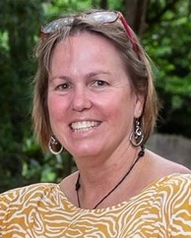 | Lynn Woodward  BAppSc (QUT, Qld), MAppSc (Brunel, UK), MBioethics (Monash, Vic), PhD (JCU, Qld)  Dr Lynn Woodward is a senior lecturer in the College of Medicine and Dentistry at James Cook University. She teaches ethics into the medical degree and runs an Introductory Bioethics course. Lynn has a laboratory based background, with a Master’s degree in Applied Immunology and completed her PhD in a project developing a genetically modified subunit vaccine for botulism. More recently she has been interested in the field of Bioethics and completed a Masters of Bioethics at Monash University. She was awarded the Monash WHO Bioethics Fellowship which allowed her to undertake work in the Ethics in Health Unit of the World Health Organization in Geneva.  Lynn’s previous work at JCU included a role with the Australian Institute of Tropical Health & Medicine (AITHM), where she developed the AITHM Biobank and managed a Phase I trial of a novel malaria vaccine.  Lynn is also Chair of the Metro North Health Human Research Ethics Committee B and currently sits on the Townsville Hospital Health Service and University of the Sunshine Coast HRECs.

