The 9th National Institutional Biosafety Committee forum will be held in Canberra at the [Shine Dome](https://www.shinedome.org.au/) on the 12th and 13th of May 2022.

The OGTR’s IBC forum is an important event that allows us to share information, experience, and learnings. It also gives us the chance to meet and for IBCs to form valuable connections.

We will be celebrating 20 years of regulation with a special session including GM crops, clinical trials, and community attitudes. We will also be discussing the need to have good governance arrangements in place and what that may look like for different types of research, clinical trials, facility management, and commercial GMOs. We will provide an update on what has been happening at the OGTR; and most importantly give you a chance to share your experiences when it comes to responding to adverse external events such as weather and pandemics.

Tuesday April 26 is the last day to register for the 2022 IBC Forum.Please contact [ogtr@health.gov.au](mailto:ogtr@health.gov.au) for a registration form.

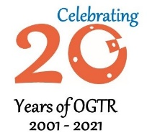

OGTR News Update – April 2022

IBC Forum

**Dr Raj Bhula Reappointed:**

Dr Raj Bhula has been reappointed as Gene Technology Regulator until July 2026. We look forward to 5 more years of Dr Bhula’s leadership and expertise.

**PC3 Guidelines:**

The OGTR has initiated a review of the PC3 facility guidelines. Thanks to those who have provided comments on the draft guidelines and associated guidance document. We are now finalising the documents considering the comments received.

**Website Update:**

Our [**new website**](https://www.ogtr.gov.au/) is designed to improve accessibility and make the application process easier. Now accessible for mobile phones as well as screen readers.

**Notices**

**Community Attitudes**

The 2021 survey of community attitudes towards gene technology commissioned by OGTR has delivered some interesting findings. Trends are on par with the 2019 survey results. Awareness of the uses of GM including in medical therapies, food security and the environment (fewer pesticides needed) can influence some people’s views on GMOs, particularly men with more moderate opposition to GMOs. The pandemic has polarised a small portion of the Australian community, those either completely in favour of gene technology (1 in 5) or completely against it (1 in 9). Read the full [2021 report](https://www.ogtr.gov.au/resources/publications/community-attitudes-2021-report) and the [2019 report.](https://www.ogtr.gov.au/resources/publications/community-attitudes-2019-report)

**20 Years of OGTR**

Over the past twenty years, the field of gene technology has seen many exciting developments, some of which could not have been imagined when the Gene Technology Act was written. In gene technology research, new tools are being used to enable scientists to modify the genes or genomes of organisms much faster, cheaper, and easier than ever before.

**Thoughts, reflections and celebratory comments from a committee chair and a former regulator:**

**Dr Joe Smith, former GTR (2009-2014)**

*‘Quiet achievers. A remarkably small expert, dedicated and talented team who nonetheless steadfastly, yet creatively, administer, manage and safeguard a significant and complex regulatory responsibility.’*

**Associate Professor Judy Jones, Chair of GTECCC**

*‘A robust regulatory scheme for the safe development and application of gene technology in Australia, recognised nationally and internationally for its scientific rigour, transparency and effectiveness.’*

**The OGTR collaborated with GTTAC members to write a retrospective paper on** [***20 years of legislation - How Australia has responded to the challenge of regulating GMOs in the clinic.***](https://www.frontiersin.org/articles/10.3389/fmed.2022.883434/abstract)

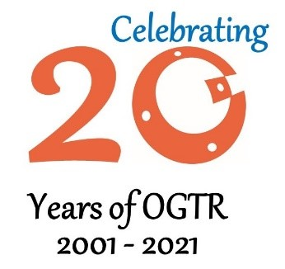

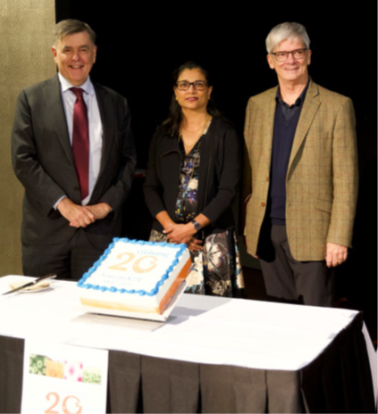

Photo Above: Dr Brendan Murphy, Dr Raj Bhula and Dr Joe Smith at the OGTR 20-year anniversary celebration.

**Retirement News**

Since the last newsletter in 2019 there have been a number of staff movements:

Michael Dornbusch (Head of Evaluation Branch), Will Tucker (Director of Contained Dealings Evaluation Section), Andrew Radanovich (Director of Monitoring and Compliance Section), Alison Wardrop (Assistant Director of Plant Evaluation Section), Brian Weir (Monitoring and Compliance Section), and Elisa Harris (Legal Officer) have all retired. Good luck to them in their adventures.

[**Subscribe**](https://www.ogtr.gov.au/about-ogtr/contact-and-subscribe/subscribe-ogtr-news) **to OGTR news including notifications for new applications, consultations, issued licences and legislative changes.**

**Useful Links:**

[**How we regulate GMOs**](https://www.ogtr.gov.au/about-ogtr/how-we-regulate-genetically-modified-organisms-gmos)**.**

[**Twenty Years of OGTR.**](https://www.ogtr.gov.au/about-ogtr/twenty-years-ogtr)

[**Apply for organisation accreditation.**](https://www.ogtr.gov.au/apply-gmo-approval/apply-organisation-accreditation)

**[Apply for physical containment facility certification.](https://www.ogtr.gov.au/apply-gmo-approval/apply-physical-containment-facility-certification)**

Desktop Audit Update

While most inspections completed byMonitoring & Compliance over the past two years have been “desktop” virtual inspections, the team is now back on the road with onsite inspections resuming. The success and experience from the desktop inspection process means it will continue to be used to supplement the onsite inspection program in certain circumstances.

Smart Forms

We have introduced a new form for the Notification of Minor Works to certified facilities to avoid the need to apply for suspension. Use this form to notify OGTR of commencement or completion of minor works to your PC1 or PC2 facility. You can find the form on [our website](https://www.ogtr.gov.au/ongoing-regulatory-compliance/requesting-changes-facility-certification), as well as further guidance on minor works suitable for notification.

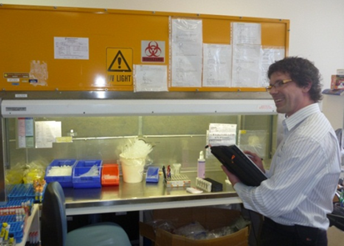

Photo Above: Peter inspecting a laboratory.