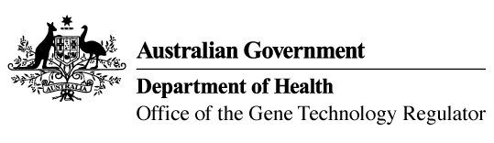

Invitation to comment on a field trial
of genetically modified sorghum
The Gene Technology Regulator is assessing an application from The University of Queensland to conduct a field trial of sorghum genetically modified for an asexual seed formation trait. The trial is proposed to take place between September 2022 and June 2025, on one site at the University’s Gatton Campus in Queensland with a maximum area of one hectare per season. The GM sorghum grown in this field trial would not be used for human food or animal feed.
The Regulator has prepared a Risk Assessment and Risk Management Plan (RARMP) for this application and welcomes written submissions relating to the protection of human health and safety and the environment prior to making a decision on whether to issue the licence. The consultation RARMP and related information can be obtained via our website (search for DIR 189), or from the contacts below. Submissions should reference DIR 189 and be received by 12 May 2022.
Office of the Gene Technology Regulator
MDP 54 GPO Box 9848 CANBERRA ACT 2601
Telephone: 1800 181 030 OGTR Website
E-mail: ogtr@health.gov.au

