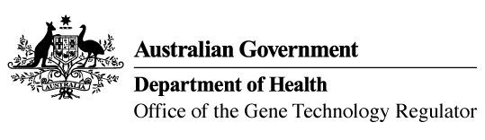

Invitation to comment on a field trial
of genetically modified canola and Indian mustard
The Gene Technology Regulator is assessing an application from Nuseed Pty Ltd to conduct a field trial of canola and Indian mustard genetically modified for altered oil content and herbicide tolerance. The trial is proposed to take place at up to 20 sites with a total area of 150 ha per year over 5 years. Sites would be in NSW, Vic and Qld. The plants grown in this field trial would not be used for commercial human food or animal feed.
The Regulator has prepared a Risk Assessment and Risk Management Plan (RARMP) for this application and welcomes written submissions relating to the protection of human health and safety and the environment prior to making a decision on whether to issue the licence. The consultation RARMP and related information can be obtained via the contacts below. Submissions should reference DIR 188 and be received by 26 April 2022.
Office of the Gene Technology Regulator
MDP 54 GPO Box 9848 CANBERRA ACT 2601
Telephone: 1800 181 030 OGTR Website
E-mail: ogtr@health.gov.au

