Genetically Modified Organism Herbicide Tolerance Trait Review

 Rohan Rainbow



Contents

Contents 2

List of Figures 4

List of Tables 4

Disclaimer 4

Executive Summary 5

List of Acronyms 8

Chapter 1: Introduction and scope of review 10

Chapter 2: GM and non-GM herbicide tolerance development and commercial introduction 12

Value proposition and Australian investment in herbicide tolerant crops 12

Rationale for herbicide tolerance trait stacking 16

Summary of key points 17

Chapter 3: Grower attitudes and use of herbicide tolerance technology 18

Producer attitudes to use of herbicide tolerant crops 18

Use of herbicide tolerance traits in Australian farming systems 20

Attitudes and practice of integrated weed management 29

Industry stewardship of herbicide tolerant crops 34

Summary of key points 36

Chapter 4: Gene-flow and seed recruitment of GM crop plants and outcrossing 37

Gene Flow 37

Seed recruitment 40

Summary of key points 41

Chapter 5: Herbicide tolerance commercial deployment strategies and industry stewardship 42

Summary of key points 44

Chapter 6: Herbicide tolerance regulation 45

Assessment for herbicide resistance evolution risk 45

Roles and responsibilities for stewardship of weed herbicide resistance management 50

Summary of key points 52

Chapter 7: The future landscape for herbicide tolerance technology 53

Summary of key points 56

Chapter 8: Conclusions and options 57

Potential farming systems change through production of crops with multiple herbicide tolerance traits 57

Potential policy options to consider for the regulation of GMOs with multiple herbicide tolerant traits. 58

Summary of options to address the issues outlined in the report 59

Summary of key points 61

Bibliography 62

Appendices 69

Appendix 1. Registered herbicides for volunteer crop control 69

Appendix 2. Herbicide resistance in Australia 72

Background on Author 75

# List of Figures

Figure 1. Herbicide resistance in the grains producing regions of Southern Australia13

Figure 2. Area of herbicide resistant weeds in cotton producing regions of Australia 13

Figure 3. Cumulative adoption of decision to first use no-till sowing technology 14

Figure 4. National Australian breakdown of additional herbicide cost due to weed resistance, cost of weed management expenditure and costs of integrated weed management 14

Figure 5. Adoption of no-tillage, autosteer and IWM practices 28

Figure 6. RIM simulation modelling of integrating competitive wheat cultivars with other IWM practices on the soil seedbank in March 30

Figure 7. Weed control expenditure per hectare of cropping area in each region 30

Figure 8. Weed control tactics used in cotton producing regions of Australia 31

# List of Tables

Table 1. Summary of current and potential GM and non-GM crop HT traits 26

Table 2. Herbicide resistance reported in Australian cotton and grain crops compared with current registered herbicide options in GM and non-GM crops 54

Table 3. Herbicide options to control volunteer canola in summer fallow and non-cropping situations 69

Table 4. Pre-plant herbicide options to control canola volunteers in winter crop situations 69

Table 5. Post-emergent herbicides to control volunteer canola in winter crop situations 70

Table 6. Herbicide options to control volunteer cotton 71

Table 7. Herbicide options to control large 15 to 30 node volunteer cotton and ratoon cotton 71

Table 8. Herbicide resistance confirmed to at least one herbicide mode of action group in Australia in grass weeds 72

Table 9. Herbicide resistance confirmed to at least one herbicide mode of action group in Australia in broadleaf weeds 73

Table 10. Herbicide resistance reported in Australian cotton and canola crops 74

# Disclaimer

This report is based on the information publicly available at the time of writing. The author does not endorse or recommend the products of manufacturers referred to in this report. This document and the information detailed is this report is solely for the use of the authorised recipient and copyright is owned by the Commonwealth. Crop Protection Australia makes no representation, undertakes no duty and accepts no responsibility to any third party who may use or rely upon this document or the information.

# Executive Summary

Weed control is one of the major costs to crop production and a major determinant of crop and pasture rotation and management. The impact can be very specific to particular weed problems in different crop and pasture production systems and these can differ greatly across regions. The economic costs of weeds to Australian producers are also a key driver of practice change, as is the importance of managing herbicide resistance to sustain viable agricultural production.

The report considers the current and potential future farming systems changes, environmental risks and impacts including the impact on producer practices of the use of cultivars with multiple genetically modified organism (GMO) herbicide tolerance traits. The report details the rationale for a broad framework or potential policy options to provide guidance to the Office of the Gene Technology Regulator (OGTR) when assessing a GMO with multiple herbicide tolerant (HT) traits. The report outlines an understanding of current and future potential risks from resulting farming systems change through production of genetically modified (GM) crops with multiple herbicide tolerance traits with a rationale for the OGTR to consider whether some form of guidance or industry advice might be appropriate to address the issues outlined in the report.

Extending multiple HT traits into a stack would potentially enhance future positive change to farming systems, particularly if the technology offers additional timing during the crop growth period to provide effective weed control or weed seed set control, while enabling effective crop competition with weeds. The report suggests that the most critical functions of GM crop HT traits risk assessment are adequately managed with the current regulatory processes in place with the OGTR, FSANZ and APVMA.

There is a requirement for the broad value chain of industry stakeholders to discuss the complex strategic issues resulting from commercial investment in GM and non-GM HT stacking in the commercial landscape and its impact on farming systems and resulting international trade of agricultural product. There is also a requirement for a formal industry feedback mechanism into the regulatory process to manage strategic farming systems related issues, rather than consideration of individual trait or herbicide issues. It is also clear that there is both a requirement and opportunity for improved strategic guidance on crop HT stewardship for volunteer crop control.

There is a requirement for some form of formal industry discussion and consensus agreement on a long-term strategy to address these issues. The extension of current GM crop advisory committees used under the current licence agreements is required, or establishment of a new grains industry committee modelled on that for the cotton industry, or potentially merged for some aspects. The membership of this extended strategic advisory committee should however be extended to include peak producer bodies, plant breeders and traders.

The key issue arising from this review is the strategic deployment of the finite resource of potential HT traits, both GM and non-GM, to maximize the long-term sustainable use of the technology within a farming systems context with flexible crop rotation choices. Options to address this include:

* **Broadening the role of existing strategic expert stewardship groups**
  + WeedSmart Executive Committee and investment stakeholders to expand its stewardship and communications program to specifically include HR management when using HT GM and non-GM crops, including HT crop volunteer control.
  + CropLife Australia Herbicide Resistance Management Review Group (HRMRG) to include development of strategies in the context of HT crops and HT trait stack crops.
* **Establishing a new commodity specific or related cross industry strategic expert stewardship group**

Membership should include:

* + Expert scientists
  + Representation from the herbicide registrant and plant science industry
  + Peak producer organisations
  + Commercial plant breeding representatives
  + Representatives from domestic and international export traders
  + Combination of some or all of the options above.

The key gap identified in this report is that there is a need for a formal industry feedback mechanism into the regulatory process to manage strategic farming systems change-related issues, rather than consideration of individual traits or herbicide use issues. A key missing link is the integration and regulation of outcomes from commercial breeding programs. It is also clear that there is both a need and opportunity for improved strategic regulatory guidance on crop HT stewardship for volunteer crop control and ensuring that product meets trade and market requirements. Options to address this include:

* **Stacked GM HT crop volunteer risk management**
  + Registrant responsibility under the GM crop license agreement with the OGTR to extend current advisory committees such as TIMS herbicide technical panel, or HRCG to provide annual formal feedback on the GM HT traits and stack combinations including non-GM used in crop breeding program; or
  + Establishment of a new grains industry committee modelled on the cotton industry TIMS committee or merging the grains HRCG into the TIMS herbicide technical panel for some functions. Membership should include:
    - Expert scientists
    - Representation from the herbicide registrant and plant science industry
    - Peak producer organisations
    - Commercial plant breeding representatives
    - Representatives from domestic and international export traders.
* **Stacked GM and non-GM HT crop volunteer and herbicide residue risks on trade and market access**
  + Broaden the APVMA Trade advice notice (TAN) process as a mechanism to manage consultation with industry stakeholders on new herbicide registrations for a crop variety with a new HT trait stack combination not already assessed by the OGTR, including herbicide residue risks and crop volunteer control risks.
  + Establish a new regulatory requirement within the APVMA to require herbicide registrants and/or GM HT trait license holders to submit a registration variation if the mix of HT traits or combination of traits changes from the original application, particularly addressing herbicide residue and volunteer control which would require a new formal TAN process for industry consultation and feedback.

The potential options highlighted in this report are intended to build on the established expertise, capability and processes already in place and successfully in operation. The importance of maintaining independence, public transparency and a science-based risk management approach is critical for enabling new HT technology to be assessed for integration into a changing and improving sustainable farming systems. It is important that Australia has a regulatory framework that builds confidence and certainty from investment in new technology. Any proposed change to improve this will require ongoing dialogue and formal engagement with the plant science sector and industry producers as well as state governments that also have a responsibility to industry and the community.

# List of Acronyms

ABARES Australian Bureau of Agricultural and Resource Economics and Sciences

ABCA Agricultural Biotechnology Council of Australia

ACCC *A*ustralian Competition and Consumer Commission

ACCase Inhibition of acetyl-CoA carboxylase

ALS Inhibition of acetolactatesynthase

AOF Australian Oilseeds Federation

APVMA Agricultural Pesticides and Veterinary Medicines Authority

ARG Annual ryegrass

BCG Birchip Cropping Group

Bt *Bacillus thuringiensis*

CL Clearfield®

CRDC Cotton Research Development Corporation

CSIRO Commonwealth Scientific Industrial Research Organisation

EIQ Environmental Impact Quotient

FSANZ Food Standards Australia New Zealand

GGL Grain Growers Limited

GM Genetically modified

GMAC Genetic Manipulation Advisory Committee

GMO Genetically modified organism

GPA Grain Producers Australia

GRDC Grains Research and Development Corporation

GTA Grain Trade Australia

HRMS Herbicide Resistance Management Strategy

HSD Harrington Seed Destructor

HR Herbicide resistant

HT Herbicide tolerant

HPPD Inhibition of the 4-hydroxyphenyl pyruvate dioxygenase enzyme

HRCG Herbicide Resistance Consultative Group

HRMS TIMS - Herbicide Resistance Management Strategy

HRCG Bayer/Monsanto - Herbicide Resistance Consultative Group

HRMRG CropLife Australia - Herbicide Resistance Management Review Group

IMI Imidazolinone herbicide

IR Insect resistant

ISAAA International Service for the Acquisition of Agri-biotech Applications

IWM Integrated weed management

LL Liberty Link®

MOA Mode(s) of Action

MRL Maximum residue limit

No-till No soil tillage prior to crop planting

NWPGP National Working Party for Grain Protection

OH&S Occupation health and safety

OGTR Office of the Gene Technology Regulator

PPO Inhibitors of protoporphyrinogen oxidase

PRAMOG Paddock Risk Assessment Management Option Guide

PS II Photosystem II inhibitor

RIM Resistance and Integrated Management model

RR Roundup Ready®

RR Flex Roundup Ready® Flex

RR TruFlex Roundup Ready® TruFlex

SRA Sugar Research Australia

TIMS Transgenic Insecticide Management Strategy

TT Triazine tolerant

# Chapter 1: Introduction and scope of review

Weed control is one of the major costs to crop production and a major determinant of crop and pasture rotation and management. The impact can be very specific to particular weed problems in different crop and pasture production systems and these can differ greatly across regions. The economic costs of weeds to Australian producers are also a key driver of practice change, as is the importance of managing herbicide resistance to sustain viable agricultural production. There are currently 36 unique herbicide resistant weed species in Australia (Heap 2020).

The development and delivery of new weed management technologies including genetically modified organisms (GMOs) in crops with herbicide tolerance need to deliver production benefits in farming systems, with a clear value proposition for use while resulting in product being acceptable to markets.

Genetically modified (GM) herbicide tolerant (HT) crops have been grown on a widespread commercial basis since 1996, and in 2015, the global cultivation reached 147.9 million hectares, a 200-fold increase from the 1996 level of 0.7 million hectares (Brookes *et al* 2017).

Seven key components that will ultimately impact on production and environmental outcomes of GM crop HT technologies include:

1. Technology impacts and production benefits.
2. Environmental risks.
3. Food safety risks.
4. Current and future costs of management of key weeds and herbicide resistance to Australian producers.
5. Future farming systems opportunities.
6. Market acceptance of both the GM trait and resulting herbicide residues, including wider community sentiment.
7. Economics, value proposition and drivers relating to weed and herbicide resistance management and anticipated adoption of future practice change.

The report considers the current and potential future farming systems changes, environmental risks and impacts including the impact on producer practices of the use of cultivars with multiple GM herbicide tolerance traits. GM crop technologies delivered either through stacking using conventional breeding or as a single gene transformation event using a ‘cassette’ approach, plus combining GM and non-GM herbicide tolerant crop traits through natural or mutagenesis crop selection, all present different challenges for herbicide resistance management, regulation, market and community acceptance.

Based on a review of published literature, research projects, commercial announcements and selected expert interviews, the report considers the potential pros and cons of single GMOs containing multiple herbicide tolerant traits to contribute to an effective, integrated ‘framework’ approach. Relevant issues that were considered include:

* What current agronomic and industry stewardship practices for weed management in GM crops containing multiple HT traits could potentially increase or reduce risks of herbicide resistance development in weeds.
* Australian and international evidence from published literature and research reports to suggest that growing GM crops containing multiple HT traits increases or decreases weediness of crop plants and risks of herbicide resistance development in weeds.
* How current regulator assessment accounts for herbicide resistance evolution risk and weed seed population recruitment risk, including in-crop weeds, non-target weed species or managing volunteer crop plants.
* What current agronomic and industry stewardship practices of GM HT crops using individually or in combination with conventionally bred herbicide tolerant crops contribute to herbicide resistance in weeds.
* How HT crops contribute to the matrix of herbicide resistance risks when used in combination with advanced non-chemical controls such as weed seed capture and destruction, or genetic approaches to early crop vigour and weed competition plus emerging site specific autonomous chemical and non-chemical weed control technologies.
* Roles and responsibilities of Australian Commonwealth Government regulators and state and territory weed/land management regulators and delivery programs, as well as industry stakeholder and producer groups in achieving suitable standards of stewardship of GMO technologies and weed herbicide resistance management.
* Current and potential future approaches to providing stewardship advice on pesticide use associated with new HT GM crops and what should be considered in developing that advice.

This report provides an understanding of current and future potential risks from resulting farming systems change through production of GM crops with multiple herbicide tolerance traits. This review details the rationale for potential policy options and industry feedback framework from stakeholders across the crop industry value chain. This includes options to provide guidance to the Office of the Gene Technology Regulator (OGTR) and Agricultural Pesticides and Veterinary Medicines Authority (APVMA) when assessing a GMO with multiple HT crop traits and the resulting herbicides used by Australian producers in current and future farming systems.

# Chapter 2: GM and non-GM herbicide tolerance development and commercial introduction

## Value proposition and Australian investment in herbicide tolerant crops

The combination of global herbicide tolerant (HT) crop benefits in combination with changes to farming systems such as no-tillage planting systems has increased farm incomes by $69.27 billion over the period 1996 to 2015, of which the value of this income gain in 2015 was $6.76 billion (Brookes *et al* 2017). Weeds impact on agricultural production, the environment, along with public and private infrastructure and are estimated to impose an overall average cost of nearly $5 billion annually across Australia, with yield loss from weed competition, combined with the cost of weed control is estimated on average at $82.7 million in sugarcane and $195.8 in cotton (McLeod 2018). Llewellyn *et al* (2016), estimates the total cost of weeds (revenue loss plus expenditure) to Australian grain growers is estimated at $3,318 million, with weeds costing Australian grain growers $146/hectare, as well as resulting yield loss with weed competition amounting to 2.76 million tonnes of grain per annum. Herbicide resistance is estimated to cost $187 million in additional herbicide treatment costs plus the costs of implementing additional integrated weed management practices.

Herbicide resistance (HR) in Australia has been surveyed for many years since the first reported incidence in 1985 of annual ryegrass (*Lolium rigidum*) resistant to inhibitors of acetyl-CoA carboxylase (ACCase) and inhibitors of acetolactatesynthase (ALS) (Heap 2020), which today have become widespread across Australia (Figure 1). While there have been regional surveys of herbicide resistance, it was not until a GRDC review of the Western Australian HR Initiative in 2009 that a nationally coordinated approach to HR surveys was taken in 2010 with the establishment of the Australian Herbicide Resistance Initiative (AHRI).

AHRI researchers in Western Australia detected the nation’s first glyphosate resistant wild radish (*Raphanus Raphanistrum L.)* population in 2010, which significantly was also resistant to ALS inhibitors (imazethapyr, chlorsulfuron, sulfometuron-methyl and metosulam), Carotenoid biosynthesis inhibitors (diflufenican) and Synthetic Auxins (phenoxies MCPA, 2,4-D). Since 2002-03, the Grains Research and Development Corporation (GRDC) has invested more than $115 million in weeds research with additional funding committed until 2022 (GRDC 2019).

With ACCase resistance in the cotton industry evolving since the 1980’s to over 31,000 hectares today, following the commercial introduction of Roundup Ready® cotton in 2001 glyphosate herbicide resistance was widely reported on over 92,000 hectares in 2018/19 (Otto 2020) (Figure 2).

A literature review by Carpenter *et al* (2002) found that there has been rapid adoption of HT traits in the US, where no-till soybean acreage increased to 35 per cent following the commercial introduction of HT soybean, increasing to 91 per cent by 2007 (Bonnet, 2008). A similar trend is observed in Argentina where soybean fields are 98 per cent planted with HT varieties (Carpenter *et al* 2002). The International Service for the Acquisition of Agri-biotech Applications (ISAAA) (2018) reports that in the first 21 years of commercialisation (1996-2016), benefits from HT crops were valued at US$ 89.02 billion or 47.8 per cent of the global biotech crop value of US$ 186.1 billion, and for 2016 alone at US$ 8.44 billion or 46.4 per cent of global value of US$ 18.2 billion.

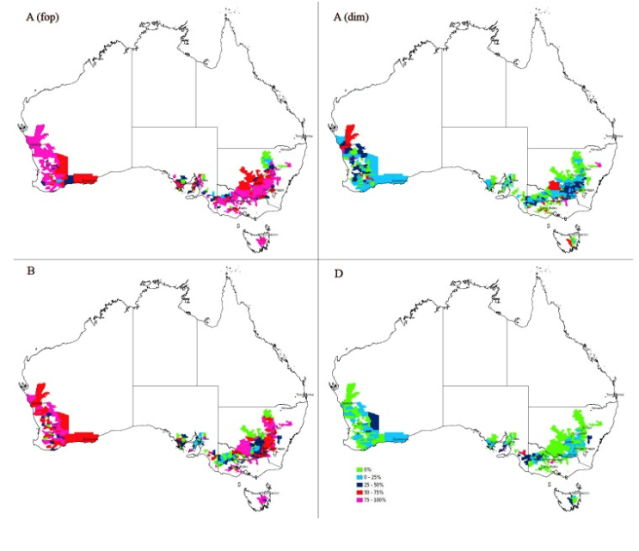

Source: Broster J, Herbicide resistance, Charles Sturt University, [Charles Sturt University](https://www.csu.edu.au/plantinteractionsgroup/herbicide-resistance) accessed 22 June 2020.

**Figure 1. Herbicide resistance in the grains producing regions of Southern Australia**

Brookes (2016) found that over 20 years, Australian cotton and canola farmers have gained AUS$ 1.37 billion worth of extra income and produced an additional 226,000 MT of canola that would otherwise have not been produced if conventional herbicide and insecticide technology had been used. The technology also enabled Australian farmers to reduce their use of insecticides and herbicides by 22 million kilograms of active ingredient on these two crops. The strategic and economic importance of alternate broad-spectrum herbicides available in HT crops shifts the timing of optimal application to deliver greater efficacy of weed control. Reducing weed-seed recruitment as a component of weed and herbicide resistance management in farming systems should also be considered. The average increase in farm income using genetically modified HT traits was $64/ha/year in canola and $27/ha/year in cotton. Deloitte Access Economics (2013) considered that the broad-spectrum herbicide product paraquat, which provides an effective herbicide rotation option for resistance management, delivers significant productivity and economic benefit, estimated to be worth AUS$ 1.8 billion over a ten-year period.

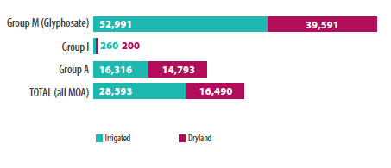

Source: Otto L (Ed), Qualitative report on the 2018-10 cotton season: A survey of consultants, Cotton Research and Development Corporation and Crop Consultants Australia, Narrabri, Australia, 2020.

**Figure 2. Area (hectares) of herbicide resistant weeds in cotton producing regions of Australia**

The commercial introduction of GM Roundup ready® (RR) canola came at a time when the adoption of no-tillage farming practice had peaked in Australia in 2008 (Figure 3), averaging around 85 per cent of grain producers nationally; up to 74 per cent of growers reported herbicide resistance in the south east central region of Western Australia, averaging 39 per cent of all respondents nationally (Llewellyn & D’Emden 2010).

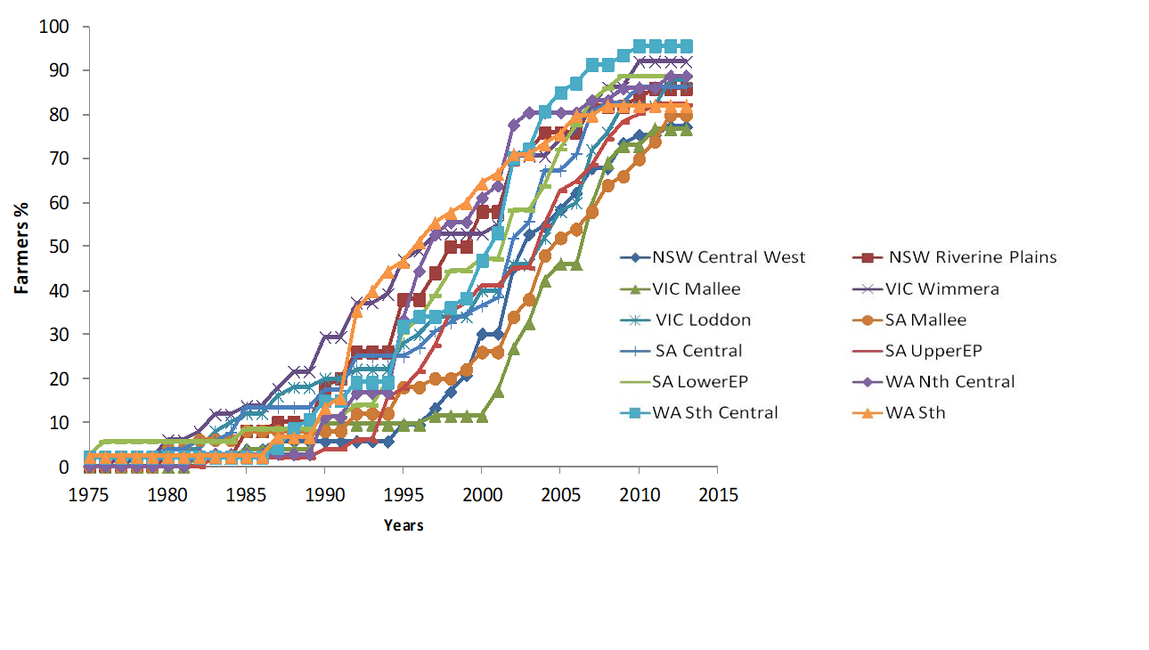

Source: Llewellyn RS & D’Emden FH, Adoption of no-tillage cropping practices in Australian grain growing regions, Grains Research and Development Corporation, Canberra, Australia, 2010. Additional data: Llewellyn RS (2014) *Pers com* CSIRO Used with permission

**Figure 3. Cumulative adoption of decision to first use no-till sowing technology**

No-tillage prior to sowing is practiced in 72.7 per cent of dryland cotton, but represents only 5.2 per cent of plantings in irrigated cotton. Irrigated cotton constituted 63.6 per cent of the total cotton crop area in 2018/19, where the majority was planted using minimum tillage (24.8 per cent) or conventional tillage (70 per cent) to all GM RR cotton (Otto 2020).

Herbicide resistance is a significant cost to grain producers (Figure 4), who in some cases are also cotton producers, resulting in significant costs to production including herbicides used in the crop production systems as well as other chemical and non-chemical weed control costs.

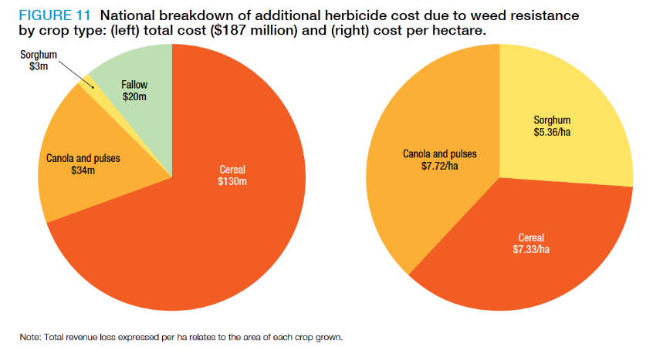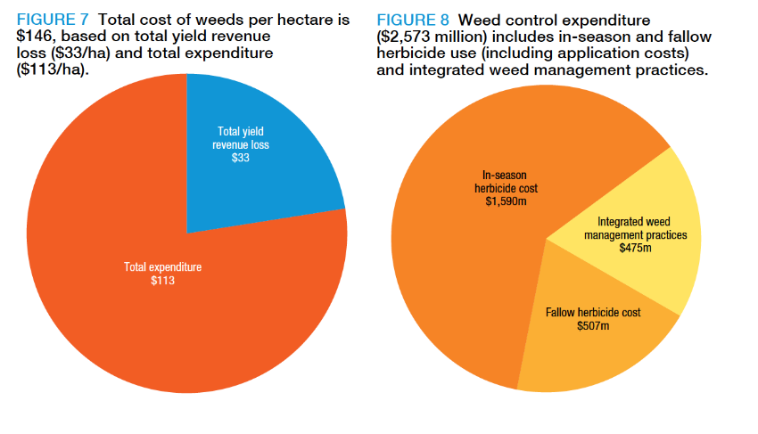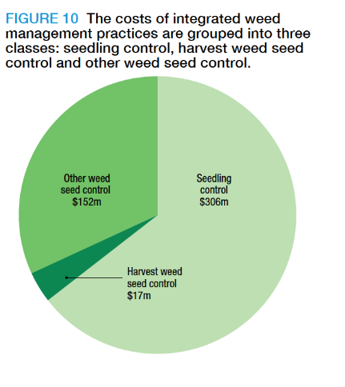

Source: Llewellyn RS, Ronning D, Ouzman J, Walker S, Mayfield A & Clarke M, Impact of Weeds on Australian Grain Production: the cost of weeds to Australian grain growers and the adoption of weed management and tillage practices, Report for GRDC, CSIRO, Australia, 2016.

**Figure 4. National Australian breakdown of additional herbicide cost due to weed resistance (left), cost of weed management expenditure (centre) and costs of integrated weed management (right).**

Australian growers require access to effective weed control technologies in order to maintain crop production in today’s modern farming systems. Weed management is a key factor for current broadacre field crop production systems, which drives farm business decision-making, crop rotation and variety choice. There is a strategic need for new herbicides of a different and preferably new mode of action as part of an Australian resistance management and weed control strategy. This includes opportunity for integration with HT crops using either GM or non-GM HT technologies.

## Rationale for herbicide tolerance trait stacking

The adoption of GM herbicide tolerant canola in Australia has been relatively fast. The most substantial growth is in Western Australia (WA), where approximately 28 per cent of the state’s canola was planted as GM in 2017. In Victoria and New South Wales (NSW), growth has not been as strong but it remains a popular crop choice at 14 per cent and 11 per cent respectively (Whitelaw *et al* 2018).

A study of producer adoption following the commercial introduction of RR canola (Hudson & Richards, 2014) noted the drivers for initial adoption were:

* A new effective weed management tool, not previously available.
* Increased flexibility to sow early or sow dry with minimum or no-tillage systems.
* Improved yield, in particular overcoming the yield penalty associated with triazine tolerant (TT) canola varieties.
* Herbicide safety, with no residual plant back issues for re-seeding to other crop types following a crop establishment failure.

Whitelaw *et al* (2018) notes that the grower is ultimately the decision maker when determining which crops to plant on their property. Their decisions will be influenced by many factors including both economic and agronomic judgments. For most of the GM canola varieties currently commercially available, the economic decision is not solely based on one year’s performance. There are also residual benefits, which flow onto subsequent years through improved paddock health.

Production impact and management flexibility is a key value proposition driver for adoption of HT crops by growers, with benefits of increased yield, simplified management of weed control and fewer and more flexible herbicide applications. GM HT crops offer the added advantage of managing plant back crop safety and crop rotation flexibility compared with existing non-GM HT crop varieties TT or imidazolinone (IMI) Clearfield® (CL), while providing an additional herbicide rotation tool for managing herbicide resistance.

The economic value of GM HT crops however has broader farming systems value, highlighted by Anderson (2019) who estimated that the GM food crop moratorium in South Australia (SA) cost between $11-33 million 2004-18, increasing by at least another $5 million if the moratorium had been extended to 2025. SA farmers would also have had the benefit of reduced weed control costs and increased yields for the next season’s crop following the GM canola, which would add up to another $0.9 million per year if the moratorium was dropped.

Brookes and Barfoot (2017) indicates an average net increase in gross margins for Australian GM canola in 2015 of US$ 37/hectare, while Whitelaw *et al* (2018) found that the GM canola moratorium in South Australia did not lead to enhanced grain premiums over comparable markets.

Economic value, with increased production flexibility and ease of use, combine to deliver a high value proposition for adoption by producers. Combining multiple HT traits into a crop, increases this value proposition for adoption, providing reduced production risks form part of the return on investment.

This has included combining RR HT through conventional breeding with RR+TT HT (Pioneer Seeds, 2020) or RR+CL HT (Pacific Seeds 2020a), or CL+TT HT (Pacific Seeds 2020b) cultivars. The complexity of stewardship with the combination of these traits has been highlighted and detailed to producers through industry stewardship guidelines. The use of hybrid varieties has delivered significant productivity benefits, reflected in the dominance of hybrid canola varieties grown today. This has assisted in addressing the industry need for seed purity and reducing risks of volunteers of other HT traits in the field production system.

Commercial investment is reflected today in development of stacked traits for herbicide tolerance, particularly focused on global GM maize and soybean crops to include up to six herbicide tolerance traits (Bayer 2020a). Increasingly the focus is on Group I phenoxy (2,4-D), benzoic acid (dicamba) herbicides, Inhibition of the 4-hydroxyphenyl pyruvate dioxygenase enzyme (HPPD) and Inhibitors of protoporphyrinogen oxidase (PPO) herbicides. The generations of these stacked traits can be summarised as:

* 1st generation HT traits – glyphosate tolerance, or glufosinate tolerance
* 2nd generation HT traits – glyphosate & glufosinate tolerance
* 3rd generation HT traits – glyphosate, glufosinate & dicamba tolerance
* 4th generation HT traits – glyphosate, glufosinate, dicamba, HPPD & 2,4-D tolerance
* 5th generation HT traits – glyphosate, glufosinate, dicamba HPPD, 2,4-D & PPO tolerance.

The value proposition for these HT traits is, however, increased with the introduction of additional insect resistance plus other biotic and abiotic traits, as were yield and yield stability traits and stress traits for drought (CropLife 2017). There is also the development of enhanced quality traits including the Australian development of Omega 3 canola (Nufarm, 2020). These factors combine to deliver a high value proposition, both for commercial investment by the plant bioscience companies and for adoption by producers. They will drive commercial interest and investment in stacking HT traits with biotic and abiotic traits to deliver productivity and flexibility to producers.

## Summary of key points

* Over 20 years, Australian cotton and canola farmers have gained AUS $1.37 billion worth of extra income through production of GM crops including herbicide tolerance.
* The commercial introduction of GM Roundup ready® canola and dryland cotton came at a time when the adoption of no-tillage farming practice had peaked in Australia.
* The adoption of GM herbicide tolerant canola in Australia has been relatively fast, with the most substantial growth in in Western Australia
* A high value proposition, both for commercial investment by the plant bioscience companies and for adoption by producers, will drive commercial interest and investment in stacking HT traits.

# Chapter 3: Grower attitudes and use of herbicide tolerance technology

## Producer attitudes to use of herbicide tolerant crops

Australian producers have been growing non-genetically modified (non-GM) HT crops since 1993, initially growing triazine tolerant (TT) canola in 1993, then imidazolinone (IMI) Clearfield® (CL) canola in 2000 (Potter *et al*, 2009). Australian regulatory approval for commercial production of genetically modified (GM) Roundup Ready® (RR) HT cotton with combined insect resistance traits was approved by the Genetic Manipulation Advisory Committee (GMAC)in 2000, (GMAC 2000). OGTR approval against these same standards of assessment for human health and environmental safety was given for GM RR HT canola in 2002 (OGTR 2002b). However, due to concerns over market access and coexistence of GM and non-GM production systems, most state governments placed a moratorium on GM production until such time as these issues were resolved by the grains industry (Anderson 2019). In 2008, the New South Wales and Victorian governments lifted the moratoriums, resulting in 108 growers choosing to plant canola in the first year (Hudson & Richards 2014).

Prichard and Marcroft (2009) found positive producer feedback in 2008 on the features of RR canola included:

* Excellent weed control
* Simple system
* Opportunity to rest selective herbicide groups
* Ideal for no-till: ability to sow directly into stubbles and spray post emergence
* Cheaper herbicides than the mixes used in TT and IMI tolerant canola
* Safer herbicide, and a preference by some for the dry formulation
* The vigour of the hybrids grown, noting this trait is related to the hybrid, rather than the RR trait
* Higher yield and gross margins than other canola types for some growers.

The Grains Research and Development Corporation (GRDC) commissioned the Birchip Cropping Group (BCG) to undertake a survey which assessed the impacts of the first genetically modified (GM) canola, Roundup Ready®, available to farmers in New South Wales (NSW) and Victoria. The survey by Hudson & Richards (2014) assessed the impact of GM herbicide-tolerant canola on the farming operations of farmers growing GM canola exclusively, those growing both GM and non-GM canola and farmers growing non-GM canola exclusively. The key focus areas of the survey were adoption patterns; agronomic, economic and environmental impacts; and changes in attitude to concerns around coexistence of GM and non-GM canola production systems. Real-time information was collected from a statistically relevant sample of GM and non-GM growers from when GM canola was first introduced in 2008. The 1346 farmer surveys were conducted from 2008 to 2010. Of these, 968 surveys were with non-GM farmers and 378 with GM farmers, with the number of farmers growing GM crops slightly declining, but the area of GM crop plantings increasing in 2009 and 2010. The area planted to HT TT canola maintained market share dominance throughout the survey, followed by IMI tolerant CL canola, GM canola and conventional canola.

The major drivers identified in the Hudson & Richards (2014) 2008 survey to the adoption of GM canola were:

* Growers utilising GM Canola achieved more effective weed control compared to TT canola, with reduced overall pesticide use and improved farming practices such as enhanced use of conservation and no-tillage;
* Effective weed control, particularly for priority weeds such as herbicide tolerant annual ryegrass and wild radish; and
* Lower risk of herbicide resistance and a lower environmental footprint.

The survey by Hudson & Richards (2014) indicated there was an increasing trend in the level of concern expressed by both GM and non-GM canola growers in relation to the development of glyphosate herbicide resistance. GM canola growers adopted alternate weed control practices, such as use of an alternate knockdown herbicide (paraquat/diquat), particularly when used in the ‘double knock’ technique prior to planting GM canola. Over the three-year survey:

* There was no significant difference in canola yields reported between GM and GM canola.
* GM canola growers were more likely to use conservation tillage practices than non-GM canola growers.
* The average cost of weed control using GM herbicide tolerant canola was higher than that of alternate non-GM canola weed management programs.
* The economic impacts of GM canola were variable due to the initial lack of access to GM canola varieties adapted to the major canola growing regions, the cost of access to the GM technology and grain marketing/ logistic issues.
* Concerns relating to coexistence failed to materialize with the majority of GM canola and non-GM canola growers reporting no impacts on their farming operations. The issue of coexistence did not influence farmers’ choice in opting to grow GM canola or whether to increase the area of GM canola grown.
* GM and non-GM growers participating in the survey indicated that they would increase their adoption of GM canola in the future.

The major barriers to adoption of GM canola identified by Hudson & Richards (2014) in the initial 2008 survey were:

* Perceived lack of economic value derived from the RR canola technology package (i.e. cost of access + the cost of weed control + yield + farm gate grain price + logistics costs), when compared to the established economic value of alternate non-GM weed control management system options.
* Limited access to GM canola varieties with a range of maturity types adapted for growing across the geographically large and climatically diverse states of Victoria and New South Wales.
* Limited flexibility in the RR HT canola system (e.g. including use of herbicide tank mixtures).

By 2010, most of these barriers had been addressed and resolved. While the adoption of genetically modified canola was less than anticipated, RR canola was found to be a useful tool for integrated weed management (IWM), particularly if annual ryegrass (ARG) (*Lolium rigidum*) numbers are low (Chamberlain 2016). RR canola was found to be inadequate if ARG numbers were high, particularly where late germinations limited the effectiveness and timing of the glyphosate control.

Despite inherently lower yield potential, TT canola was considered to have an important role in managing brassica-type weeds and silvergrass (*Vulpia spp*), and inclusion of a different herbicide mode of action group. RR canola crops were at least as high yielding as non-GM canola, returning excellent gross margins, while herbicide costs in subsequent seasons can be much lower after RR canola.

Evaluation of producer workshops delivered by BCG during the introduction of RR canola revealed they had a direct impact on grower understanding of a range of IWM tactics, the ecology of certain weeds, selection pressure for resistance, the benefits of sound crop and herbicide rotations and the usefulness of RR canola as an IWM tool. These diagnostic schools also created a better understanding and more confidence amongst attending growers of IWM through herbicide rotation, importance of monitoring after spraying, the usefulness of IMI CL, TT and RR canola and a longer-term approach to weed control.

Australian cotton growers have recorded that their principal reason for switching to GM *Bacillus thuringiensis* (Bt) or Ingard® cotton following its commercial introduction in 1996, was because of the environmental advantages of fewer insecticide sprays (Hassall & Associates 2001); GM Bt cotton contains a gene encoding the Cry1Ac protein, which is toxic to a range of lepidopteran pests including *Helicoverpa armigera* and *H. punctigera*. Werth *et al* (2013) studied changes in weed species since the introduction of glyphosate-resistant RR cotton and found that reliance on one weed-control method, in this case glyphosate, led to shifts in the weed spectrum to glyphosate-tolerant and resistant species. Irrigated cotton systems, which employ a wide range of control tactics such as residual herbicides and tillage, are also seeing changes in weed species associated with an increased reliance on glyphosate. RR cotton has allowed growers to reduce their use of residual herbicides, which pose risks to land, water and biodiversity, with a 32.4 per cent reduction in residual herbicide use reported since the introduction of RR technology (CRDC 2007).

Following regulatory approval for commercial use of Roundup Ready® Flex (RR Flex) cotton in 2005 (OGTR, 2005), it was some time before a similarly improved HT technology was approved in canola for commercial production of Roundup Ready® TruFlex (RR TruFlex) canola (OGTR, 2014). RR Flex and RR TruFlex canola provided a significant improvement in flexibility for use of RR HT technology in production systems, allowing later application into the growing season for improved weed control and application timing options.

RR canola continues to be promoted as a very useful tool, forming part of an IWM package in the southern and western regions of Australia to reduce weed numbers and allow a broader rotation of herbicide groups (Chamberlain, 2016). The *Monsanto Crop Management Plan Best Practice Guide* was changed in 2013 to provide broader practical information to growers in a whole farming systems context, rather than the GM crop in isolation. It was recognised by growers that any HT canola system can fail if weed numbers are very high and RR canola should not be used in a very weedy paddock. From this study, it was recognised that the grains Industry needed to promote best practices for volunteer canola control, with respect to adventitious presence of GM material in non-GM varieties, (Pritchard 2014) which were further developed by the Australian Oilseeds Federation (AOF 2015 & AOF 2019).

## Use of herbicide tolerance traits in Australian farming systems

The first canola variety bred in Australia was released in 1978; initially all varieties had conventional herbicide tolerance but triazine tolerant (TT) varieties were first released in 1993 (Potter *et al* 2009). In 1999, TT canola accounted for almost 50 per cent of the Australian crop, even though the varieties had a yield penalty relative to non-TT varieties. In most cases, TT canola was chosen because prevalent weeds could not be controlled in the conventional varieties. Non-genetically modified (non-GM), imidazolinone (IMI) Clearfield® (CL) herbicide tolerant (HT) canola was introduced into Australia in 1999 (GRDC 2017b), with wheat, barley, maize, lentils and sorghum since being commercialised.

It is important to note the producer reliance on independent paid agronomy advice and the key role that agronomists have in farm business decision making, including the use and production of HT crops. The proportion of grain growers relying on advice from paid agronomists is high in Australia, trending up from 57 per cent in 2017 to 61 per cent in 2019 - these agronomists being responsible for 72 per cent of the grain produced in Australia (GRDC 2019). Agronomists have had, and will continue to have, a key role in the adoption of HT and genetically modified (GM) HT crops in Australia, recognising that some agronomists discouraged adoption of Roundup Ready® (RR) HT canola when first introduced based on the concerns of accelerating glyphosate resistance (Hudson and Richards 2015).

The first GM HT RR cotton crops were commercially grown in 2000, either as single trait seed, or combined with Bt insect resistance (IR) technology (GMAC 2000). By 2015, almost all of the 270,000 hectares of Australian cotton crop used crop biotechnology, with 94 per cent of the crop having both HT RR and IR traits, while most of the remaining 6 per cent was HT only (Brookes 2016).

### Current use of GM RR HT traits in Canola

GM RR canola currently represents over 20 per cent of the Australian canola crop. It recently peaked at 24 per cent (ABCA 2020) of all canola crop plantings (both GM and non-GM) of 3.17 million hectares in 2017-18 with production of 3.89 million tonnes. However, this has declined to 1.8 million hectares in 2019-20 with production of two million tonnes (ABARES 2019). Hudson & Richards (2014), through their survey of canola growers, considered four key impacts from the adoption of RR canola: Agronomic, Environmental, Economic and Coexistence. These are summarised in the following sections.

#### Agronomic

The survey compared the impact of RR canola adoption practices against the various non-GM canola weed control management systems such as Conventional Canola, TT and CL HT canola. The survey found that the greatest benefits were when RR replaced TT canola, which at the time of the survey represented an estimated 65 to 75 per cent of the total area planted to canola in NSW and Victoria. In comparison to TT, RR growers achieved:

* More effective control of grass and broadleaf weeds.
* Weed control programs of applied herbicides were reduced by GM growers.
* Reduced use of pre-emergent soil residual herbicides (area treated 26 per cent less).
* Reduced use of high-risk Group A herbicides (-86 per cent) and moderate risk Group C herbicides (-100 per cent).
* Replacement of atrazine and simazine herbicides used, including active ingredients applied (-54 per cent); pre-emergent soil residual herbicides (-44.6 per cent); and post-emergent soil residual herbicides (-97.9 per cent).
* Reduced (-48 per cent) reliance on glyphosate for knockdown weed control prior to crop establishment.
* Encouraged producer adoption of conservation and no-tillage practices.
* Increased flexibility in crop management, especially relating to ‘time of sowing’ and ‘weed control’ operations.
* A lower environmental footprint (using the Environmental Impact Quotient[1] EIQ/hectare).

While these benefits were demonstrated when comparing RR canola to TT canola, they were not necessarily of the same magnitude or present when compared to the alternate non-GM canola weed control management systems (i.e. Conventional canola and CL canola). For example, when compared to RR canola, both conventional canola and Clearfield® canola growers reported more favourable gross margins. When compared to conventional canola and CL, RR canola delivered reductions in the:

* Number of weed control programs.
* Range and use of tank mixtures.
* Use of high risk (Group A & Group B) and moderate risk (Group D & Group I) herbicides; and
* Frequency of cultivation and the use of high soil impact cultivation equipment.

#### Environmental

The adoption of RR in preference to TT canola has led to a lowering of the environmental footprint from growing canola (using the EIQ/hectare). This was achieved through a reduction in the use of both pre-emergent and post-emergent herbicides, primarily Group C herbicides (i.e. atrazine and simazine). Data revealed that when GM growers replaced the application of Group C herbicides they reduced the active ingredients applied (-54 per cent).

Specifically, in comparison to TT, the data showed that GM canola weed management systems:

* + Reduced the pre-emergent herbicide environmental footprint by 56 per cent.
  + Reduced the post-emergent herbicide environmental footprint by 49 per cent.
  + Reduced the cumulative weed control program environmental footprint by 60 per cent.

The GM canola weed management systems also allowed growers to achieve enhanced adoption of conservation tillage practices including:

* Reduction (-29 per cent) in the use of cultivation for weed control.
* Increase (+39 per cent) in the use of low soil impact cultivation equipment for weed control.
* Increased (+5 per cent) use of No-tillage equipment for crop establishment.
* Reduction in the consumption of diesel fuel (-16 per cent) and emissions of compounds such as carbon dioxide, carbon monoxide and oxides of nitrogen).

When compared to the application of all herbicide groups across all non-GM canola weed control programs, the adoption of GM canola reduced the use of pre-emergent soil residual herbicides (-44.6 per cent) and post-emergent soil residual herbicides (-97.9 per cent). Further, the survey found that in relation to the application of herbicide groups that are at risk for weeds developing herbicide resistance, respondents growing GM canola within and between years were less likely to apply:

* **High herbicide-risk herbicides:**
  + Group A - clethodim (Select®), haloxyfop (Verdict®), quizalofop (Targa®) as part of a post-emergent weed control program.
  + Group B ALS - triasulfuron (Logran B®), chlorsulfuron (Glean®) as part of a pre-emergent weed control program.
  + Group B IMI - imazamox/imazapyr (Intervix®), imazapic/imazapyr (On Duty®) as part of a post-emergent weed control program.
* **Moderate herbicide-resistance risk herbicides:**
  + Triazine (Group C) herbicides as part of either pre-emergent and/or a post- emergent weed control program.
  + Trifluralin (Group D) as part of a pre-emergent weed control program.
  + Glyphosate (Group M) as part of a pre-plant knockdown weed control program (in preference to glyphosate use in the GM HT crop).

During the survey, there was an increasing trend in the level of concern expressed by both GM and non-GM canola growers in relation to the development of glyphosate herbicide resistance. In response to this concern, growers adopting GM canola increasingly reduced the use of glyphosate as their dominant knockdown herbicide for weed control prior to planting (-48 per cent), giving preference to a range of alternate weed control options. These included:

* Adoption of the Group L herbicide SpraySeed® (paraquat/diquat) as an alternate knockdown herbicide, either applied as a stand-alone herbicide or in combination with glyphosate as part of the second herbicide application ‘double knock’ technique; and/or
* Increased use of cultivation for weed control prior to planting, and/or Increased use of trifluralin for pre-emergent weed control prior to planting.

By contrast, the majority (>90 per cent) of farmers growing non-GM canola continued to use glyphosate as their knockdown of choice for weed control prior to planting non-GM canola.

Despite concerns about development of glyphosate resistance, there was an increasing trend for farmers to apply two applications of glyphosate for post-emergent weed control in GM canola. During the survey period farmers growing RR canola increased the use of multiple (x2) applications of glyphosate (+33.9 per cent) for in-crop post-emergent weed control. As a result, these farmers were less likely to apply one or more grass selective post-emergent herbicides when compared to farmers growing non-GM canola. The most practiced double knock technique includes a full label rate of glyphosate followed up by a full label rate of paraquat/diquat within 1-14 days. This technique utilised herbicides with different modes of action and ensured any weeds surviving the glyphosate application or newly germinated weeds were effectively controlled.

#### Economic

During the survey period, the average variable cost of weed control in RR canola was higher ($58.08/hectare) than the non-GM HT canola weed control management systems, IMI tolerant ($46.16/hectare) and TT ($38.70/hectare). The difference in costs between GM canola and the alternate weed control management systems in canola are attributed to the:

* + Technology access fee for the RR canola technology.
  + Increased use of the pre-emergent herbicide trifluralin for complementary control of herbicide-resistant annual ryegrass.
  + Increased use of multiple applications of glyphosate for in-crop, post-emergent weed control.

Overall, the survey indicated that the major barrier to the wider adoption of GM canola was the perceived lack of economic value derived from the RR canola technology package (i.e. the cost of access + the cost of weed control + yield + farm gate grain price + logistics costs). Despite this, the overall sentiment expressed by GM and non-GM growers was positive towards GM canola and indicated that they would increase adoption of GM canola.

#### Coexistence

The survey found that concerns relating to the coexistence of GM and non-GM canola crops prior to the introduction of GM canola did not materialize, with the majority (84 per cent - 89.3 per cent) of GM canola respondents indicating t t they had not received any complaints relating to their growing of GM canola. In each year of the survey, the majority (70 per cent-95 per cent) of respondents growing GM canola reported that they were also growing non-GM canola. Consistently the majority (92.6 per cent to 94.9 per cent) of non-GM canola growers indicated that the GM canola crops being grown did not have an impact on farming operations. As a result, coexistence was not a major factor influencing farmer’s choice in opting to grow, or not to grow, GM canola or whether to increase GM canola area.

### Potential Future GM HT traits

The Office of the Gene Technology Regulator (OGTR) approved the commercial release in Australia of MON 88302 canola, also known as Roundup Ready® TruFlex™ (RR TruFlex) canola in late 2014 (OGTR, 2014), however RR TruFlex commercial crops have only been grown in sizable areas in 2020. Glufosinate was recently been approved for use on HT canola in Australia in May 2020 (APVMA 2020a), however commercial production of seed is unlikely until 2021. Producer adoption is anticipated, particularly where there is a focus control of grass weeds and suppression of wild radish (*Raphanus raphanistrum L*).

The Office of the Gene Technology Regulator (OGTR) is currently assessing the commercial release in Australia of MON 88701 in cotton which include the HT traits for tolerance to both dicamba and glufosinate (OGTR 2020). There is considerable industry discussion around the stewardship in Australia of dicamba tolerant crops based on the recent US court decision (Bayer 2020c). In addition, there are international plans for commercial introduction of additional traits with herbicide tolerance in cotton to a novel PPO herbicide (Bayer 2020).

While HT crop varieties have been developed in Australia through natural selection such as developing barley plants and hybrids and cultivars with increased resistance to inhibition by acetyl-CoA carboxylase inhibiting herbicides (AU2014210372 2014), use of non-GM mutagenesis breeding has also been successful for the development of Imidazolinone (IMI) tolerant pulse crops (Mao et al, 2016 & McMurray 2016). GM enzymes which are able to degrade and/or cleave bipyridylium herbicides such as paraquat and diquat, as well as polynucleotides encoding these enzymes have been developed that provide scope for transgenic plants producing these enzymes which are resistant to bipyridylium herbicide activity (WO2009111840A1 2017).

At a global level, increasing soybean HT traits from third generation HT technologies (which include tolerance to glyphosate, glufosinate and dicamba) to fourth generation advances to include HPPD and 2,4-D HT traits in phase 3 field trials already underway, providing five HT traits, is attracting significant industry interest (Bayer, 2020a). With the increased incidence of herbicide resistance to many of the key herbicide modes of action (MOA), there has been a global focus on the development of new herbicides and GM HT traits including a focus on inhibitors of hydroxyphenylpyruvate dioxygenase (HPPD) and inhibitors of protoporphyrinogen oxidase (PPO). The introduction of PPO HT in fifth generation HT traits currently in phase 2 development by Bayer (2020), would deliver up to six HT traits in a stack.

A summary of traits currently commercialised in Australian GM and non-GM crops as well as a summary of HT traits in global development matched against herbicide modes of action already registered for use in Australian crop production systems, highlights that there is significant progress in HT trait development (Table 1). GM HT traits in Australia are currently only registered for commercial production in cotton and canola, being HT to glyphosate and glufosinate, with GM HT dicamba cotton scheduled for use in commercial production in the second half of 2020. The Australian maize and soybean industries currently only produce non-GM crops, as does the sugarcane industry. There has however been considerable global success with the development of GM HT sugarcane to glyphosate (Idrees *et al* 2013) glufosinate (Enríquez-Obregón *et al* 1998), imidazolinone and acetolactate synthase (ALS) inhibitor herbicides (van der Vyver 2013). Sugarcane lines tolerant to the imidazolinone herbicide imazapyr have been successfully generated by *in vitro* mutagenesis techniques offering improved options for weed control (Rutherford 2017).

This analysis indicates that global GM HT trait development is rapidly accelerating to cover a majority of the broad spectrum or post crop emergent herbicides available, with GM HT trait development occurring in parallel with new molecule mode of action (MOA) development. Australian HT traits are currently mainly non-GM, or the crop is naturally tolerant to the herbicide MOA. The key question that needs to be considered is, do producers potentially have sufficient herbicide tools to control volunteer HT crop plants? For canola crop volunteers, current registered herbicide options in non-crop fallow situations include Group I phenoxy (2,4-D and MCPA), Group L bipyridyl (paraquat and diquat), Group G inhibitors of protoporphyrinogen-oxidase (PPO) (carfentrazone ethyl, butafenacil and pyraflufen) and Group Q bleachers; inhibitors of carotenoid biosynthesis (Amitrol), modes of action herbicides (Appendix 1 Table 3). Of these herbicides, Group I phenoxy (2,4-D and MCPA) and Group L bipyridyls (paraquat and diquat) are commonly used for fallow volunteer control of canola.

Pre plant herbicide options also include Group G inhibitors of the 4-hydroxyphenyl pyruvate dioxygenase (HPPD) enzyme (isoxaflutole and saflufenacil), Group B Inhibition of acetolactatesynthase (ALS) (florasulam) and Group C inhibitors of photosynthesis at photosystem II (PS II inhibitors) triazine herbicides (simazine) as long as the crop is not triazine tolerant (TT) (Appendix 1 Table 4). There are no additional effective herbicide modes of action (MOA) for post emergent volunteer canola controls in cereal crops (Appendix 1 Table 5).

Cultivation and herbicides are two of the most common methods of volunteer cotton control (CRDC, 2019). Herbicide control options for volunteer cotton are similar to those for canola, with the addition of a registered option for Group N glufosinate for non-glufosinate HT cotton (Appendix 1 Tables 6 & 7). Of these herbicides, Group L bipyridyl (paraquat and diquat), Group G inhibitors of protoporphyrinogen-oxidase (PPO) (carfentrazone ethyl) and Group C inhibitors of photosynthesis at photosystem II (PS II inhibitors) nitrile herbicide (bromoxynil) are commonly used for control of volunteer cotton (Charles *et al* 2013).

Due to the emergence of herbicide resistance in Australia to most broad spectrum or post sowing herbicide modes of action (except specifically glufosinate, dicamba, HPPD and PPO herbicides (Heap 2020)), pre-plant, soil incorporated and post sowing pre-emergent herbicides have been a key technology used in weed management systems, particularly in no-till production systems. While pre- planting tillage of weeds and crop volunteers is always an option for producers, the economic and sustainability impacts from the loss of these conservation-farming practices would be significant.

The current commercial availability of RR+CL, RR+TT and CL+TT HT canola has led to the early adoption of these double or double-stacked traits by producers due to the cost-effective weed control and flexibility options these HT crops deliver. While most approvals are now completed for commercial release of the RR+LL+Dicamba in the Roundup Ready® Xtend crop system (Bayer 2020b), it will remain to be seen how it is adopted by producers and how the recently approved LL HT canola is stacked with additional HT traits. While it would technically be reasonably straight forward to cross these traits in canola using conventional breeding to deliver a RR+LL+CL or RR+LL+CL+TT HT canola, commercial seed technology costs and the challenges this presents to management of crop volunteers would be an issue for producers.

Australian grain producers are increasingly utilising HPPD and PPO herbicides in their weed management programs, particularly to rotate herbicide MOA in an integrated IWM herbicide resistance management program. There has not yet been any reported weed resistance to HPPD or PPO herbicides in Australia (Heap 2020). The commercial investment and key advances in herbicide molecule development and of HPPD and PPO herbicides has placed these products in the spotlight, attracting interest for both use by producers and commercial investment in development of GM HT traits in crops. The issues of stacking HPPD and PPO traits are discussed further in later sections of this report.

**Table 1. Summary of current and potential GM and non-GM crop HT traits**

Table 1. Summary of current and potential GM and non-GM crop HT traits

Sources:

1. Obert JC, Ridley WP, Schneider RW, Riordan SG, Nemeth MA, Trujillo WA, Breeze ML, Sorbet R, Astwood JD, The composition of grain and forage from glyphosate tolerant wheat MON 71800 is equivalent to that of conventional wheat (Triticum aestivum L.). J Agric Food Chem. 2004; 52(5): 1375-1384.

2. Nandula V, Herbicide Resistance Traits in Maize and Soybean: Current Status and Future Outlook, Plants, 2019; 8: 337.

3. Duke S & Cerdeira A, Transgenic Crops for Herbicide Resistance, Transgenic Crop Plants; 2, 2010.

4. Koch MS, DeSesso J, Williams AL, Michalek S & Hammond B, Adaptation of the ToxRTool to Assess the Reliability of Toxicology Studies Conducted with Genetically Modified Crops and Implications for Future Safety Testing. Critical reviews in food science and nutrition. 2014; 56 (3), Cited in; Table 2.

5. Gottula J, Chapman K, Gao Y, Gillikin N, Beale J, Dharmasri C & Privall L, Molecular Biology & Physiology, Agronomic Performance and Crop Composition of Genetically Engineered Cotton Tolerant to HPPD Inhibiting Herbicides, The Journal of Cotton Science 2018; 22:75–85.

6. Fartyal D, Agarwal A, James D, Fartyal D, Agarwal A, James D, Borphukan B, Ram B, Sheri V, Pawan K, Agrawal PK, Achary VMM & Reddy MK, Developing dual herbicide tolerant transgenic rice plants for sustainable weed management. Sci Rep 2018; 8, 11598.

7. Dhirendra F, Aakrati A, Donald J, Bhabesh B, Ram B, Sheri V, Renu Y, Mrinalini M, Panditi V, Achary VMM & Reddy MK, Co-expression of P173S Mutant Rice EPSPS and igrA Genes Results in Higher Glyphosate Tolerance in Transgenic Rice, Frontiers in Plant Science, 2018, 9:144.

8. Idrees N, Bushra T, Zahida Q, Muhammad J, Rao T, Abdul F, Javed BS & Tayyab H, Herbicide-resistant sugarcane (Saccharum officinarum L.) plants: An unconventional way of weed removal, Turkish Journal of Biology, 2013; 38.

9. Enríquez-Obregón G, Vázquez-Padrón R, Prieto-Samsonov D, De la Riva GA, & Selman-Housein G, Herbicide-resistant sugarcane (Saccharum officinarum L.) plants by Agrobacterium-mediated transformation, Planta 1998; 206, 20–27.

10. Bayer Crop Science, Delivering World Class Innovation, Bayer Crop Science R&D Pipeline Update, 13 February 2020, https://www.cropscience.bayer.com/news-and-stories/a/crop-science-rd-pipeline-update

11. Larue CT, Ream JE, Zhou X, Moshiri F, Howe A, Goley M, Sparks OC, Voss ST, Hall E, Ellis C, Weihe J, Qi Q, Ribeiro D, Wei X, Guo S, Evdokimov AG, Varagona MJ & Roberts JK, Microbial HemG‐type protoporphyrinogen IX oxidase enzymes for biotechnology applications in plant herbicide tolerance traits. Pest Manag Sci, 2020; 76: 1031-1038.

12. Mao D, Paull J, Preston C, Yang SY, Sutton T, Michelmore S & McMurray L, Herbicide tolerance delivers options, GRDC Ground Cover Supplement 2016; 125.

13, McMurray L, Development of herbicide tolerant pulses, GRDC Final Report DAS00107, Grains Research and Development Corporation, 2016.

14. Sudiantoa E, Beng-Kaha S, Ting-Xiangb N, Salda NE, Scott RC & Burgos NR, Clearfield® rice: Its development, success, and key challenges on a global perspective, Crop Protection, 2013; 49, 40–51.

15. Tan S, Evans, RR, Dahmer ML, Singh BK, & Shaner DL, Imidazolinone‐tolerant crops: history, current status and future, Pest Manag Sci, 2005;61: 246-257.

16. Patent - Group A, acetyl CoA carboxylase inhibitor (Haloxyfop) Herbicide Tolerant Barley, Publication Number: AU2014210372 (AusPat, WIPO), 2014.

17. Schultz J, Weber M, Allen J, & Bradley K, Evaluation of Weed Management Programs and Response of FG72 Soybean to HPPD-Inhibiting Herbicides, Weed Technology, 2015; 29.

18. van der Vyver C, Conradie T, Kossmann J & Lloyd J, In vitro selection of transgenic sugarcane callus utilizing a plant gene encoding a mutant form of acetolactate synthase. In Vitro Cell Dev Biol Plant, 2013; 49(2): 198-206.

19. Agricultural Pesticides and Veterinary Medicines Authority, APVMA Public Chemical Registration Information System Search database, https://portal.apvma.gov.au/pubcris accessed 19 June 2020b.

## Attitudes and practice of integrated weed management

Farming systems have changed significantly in the last 10 to15 years, with no-tillage sowing systems today being the dominant farming systems used in broadacre crop production (Llewellyn & D’Emden 2010, GRDC 2017). Farming systems have changed and will continue to change, as new technologies enable new production systems not previously possible to be adopted.

Storrie *et al* (2019) suggest that despite herbicide resistance first being identified in Australia in 1982, growers continue to predominantly rely on herbicides, with insufficient focus on seedbank management. The effects of over 20 years of minimum tillage and heavy glyphosate use are only just being expressed in weed populations, with ever increasing numbers being found resistant to glyphosate. Therefore, the trend for increasing herbicide resistance in Australian cropping systems is likely to continue, at least in the near future.

Due to the great success of herbicides improving weed control and increased farmer returns over the last 35 years, non-herbicide management has been neglected by many growers (Storrie *et al* 2019). This is however rapidly changing. A GRDC (2017) survey of practices found that grain producers undertaking integrated weed management (IWM) increased from 64 per cent to 72 per cent, with seven per cent likely to adopt IWM in the future. Also 92 per cent of producers undertook activities that minimised weed resistance and 82 per cent minimised chemical use. Grain growers producing greater than 15,000 tonnes are significantly more likely than those producing less to have adopted IWM (88 per cent and 71 per cent, respectively).

A detailed study on the economic impact of weeds on grower practices for weed control by Llewellyn *et al* (2016) has shown a significant increase in the adoption of the use of the double-knock technique. This entails using one broad spectrum herbicide such as glyphosate followed by a second MOA herbicide, such as the bipyridyl herbicides paraquat and diquat or the PPO inhibitor saflufenacil, to control weed escapees from the first application. This has been a very successful integrated weed management (IWM) approach that has been widely adopted (Figure 5).

While conventional tillage prior to sowing is a traditional method that controls weeds during the tillage period, the process also brings weed seeds close to the soil surface and often triggers new or accelerated germination rates of new weeds, exposes the soil to increased erosion, reduces trafficability at planting and can often delay the optimal sowing time for crops. No-tillage planning systems have become widely adopted (Figure 5) for these reasons.

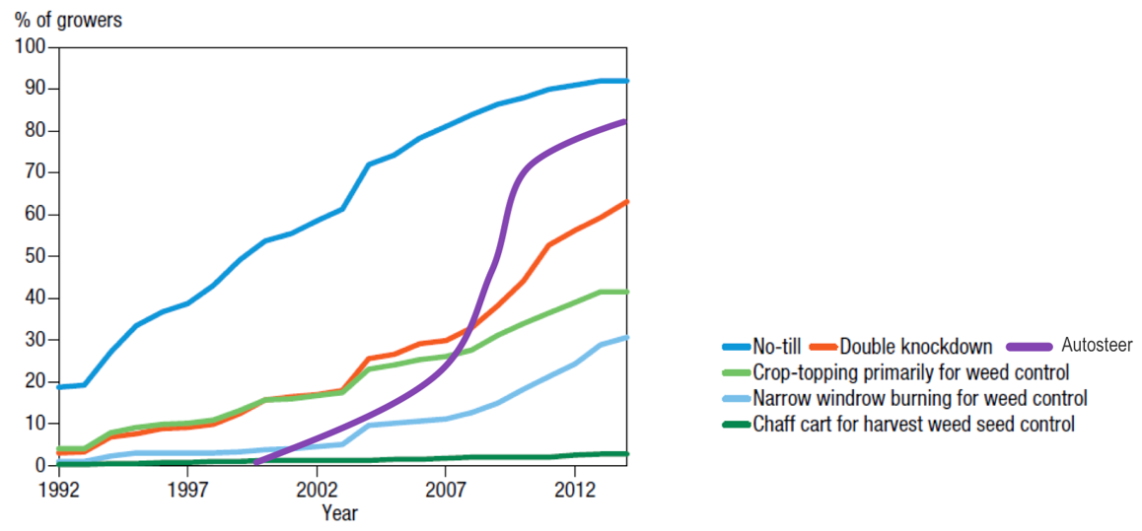

Sources: Llewellyn RS, Ronning D, Ouzman J, Walker S, Mayfield A & Clarke M, Impact of Weeds on Australian Grain Production: the cost of weeds to Australian grain growers and the adoption of weed management and tillage practices, Report for GRDC, CSIRO, Australia, 2016.

Llewellyn R, Ouzman J, Adoption of precision agriculture-related practices: status, opportunities and the role of farm advisers, CSIRO Report for Grains Research and Development Corporation, Canberra, Australia, 2014.

**Figure 5. Adoption of no-tillage, autosteer and IWM practices**

### Weed seed capture and destruction

Windrow burning has been a successful IWM innovation (Figure 5). Higher biomass levels and high temperatures of burning narrow windrows from harvest has increased the mortality of annual ryegrass and wild radish with generally less than 10 per cent of field area exposed by this practice (Walsh & Newman 2007).

The development of alternative, non-chemical weed control strategies, especially new weed seed collection and destruction techniques at grain harvest has also been a successful IWM innovation (Figure 5). Walsh *et a*l (2013) found that harvest weed seed control (HWSC) systems target weed seed during commercial grain harvest operations and acts to minimize fresh seed inputs to the seedbank. These systems exploit two key biological weaknesses of targeted annual weed species: seed retention at maturity and a short-lived seedbank. HWSC systems, including chaff carts, narrow windrow burning, bale direct, and the Harrington Seed Destructor (HSD) (Walsh *et al* 2012), target the weed seed bearing chaff material during commercial grain harvest. The destruction of these weed seeds at or after grain harvest facilitates weed seedbank decline, and when combined with conventional herbicide use, can drive weed populations to very low levels (Walsh *et al* 2014). Very low weed populations are key to sustainability of weed control practices. Further innovation of the HSD into an integrated design (iHSD) where harvest at 15 cm cutter height can collect up to 75 per cent of annual ryegrass seed populations in cereal crops (Broster *et al* 2015) and can achieve 93 per cent weed seed kill of annual ryegrass and 99 per cent kill of wild radish, wild oats and brome grass through the destructive mill process integrated into the combine harvester (Walsh 2016).

### Crop competition

Competitive crop varieties are an effective IWM practice for competing with weeds and reducing weed seed recruitment. Although cultivars with high competitive potential have been identified amongst cereal crops, competitiveness has not traditionally been considered a priority for breeding or farmer cultivar choice, however, the challenge of managing herbicide-resistant weed populations has renewed interest in cultural weed control options, including competitive cultivars (Andrew *et al* 2014).

The importance of crop competition in weed management is often overlooked but it can play an important role in cropping systems. Research by Zerner *et al* (2008) suggests that breeding selection for high early vigour could reduce the negative effect of reduced plant height on weed competitive ability. Increasing plant height improved bread and durum wheat's ability to tolerate and suppress oats sown as a surrogate volunteer or weed. In addition to plant height, traits associated with early vigour such as length and width of leaves 1 and 2, early plant biomass and leaf area index were also shown to have a significant influence on crop yield loss and weed suppression.

Competitive ability of 86 wheat (*Triticum aestivum* L.) genotypes varying for early vigour was investigated by Zerner *et al* (2016). Several of these wheat lines showed consistently greater weed suppression than the commercial wheat cultivars investigated. Genotypic variation was much greater for weed suppression than weed tolerance, suggesting greater opportunity for the selection of improved weed suppression in wheat. Strong positive correlation between weed suppression and tolerance (r = 0.79, P < 0.001) suggests that wheat lines selected on the basis of high weed suppression may also exhibit improved weed tolerance.

Research undertaken by Gill (2014) with competitive cultivar breeding lines of wheat showed that grain yield tolerance to weeds and weed suppressive ability were highly heritable. Plant traits such as tillering ability, leaf size, canopy cover and early vigour were found to be important components of competitive ability. With top-crossing to commercial wheat varieties, significant gains were made in combining high early vigour in an agronomically suitable background. More than 6,000 breeding lines were phenotyped for a range of plant characteristics. The most vigourous of the lines express early ground cover comparable with barley and some lines produced grain yields similar to current commercial varieties. Some of these lines caused 30-50 per cent greater weed seed set reduction than commercial varieties.

A Resistance and Integrated Management (RIM) model (Pannell *et al* 2014) analysis (a computer model that evaluates biological and economic performance of IWM systems for herbicide-resistant weeds) showed that integrating wheat lines with high competitive ability into cropping systems with herbicide-resistant weeds can provide significant reductions in weed infestation, ryegrass seedbank and improve gross margins (Gill, 2014). Using this model and the findings of the competitive cultivar research by Gill (2014) shows the integration of a high wheat seed rate, a competitive wheat cultivar and windrow burning post-harvest over a period of consecutive seasons in a wheat-barley-canola rotation results in annual ryegrass weed seed recruitment decaying to the point where the population becomes negligible (Figure 6).

Figure 6. RIM simulation modelling of integrating competitive wheat cultivars with other IWM practices on the soil seedbank in March.

Non-selective and selective herbicides are selected by RIM as appropriate for different crops

Rotation: wheat – barley – canola (only wheat crop parameters were changed for the simulation)

**Strategy 1**: standard RIM settings (normal seed rate and all other management practices)

**Strategy 2**: same as #1 but with wheat sown at high seed rate (80 kg/ha Vs 50 kg/ha for S1); high seed rate strategy was only implemented in wheat as there can be increased disease and quality issues in barley and canola

**Strategy 3**: as per #2 + a wheat cultivar that provides 30 per cent additional weed suppression

**Strategy 4**: as per #2 + a wheat cultivar that provides 50 per cent additional weed suppression

**Strategy 5**: as per #4 + windrow burning after barley (it is considered unsustainable to burn residue of all crops in the rotation); in RIM windrow burn kills 40 per cent ryegrass seed.

Source: Gill G, Benefits of weed competitive wheat cultivars - RIM evaluation for GRDC competitive cultivar investment evaluation, University of Adelaide, 2010

**Figure 6. RIM simulation modelling of integrating competitive wheat cultivars with other IWM practices on the soil seedbank in March.**

This research highlights the importance of the use of crop competition as part of IWM strategies to manage weeds. It also highlights the value in applying herbicides in the context of a competitive crop environment as used in a HT crop production system. Use of herbicides in the absence of crop competition will facilitate higher numbers of weed set from weed escapees.

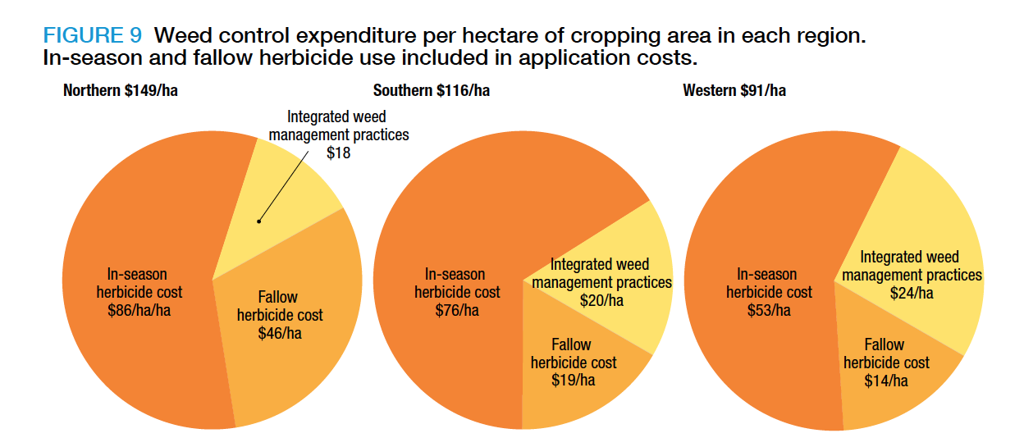

Source: Llewellyn RS, Ronning D, Ouzman J, Walker S, Mayfield A & Clarke M, Impact of Weeds on Australian Grain Production: the cost of weeds to Australian grain growers and the adoption of weed management and tillage practices, Report for GRDC, CSIRO, Australia, 2016.

**Figure 7. Weed control expenditure per hectare of cropping area in each region**

The high average in-season herbicide costs, relative to the costs of integrated weed management practices (Figure 7), highlight the high value proposition, which is reflected by the increased adoption by Australian grain producers.

IWM tactics in the cotton industry have been largely focused on herbicide options, however tillage prior to planting is practiced in irrigated systems and manual hand chipping of weeds is still commonly practiced (Figure 8).

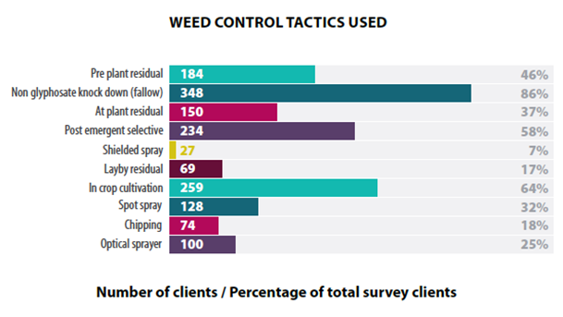

Source: Otto L (Ed), Qualitative report on the 2018-10 cotton season: A survey of consultants, Cotton Research and Development Corporation and Crop Consultants Australia, Narrabri, Australia, 2020.

**Figure 8. Weed control tactics used in cotton producing regions of Australia**

### Future herbicide application advances

The practice of integrated weed management is advanced in Australia and new technologies are likely to further advance these practices. Sensor spray technology utilising both current commercial green on brown camera spray technology such as Weed-It[2] and WeedSeeker[3] significantly reduce the volume of pesticides used in agricultural production. Technology innovations such as the optical green on green technology for control of Guinea grass in sugarcane production developed by the University of Southern Queensland (Rees *et al* 2011) is now being considered for commercialisation through a strategic alliance with John Deere[4] and are technologies that will deliver reduced pesticide use and resulting environmental footprint. Use of precision application utilising differential GPA and autosteer technologies with precision sprayer technology also has a very high rate of adoption exceeding 85 per cent (Figure 5) and will further reduce pesticide use.

Use of precision banding techniques provides scope for herbicide load reductions in crop production, extending beyond proportionate decreases in the amount of herbicide ingredient applied to paddocks (Davis & Neelamraju 2019). The use of green on green Bilberry AICPlus technology camera spray technology incorporating artificial intelligence for selected spraying of weeds within a crop has been commercialised by Agrifac.[5] These type of advances including new technologies under development to target chemical application to the weeds while avoiding crop including the Blue River See&Spray technology[6] highlights some of the significant advances agriculture will see in coming years. These technologies will change both the way pesticides are used, but also the way farms are operated, potentially in fully autonomous systems, ultimately changing the farming systems itself.

## Industry stewardship of herbicide tolerant crops

Stewardship management plans exist for all GM and non-GM HT traits in Australian cotton and canola crops that have been developed by the breeding companies supplying seed, which if being a GM HT trait is developed in collaboration with the registered GMO approval holder. Herbicide resistance in cotton and canola has only been reported for ALS, ACCase, glyphosate and microtubule inhibitors – trifluralin, however there is widespread resistance to other modes of action in other crops (Table 2, Appendix 2 Tables 8, 9 & 10).

BASF (2018) has developed stewardship guidelines for both the seed and use of the IMI chemistry, in Clearfield® (CL) canola ensuring high seed quality and purity, as well as adequate crop tolerance to the herbicides imazamox and imazapyr. The following are four key agronomic HT stewardship practices:

1. Utilise crop rotation.
2. Keep accurate records of all herbicide usage with no more than two (2) Group B herbicides applied in any four (4) year period on the same paddock.
3. Properly manage weeds in crop-fallow rotation.
4. Properly control volunteer IMI HT plants.

For GM RR canola and cotton, there are similar stewardship management plan guidelines for use of integrated weed management strategies, weed management options and volunteer control. Additionally, for GM canola, the stewardship plans also specify minimum distances for managing adventitious presence of GM grain for both grain production and seed purity.

These guidelines for GM canola stewardship have evolved from the *Monsanto Paddock Risk Assessment Management Option Guide* (PRAMOG). GM canola production stewardship guideline documents were also developed and widely distributed to producers nationally by the GRDC (Pritchard, 2014). For GM cotton, a *Herbicide Resistance Management Strategy* (HRMS) was developed by the *Transgenic Insecticide Management Strategy* (TIMS) herbicide technical panel. The HMRS is reviewed annually by the TIMS Herbicide Resistance Technical Committee in light of weed resistance surveys, consultant and grower surveys and feedback from registrants.

As part of the ongoing APVMA approval for GM Roundup Ready® (RR) canola production, Bayer Crop Science would assume responsibility for the continuation of the independent expert *Herbicide Resistance Consultative Group* (HRCG) established by Monsanto that oversees the RR Canola Crop Management Plan. The HRDC has had responsibility for reviewing this plan annually in light of weed resistance surveys, plus consultant and grower feedback, however its current operational function is unclear.

There has been discussion around the potential for formal collaboration between these panels, however collaboration occurs informally. The Australian Glyphosate Sustainability Working Group has previously provided guidance on GM HT canola and cotton stewardship development, but activities conducted by this group now occur within the Weed Smart program (described below).

As part of the training and induction process, canola producers read and sign a license and stewardship agreement which includes following the *Resistance Management Plan*, following the *Crop Management Plan*; and delivering grain to an approved grain handler and declaring the grain as RR canola. Herbicide resistance management strategies for all herbicide modes of action have been developed and supported by registrants through CropLife Australia,[7] which includes detailed herbicide resistance management strategies developed by the CropLife Australia Herbicide Resistance Management Review Group (HRMRG) (CropLIfe 2020). This is also supported by the CropLife Australia Stewardship First Program[8], which includes stewardship guidelines on chemical application and use through MyAGCHEMuse.[9]

A nationally coordinated GRDC invested WeedSmart industry stewardship program to manage herbicide resistance was launched at the Global Herbicide Resistance Challenge in 2013 which continues today, including significant support and investment of most of the major large herbicide registrants in Australia (WeedSmart 2020). This has been a significant communications and training program that supports herbicide stewardship and management of herbicide resistance in weeds. Since 2017, WeedSmart has also been supported by the cotton industry with investment from CRDC. WeedSmart supports “The Big 6” key messages for an IWM stewardship program:

1. ROTATE CROPS AND PASTURES: Use double break crops, fallow and pasture phases to drive the weed seedbank down over consecutive years.
2. DOUBLE KNOCK – TO PRESERVE GLYPHOSATE: Follow glyphosate with a high rate of paraquat to control survivors in a fallow or pre-sowing situation.
3. MIX AND ROTATE HERBICIDES: Rotate between herbicide groups; Use different groups within the same herbicide mix; Always use full rates.
4. STOP WEED SEED SET: Crop top canola, pulses and feed barley in weedy paddocks; Consider hay, brown manure or long fallow in high-pressure paddocks; Spray top/spray fallow pasture prior to the cropping phase.
5. CROP COMPETITION: Adopt at least one competitive strategy (but two is better), including reduced row spacing, higher seeding rates, east-west sowing and competitive varieties.
6. HARVEST WEED SEED CONTROL: Capture weed seed survivors at harvest using chaff lining, chaff tramlining, chaff carts, narrow windrow burning or integrated weed seed destructors.

The flow-on impacts of these stewardship programs have been significant. Australian grain producers including both GM and non-GM producers (some of which had no access to the technology due to state moratoriums) are world leading in practice of IWM with 72 per cent adoption and 92 per cent of producers undertaking activities that minimise weed resistance (GRDC 2017). Over 83.5 per cent of dryland cotton area and 94.1 per cent of irrigated cotton had more than one IWM practice in 2018/19 (Otto 2020).

The success of these stewardship programs and adoption of IWM by grain and cotton producers indicates that the introduction of additional stacked HT traits would be well managed by registrants, breeders and producers. It would be unlikely that genetically modified (GM) crops containing multiple herbicide tolerant traits could potentially increase herbicide resistance development in weeds. From the adoption of the HT stewardship programs and the rate of evolution of HR weeds, it appears that the introduction of HT traits, particularly GM HT traits, may have abated the development of herbicide resistance nationally through the introduction of weed management tools not previously utilised or available to growers. The introduction of glufosinate tolerant Liberty Link® (LL) canola and cotton is likely to test this hypothesis further.

The importance of volunteer control has been highlighted in stewardship programs for non-GM CL and TT HT canola as well as GM RR canola and cotton. There is the potential for increased management challenges for volunteer crop control, which would largely impact on the complexity of crop volunteer management and contamination for a given business, rather than contribute to weed control related issues. The commercial reality is that if these technical complexities become insurmountable, then farm businesses are likely to abandon the technology.

It is clear that discussion around volunteer control should be a central consideration for evaluation of registration applications for both herbicides and HT crops by the APVMA and of GM HT applications by the OGTR. While it is unlikely that registrant applicants will seek to make unworkable HT stacks that result in difficulty for volunteer control for producers, there is a possible commercial opportunity for breeding companies to exploit a series of these GM and non-GM HT traits in a stack. The APVMA, the OGTR, HT trait developers, producers’ groups, production traders and exporters will continue to have a complementary role in ensuring workable and sustainable technology options. There is however a recognition of potential challenges if the use of HT traits extends to phenoxy, HPPD or PPO herbicides, which warrants further industry discussion.

## Summary of key points

* Farming systems have changed and will continue to evolve, as new technologies enable new production systems not previously possible.
* Global GM HT trait development is rapidly accelerating to cover a majority of the broad spectrum or post crop emergent herbicides available.
* Stewardship management plans, including advanced IWM practices and technologies, exist for all GM and non-GM HT traits in Australian cotton and canola crops developed by the breeding companies supplying seed.
* The key question that needs to be considered is do producers potentially have sufficient herbicide tools to control volunteer HT crop plants?
* Discussion around volunteer control should be a central consideration in evaluation of registration applications for both herbicides and HT crops by regulators.

# Chapter 4: Gene-flow and seed recruitment of GM crop plants and outcrossing

## Gene Flow

Gene-flow from GM to conventionally bred crops and risks of outcrossing to other species has been studied in detail, particularly with rapeseed or canola. Canola is rapeseed that has been bred to contain less than two per cent erucic acid and less than 30 micromoles of glucosinolates, making its oil palatable for human consumption, and use in livestock feed. Cotton produced today in Australia is almost exclusively GM and there is well-established genetic incompatibility between cultivated cotton and native *Gossypium spp.* located in northern Australia, far from production regions of cultivated GM cotton (OGTR 2006). Consequently, the focus of discussion in this review is on GM canola gene flow.

The OGTR in its review of The Biology of *Brassica napus* L.(2011), notes that although the probability of outcrossing appears to be low, the large number of canola flowers and the many small seeds produced per plant ensures a substantial quantity of outcrossed seed can still be produced. Some seed may shatter onto the ground before or at harvest and germinate the following season with the succeeding crop. Although many of these seedlings may be killed by frost, disease, insect attack, early herbicide treatments and/or tillage, a proportion of seedlings may either survive or emerge later in the season to compete with the succeeding crop, warranting further chemical or mechanical control.

Three species were initially identified by Rieger *et al* (1999) as having the potential to outcross with canola grown in Australia, *Brassica juncea*, *B. rapa*, and *Raphanus raphanistrum* L. Two of these species are not yet widespread weeds of the southern Australian cropping zone. In contrast, *Raphanus raphanistrum* L. is already a major weed in Australia with existing resistance to ALS-inhibiting herbicides.

Rieger *et al* (2001) investigated the frequency of hybridisation between *Brassica napus* L. and *Raphanus raphanistrum* L. in field experiments under agronomic conditions, where *Raphanus raphanistrum* L*.* were randomly planted at two different densities into large plots of *Brassica napus*. An acetolacate synthase (ALS)-inhibiting imidazolinoneherbicide-resistant trait was used to detect potential hybrid individuals. In this study, no hybrids were detected amongst 25,000 seedlings grown from seed collected from *Raphanus raphanistrum* L. plants. Two hybrids were obtained from more than 52-million *Brassica napus* L. seedlings. Both hybrids were characterised as amphidiploids (AACCRrRr, 2n = 56) and were fertile. The frequency of hybridisation into *Brassica napus* L. in this experiment using male-fertile *Brassica napus* L. was 4 × 10–8.

Rieger *et al* (2002) reported at a landscape level the gene flow that occurs from herbicide-resistant canola crops to nearby crops not containing herbicide resistance genes, with outcrossing rates between commercial fields of non-GM herbicide tolerant canola and conventional canola at distances from 0 to 2.6 km being variable, ranging between 0 and 0.15 per cent. The maximum outcrossing rate of 0.197 per cent was measured at 1.5 km. Outcrossing was less than 0.01 per cent at 2.6 km from the pollen source. Outcrossing was not detected at sites from 3 to 6 km from the pollen source. When averaged across the individual paddocks where outcrossing had occurred, outcrossing did not exceed 0.07 per cent. Outcrossing occurred in 63 per cent of the fields, but only a few had outcrossing rates greater than 0.03 per cent.

In Canada, Beckie *et al* (2003) assessed gene flow in space and time in adjacent commercial fields of glyphosate tolerant Roundup Ready® (RR) and glufosinate tolerant Liberty Link® (LL) canola, including:

estimation of gene flow with distance; frequency and distribution of volunteers and effect on gene flow; effect of adventitious double herbicide-resistant seed presence in seedlots planted and a comparison of various marker systems to track gene flow events. At 11 sites in 1999, gene flow was determined by sampling seeds from plants located at 0, 50, 100, 200, 400, 600, or 800 metres along a transect perpendicular to the common border in the paired fields, spraying seedlings with glyphosate and glufosinate, and confirming the presence of the transgenes using commercial test strips and PCR analysis. In the spring of 2000, putative double herbicide-resistant volunteers that survived sequential herbicide applications were mapped at three of the sites using GPS and resistance in sampled plants was characterized. In 1999, gene flow between the paired fields was detected to a maximum distance of 400 metres. Values ranged from 1.4 per cent outcrossing at the border common to the paired fields to 0.04 per cent at 400 metres. In 2000, gene flow as a result of pollen flow in 1999 was detected to the limits of the study areas (800 m). Large variation in gene flow levels and patterns among the three sites was evident. Adventitious presence of double herbicide-resistant seed in glyphosate-resistant seed lots planted at two of the sites in 1999 contributed to the occurrence of double herbicide-resistant volunteers in 2000. The results of this study suggest that gene stacking in *Brassica napus* L. canola volunteers in western Canada may have been common, and reflects pollen flow between different herbicide-resistant canola, presence of double herbicide-resistant off-types in seed lots, and/or agronomic practices typically employed by Canadian growers.

The Office of the Gene Technology Regulator (OGTR) in the Risk Assessment and Risk Management Plan for the commercial release of RRcanola noted that gene transfer to other canola will not pose any greater risks to human health and safety or the environment than conventional canola (OGTR 2002b).

The OGTR (2002b) noted that: *in a commercial situation, outcrossing between canola varieties is inevitable, but the overall frequency of out-crossing will be very low decreasing significantly at distances of over 5-10 metres. Gene transfer to other canola is most likely in close proximity to RR canola. Even if gene transfer to other canola did occur, it would pose no greater risks other than the negligible risks posed by RR canola itself, or require management. Transfer of the herbicide tolerance genes will not confer a selective advantage in the absence of glyphosate and will not make plants more invasive or persistent. RR canola is as susceptible to other herbicides as conventional canola, and glyphosate tolerant volunteers can be controlled with other herbicides and management practices.*

The OGTR noted that: *Brassica rapa, Brassica juncea and Brassica oleracea are all principally weeds of agricultural cropping or disturbed habitats, but not of undisturbed natural habitats and the likelihood of some gene transfer from RR canola to the closely related weedy Brassica species Brassica rapa and Brassica juncea is high, but less than for the transfer to canola (Brassica napus) and decreases rapidly with distance from the crop. Because of the lower incidence of these species, especially Brassica juncea, and the reduced ‘fitness’ of any progeny eg. vigour, fertility etc., the overall frequency of introgression would also be lower. Gene transfer to Brassica oleracea would be unlikely, as hybrids are not readily formed. Glyphosate tolerant hybrids would be most likely to arise within or adjacent to RR canola crops, where glyphosate would not be used for weed control post-harvest because it would not control RR canola volunteers. In such situations, measures taken to control RR canola would also eliminate any glyphosate tolerant Brassica species.*

The OGTR regulatory approval determined *the risk of gene transfer from RR canola in a commercial situation resulting in adverse environmental impacts to be very low for Brassica rapa and negligible for Brassica juncea and Brassica oleracea. Gene transfer from RR canola to the less closely related brassicaceous weed species would be restricted to Raphanus raphanistrum* L*., Hirschfeldia incana and Sinapis arvensis. The overall frequency of outcrossing is expected to be extremely low, and the likelihood of introgression in any resulting hybrid plants is considered to be very low because and of genome incompatibility and the severely reduced ‘fitness’ of any progeny.*

Roush (2015) in the first year of RR GM canola commercial release in Australia studied pollen flow in paddocks from seeds collected between 2008 and 2010 from non-GM canola paddocks near GM crops. Pollen flow declined rapidly with distance and was less than 0.028 per cent at distances greater than 100 metres from source crops. From 118 non-GM paddocks sampled, the mean frequency of glyphosate-resistant individuals in non-GM crops on a per paddock basis was less than 0.2 per cent in adjacent paddocks. The highest was 0.8 per cent in Western Australia (WA) and 0.5 per cent in eastern Australia. These frequencies are below the adventitious limits for commercial delivery of non-GM canola - that is, pollen flow alone cannot cause commercial issues among neighbouring conventional growers. In one case where seed had been blown from a crop into native bushland via windrowed stalks, the amount was low relative to what would be expected in a commercial situation. The canola population declined over time and did not become weedy. This research highlights that HT volunteer canola, while still needing to be controlled, is unlikely to be an issue for producers with current management options available.

Roush (2015) also reported that although initially unplanned, the presence of RR GM canola along roadsides, in the most likely of habitats for it to establish and increase, was monitored near grain receivers and on roadsides in Victoria and New South Wales (NSW). While GM canola could be found, its frequency was low among the volunteers and canola plant density. GM canola in roadside samples averaged 14 to 20 per cent in Victoria and NSW, respectively. This is roughly proportional to the area of GM canola present in respective districts. There was no evidence of increased densities or difficulty in control of roadside canola.

This research by Roush (2015) supports the expected gene flow results of Rieger *et al* (2001), that dispersal of pollen is a very weak pathway for GM canola traits to spread into non-GM sites. However, growers should communicate and work together to avoid planting GM canola immediately adjacent (within 10 metres) to non-GM crops where this may be of concern to non-GM growers. GM canola seeds persist no better in the seedbank than non-GM. Volunteer canola plants were almost non-existent in commercial paddocks with typical weed control practices. Glyphosate resistance can be found in some cropping areas of WA, NSW and Vic, but did not correlate with RR canola use, suggesting that use of RR GM canola on any given paddock less than once in three years is not significantly accelerating resistance, compared to normal practices.

This gene flow research by Roush (2015) supports the 2002 pre-release risk assessments of the OGTR, that the introduction of RR GM canola presents no greater environmental or agronomic risks than conventional varieties. More importantly, this test of the approval system gives confidence to growers and regulators about practices and determinations of the OGTR that might be applied to future risk assessments.

## Seed recruitment

Storrie *et al* (2019) note that herbicide resistance is normally present in some individual plants of weed populations before herbicides are first applied. Several factors will affect the number of herbicide applications before the general population becomes resistant to that herbicide. These include:

* Initial frequency of resistance gene(s) and MOA of the applied herbicide
* Size of the weed population
* Proportion of the weed population treated
* Herbicide efficacy
* Weed biological factors.

Vila-Aub *et al* (2003) suggests the rate of herbicide resistance evolution is not only determined by the amount of genetic variation within the populations and the selection pressure exerted by herbicides, but also by factors related to genetics, biology and ecology of weeds. The inheritance of the resistance genes, the mating patterns of the populations, the relative fitness of susceptible and resistant phenotypes and gene flow processes also control the resistance evolution rate. Busi & Powles (2009) suggests there is progressive enrichment of minor gene trait(s) contributing toward plant survival in glyphosate-selected progenies. Using rapid recurrent selection techniques to a range of herbicide doses, up to 33 per cent annual ryegrass plant survival was obtained in the glyphosate-selected progeny at the recommended glyphosate label rate. This level of resistance probably was the maximum shift achievable with sub-lethal glyphosate dose selection in this small population.

Busi & Powles (2009) noted that cross-pollination was a crucial factor enabling the rapid rate of accumulation of minor glyphosate resistance gene trait(s) that are likely to be present at a relatively high frequency in a small susceptible population. It is clear that to manage herbicide resistance, weed populations and the weed seed bank need to be kept low and controlling seed set is critical. Baker & Preston (2008) found that canola seedbank and the number of volunteers declined rapidly under normal management practices in managed cropping systems in southern Australia. Therefore, it is unlikely that herbicide-tolerant canola will become a major weed if volunteers are managed carefully.

Busi & Powles (2016) found surviving HT Roundup Ready® (RR) canola plants in semi-natural, roadside and natural environments over consecutive years showed a low likelihood to become invasive, as plants are subjected to biological and abiotic stressors that are likely to limit their ﬁtness. In a natural environment where a canola windrow was blown by a windstorm, canola plant recruitment could persist for up to three years and population turnover declined over time to extinction. Conversely, on roadsides canola seed spillage persisted for at least three years. As no individual RR HT canola plants were found with stacked genes for multiple herbicide resistance, the findings by Busi & Powles (2016) suggest that RR volunteer canola plants can be controlled by a simple mixture of herbicide modes of action different to glyphosate, although an integrated management including mechanical control operations would be the optimal strategy.

Based on these Australian studies, it can be concluded that the combined risk of gene flow and probability of seed recruitment survival of GM canola in either a natural or unmanaged environment is not likely to result in long-term survival or issues with evolution of resistant weed seed biotypes, except for the weed resistance selection pressure from the use of the herbicide itself. This same selection pressure could easily apply in non-GM crop or non-crop situations.

## Summary of key points

* The combined risk of gene flow and probability of seed recruitment survival of GM canola in either a natural or unmanaged environment is unlikely to result in long-term survival or issues with evolution of resistant weed seed biotypes.
* Gene flow research supports the 2002 pre-release GM HT canola risk assessments of the OGTR, that the introduction of RR GM canola presents no greater environmental or agronomic risks than conventional varieties.
* This test of the approval system gives confidence to growers and regulators about practices and determinations of the OGTR that may be applied to future risk assessments.

# Chapter 5: Herbicide tolerance commercial deployment strategies and industry stewardship

There has been a rapid increase in the planting of transgenic crops with stacked traits. Many plant science and biotech companies are developing stacked-trait products with increasing numbers of insect resistance and herbicide tolerance genes for controlling a broad range of insect pests and weeds (Que 2010). In the US, the adoption of stacked corn varieties has increased sharply, from one per cent of U.S. corn acres in 2000 to 77 per cent in 2015. Adoption rates for stacked cotton varieties have also grown rapidly, from 20 per cent in 2000 to 79 per cent in 2015 (Fernandez-Cornejo & Wechsler, 2015). Consideration of using conventional breeding of approved GMOs is popular due to the reduced cost and time for new approvals. In the US and Canada, conventional breeding stacks from previously registered GM transformation events do not require new safety assessment studies, making it cheaper and faster to develop and commercialise a stack product. However, the US EPA does require separate review of the safety of the trait stacks if a specific hazard can be identified (Que 2010).

Australian cotton crops in late 2020 will have access to the herbicide tolerant (HT) stack of Roundup Ready® (RR) + Liberty Link (LL) + Dicamba tolerance traits which will be the first triple HT stack of any crop in Australia. Trait stacking in canola has been limited to a double stack of non-GM Clearfield® (CL) + triazine tolerant (TT), or GM RR+TT or RR+CL. Management of volunteer HT canola is currently relatively easy with broad-spectrum knockdownbipyridyland PPO inhibitor herbicides, or if in the cereal phase with phenoxy or HPPD inhibitor herbicides (Appendix 1 Tables 4& 5). Management of GM RR cotton volunteers/ratoons is noted as an issue as significant as managing annual ryegrass, liverseed grass and windmill grass according to a 2018/19 survey of cotton crop consultants (Otto 2020).

The recent legal settlement by Bayer CropScience in the United States from litigation issues in the US courts around the use of glyphosate and dicamba (Bayer 2020c) will likely accelerate increased commercial investment in HPPD inhibitor and PPO inhibitor HT crops as a risk management strategy for these companies.

To assist with resistance management, stewardship guidelines suggest rotating IMI tolerant winter crops with spring crops to break the cycle of winter annual weeds and allow the use of alternate site of action herbicides. If winter cropping is rotated with a fallow season where volunteers are controlled, weeds should be controlled before they set seed and alternate mode of action herbicides used. ALS-inhibiting herbicides should not be used more than two out of four years and producers should ensure their control of IMI tolerant volunteers (BASF 2018).

Due to adventitious presence delivery standards, a low number of HT GM crop volunteers will still need to be properly controlled, particularly RR volunteer canola which could potentially contaminate other HT crops such as IMI and TT tolerant canola. At times, the plant back interval due to the residual nature of herbicides, especially IMIs and triazines in low rainfall seasons, can limit crop rotation options or plantback following an establishment failure. IMI tolerant crops have increased in popularity for control of grass weeds, particularly for brome grass control using IMI tolerant barley and wheat varieties (Moody 2015).

Research suggests that GM stacked HT maize cultivars with two types of herbicide tolerance (glyphosate and glufosinate) and three types of insect resistance (corn borer, corn rootworm, and corn earworm) have 27.6 per cent higher yields than conventional cultivars or cultivars with only one GM trait (Fernandez-Cornejo *et al* 2014). Management of multiple stack volunteers may add additional complexity to volunteer management in fields, fence lines and along roadsides (Manalil *et al* 2015). While multiple stacked HT traits offer producers additional potential options to control herbicide resistant weeds, this also reduces the number of options to control volunteers.

Managing non-GM IMI tolerant cereal crop volunteers is becoming an increasing issue with so many crops now tolerant to IMI herbicides, including wheat, barley, canola, lentils, sorghum and maize (Weidemann *pers com* 2020). The issues experienced with IMI HT crops provides some insight on potential risks of volunteer management where multiple HT traits are stacked into a single crop as the complexity of volunteer management will be potentially amplified. Additionally with multiple stacked HT traits, selection pressure for herbicide resistant weeds will be increased if all the additional modes of action technology options are utilised in one season, reducing best practice herbicide rotation options to avoid repeat use of the same mode of action in subsequent seasons.

It is clear that HT crop traits are an important strategic weed management tool as part of a farm business integrated weed management (IWM) plan. With an IWM plan focus on seed set control to reduce weed seed recruitment, the resulting selection pressure of herbicides used with HT crop traits, GM or non-GM will not contribute to any greater selection pressure for herbicide resistance than if it were used in a conventional crop fallow, pre-sowing or pre harvest application situation. The combination of GM abiotic traits such as crop vigour, drought tolerance and other biotic resistance traits to insects and disease will further aid with enhanced crop competition to compete with weeds, reducing weed seed recruitment. The same logic can be used to consider if a GM HT crop with multiple stacked HT traits would present any increased risks to herbicide resistance. Herbicides such as the Group I mode of action (MOA) chemicals 2,4-D and dicamba, HPPD and PPO inhibitors could still be potentially used within a given cropping season, outside of the crop growth period in herbicide sensitive crops, either for weed or crop volunteer control. With the factors of crop competition reducing seed recruitment through the use of hybrid canola varieties such as InVigor® and the combination of herbicide MOA keeping weed numbers low, it is unlikely that herbicide resistance risk would be any greater than if the same combinations of herbicides were used outside of the growing season achieving similar efficacy, particularly if used in situations with little competition such as on fence lines and roadsides.

The OGTR in the Risk Assessment and Risk Management Plan for the commercial release of RRcanola (OGTR 2002a) notes that:

The introduction of tolerance to the herbicide glyphosate will not provide any selective advantage over conventional canola except where glyphosate is used. RR canola is only tolerant to glyphosate and its susceptibility to other herbicides is no different to conventional canola. Therefore, RR canola can be effectively managed and controlled using alternative herbicides and other (non-chemical) weed control practices that can be applied to conventional canola. *Canola can occur as an agricultural weed, particularly as plants (known as volunteers) that germinate after harvest from fallen seed. However, because it is a highly domesticated crop, canola does not establish or persist well in undisturbed, natural habitats. The risk that RR canola will be more invasive or persistent than conventional (non-GM) canola in Australia is negligible.*

*The emergence of volunteer plants subsequent to the cultivation of a crop, and their control or removal prior to the next season’s planting, is an integral part of normal agricultural practice that is not in any way restricted or peculiar to either canola or GM crops. Therefore, adoption of RR canola will mean that farmers will need to make choices and potentially modify their farming practices. This may result in increased complexity in implementing alternative weed management strategies, as well as other economic considerations. It will not pose any greater risks to human health and safety or the environment than conventional canola. Therefore, no risk management conditions are proposed in relation to weediness.*

The opportunity for incorporating Group I MOA herbicide tolerance including, 2,4-D and dicamba appears commercially attractive with considerable crop flexibility options, providing effective weed control and in particular earlier control of weed seed recruitment, including the benefit of tolerance to off target crop damage often experienced with this chemistry group. However, these products have been an essential tool in management of HT crop volunteers in both cotton and canola for many years. The current global regulatory pressure around the common alternative bipyridyl herbicide for volunteer control, which has been banned in the EU[10] and is currently under review by the US EPA[11] and APVMA[12] suggests that other options including HPPD and PPO inhibitors will be required by industry. A number of registrations of these new HPPD and PPO inhibitor herbicides have been recently introduced into the Australian market for fallow, pre-plant, in crop weed control in cereals and pulses, as well as pre-harvest weed seed set control. If tolerances to HPPD and PPO inhibitor herbicides (which are becoming increasingly important for volunteer control) are also incorporated into GM HT crops, there is likely to be significant compromises in volunteer management in farming systems.

As HT trait combinations can be commercially delivered using both a GM and non-GM approach using conventional crossbreeding, there is scope for introduction of trait combinations that may not be in the best interest of industry producers for ongoing sustainable production. While there is unlikely to be any risk to the environment due to poor crop persistence of volunteer seed, there is a case to consider the relative merits of HT trait combinations and the complexities of volunteer management to ensure that the key requirement of grain product quality at delivery (including management of contamination and adventitious presence of GM grain under seed license agreements) can be met by producers.

## Summary of key points

* HT crop traits are an important strategic weed management tool as part of a farm business integrated weed management (IWM) plan.
* HT trait combinations can be commercially delivered using both a GM and non-GM approach using conventional breeding
* Managing non-GM IMI tolerant cereal crop volunteers is becoming an increasing issue with so many crops now tolerant to IMI herbicides
* There is a case to consider the relative merits of HT trait combinations and the complexities of volunteer management

# Chapter 6: Herbicide tolerance regulation

## Assessment for herbicide resistance evolution risk

The following section detailing the legislated roles and regulatory responsibilities of the OGTR, FSANZ and APVMA has been extracted from the Australian government websites of these regulators.

### Office of the Gene Technology Regulator[13]

*The Office of the Gene Technology Regulator (OGTR) has been established within the Australian Government Department of Health to provide administrative support to the Gene Technology Regulator in the performance of the functions under the Commonwealth Gene Technology Act 2000, delivering nationally consistent legislative scheme for gene technology introduced In 2000/01 which is supported with corresponding State and Territory legislation. The Australian Government Act, which came into force on 21 June 2001, was enacted to protect the health and safety of people and the environment. It regulates all dealings with live and viable genetically modified organisms (GMOs) in Australia, including research, manufacture, import, production, propagation, transport and disposal of GMOs. The Act defines gene technology as any technique for the modification of genes or other genetic material. Gene technology does not include sexual reproduction, homologous recombination, or other techniques that the Regulations specify are not gene technology.  
  
The main features of the Act:*

* *Prohibit anyone dealing with a GMO (for example: for research, manufacture, production, commercial release or import) unless the dealing is:*
  + *licensed by the Regulator for contained use or intentional release into the environment.*
  + *a Notifiable Low Risk Dealing or exempt dealing (for example: contained work which has been demonstrated to pose minimal risk to workers, the general public and the environment).*
  + *on the Register of GMOs.*
  + *specified in an Emergency Dealing Determination.*
* *Establish a statutory officer (the Regulator) to make decisions under the legislation.*
* *Establish the Gene Technology Technical Advisory Committee and the Gene Technology Ethics and Community Consultative Committee to provide expert advice.*
* *Establish a process to assess risks to human health and the environment associated with various dealings with GMOs, including opportunities for public input.*
* *Specify extensive powers to allow monitoring, compliance and enforcement of the legislation.*
* *Establish a centralised, publicly available database of all GMOs approved in Australia (the Record of GMO dealings).*

*The OGTR provides determinations on approval for field trials and for commercial release of GMOs. Before issuing a license, the OGTR must consult with all relevant local, state and Australian Government agencies and the public, and prepare a risk assessment and risk management plan (RARMP) that identifies any potential risks, based on credible evidence, and the means of managing those risks. The RARMP contains a number of general conditions relating to ongoing license holder suitability, auditing and monitoring, and reporting requirements, which include an obligation to report any unintended effects. The RARMP also contains a number of general conditions relating to ongoing license holder suitability, auditing and monitoring, and reporting requirements, which include an obligation to report any unintended effects. The OGTR regulates GMOs, as distinct from GM products. The latter are regulated by four other national bodies with specific areas of responsibilities that include GM as well as non-GM products. Each of those bodies must notify the OGTR of any GM product approvals.*

*GM products are not regulated under the Act unless there is no existing product regulator. The use of GM products is regulated by other agencies, such as the Therapeutic Goods Administration, and for GM crops specifically, Food Standards Australia New Zealand (FSANZ) and the Australian Pesticides and Veterinary Medicines Authority APVMA). The Regulator provides advice to other regulators on the GM aspects of such products. The Australian government regulatory agencies do not take into account trade or marketing considerations on GM product, which is at the discretion of each State or Territory government.*

### Food Standards Australia New Zealand[14]

*Food Standards Australia New Zealand (FSANZ) conducts a thorough safety assessment of all GM foods before they are allowed in the food supply. This assessment ensures that any approved GM foods are as safe and nutritious as comparable conventional foods already in the Australian and New Zealand food supply.*

*The safety assessment of a GM food is conducted within the established risk assessment framework used by FSANZ. In the case of GM food, the primary purpose is:*

* *To identify new or altered hazards associated with the food as a result of the genetic modification.*
* *To assess whether there is any risk associated with any identified hazards under the intended conditions of use.*
* *To determine if any new conditions of use are needed to enable safe use of the food.*

*The safety assessment is characterised by:*

* *Case-by-case consideration of GM foods; Case-by-case assessment is necessary because the key issues requiring consideration in a safety assessment will often depend on the type of food being evaluated and the nature of the genetic modification.*
* *Consideration of both the intended and unintended effects of the genetic modification; In addition to the intended effect (e.g. a new trait, such as insect protection), there may also be other effects associated with the genetic modification that were unintended (e.g. compositional changes to the food) and which may impact on the health and safety of the population. Therefore it is important that both the intended and any unintended effects are evaluated.*
* *Comparisons with conventional foods having an acceptable standard of safety. Such a comparative approach focuses on:*
  + *The identification of similarities and differences between the GM food and an appropriate comparator.*
  + *A characterisation of any of the identified differences in order to determine if they may raise potential safety and nutritional issues.*

*The goal of the FSANZ safety assessment is not to establish the absolute safety of the GM food but rather to consider whether the GM food is comparable to the conventional counterpart food, i.e. that the GM food has all the benefits and risks normally associated with the conventional food.*

### Agricultural Pesticides and Veterinary Medicines Authority (APVMA)[15]

*The Australian Pesticides and Veterinary Medicines Authority (APVMA) is the Australian Government regulator of agricultural and veterinary (agvet) chemical products. For an agvet chemical or product to legally be manufactured, imported, supplied, sold or used in Australia, it must be registered by the APVMA, unless exempt by the Agvet Code. The registration process involves scientifically evaluating the safety and efficacy (effectiveness) of a product in order to protect the health and safety of people, animals, plants and the environment.*

*The APVMA is responsible for regulating agricultural and veterinary (agvet) chemicals (active constituents) and products containing them in Australia, up to and including the point of retail sale. A number of products of biological origin fall into the Agvet Code definition of an agricultural chemical product and therefore must be registered by the APVMA. Plants that have a naturally evolved resistance (for example, herbicide resistance or insect resistance) do not require registration with the APVMA, nor do plants that have been conventionally bred to have, say, increased resistance to insect attack. GM technology has opened the possibility of novel pesticides being produced within a plant by introduced genes not normally found in that plant. These pesticidal substances require regulation by the APVMA due to their potential impact on human health and safety or the environment.*

*Genetically modified plants with genes for herbicide tolerance will not themselves require registration, but applicants must check on APVMA requirements relating to herbicide use before release of seeds or plants. A proposed new use pattern for a chemical to be used on a genetically modified plant will require a label change application for the relevant chemical product.*

*The data requirements for a new product or a variation to a product that contains a herbicide active constituent for use in crops that have been genetically-modified for tolerance to these active constituents. The application of a herbicide to a GM crop may present increased risk in regards to:*

* *The efficacy & crop safety or phytotoxicity of the herbicide.*
* *The resulting residues.*
* *Potential development of weed resistance.*

*The applicants for such product registrations must address these areas of risk via the provision of appropriate data and/or scientific argument. The data requirements for each of the above risks arising from such products are described below.*

#### Efficacy & Crop Safety data

*Efficacy and crop safety data must be provided from trials over two growing seasons of the GM crop using the formulation contained in the proposed new or varied product. The trials must be conducted in most recently released cultivar of the GM crop that contains the relevant trait and as per the contemporary industry practice. Data from trials conducted on GM cultivars with traits previously released and superseded by new ones may not be acceptable.*

*GM crop cultivars are grown under a wide variety of climatic and edaphic conditions. Therefore, crop safety data must be generated from an appropriately representative number of growing regions. For example, GM cotton crops grown in hot (tropical) conditions are more susceptible to phytotoxicity when treated with certain herbicides. Applicants must provide appropriate data and/or scientific argument on formulation adaptations to deal with such situation-specific crop safety issues.*

#### Residues

*The GM trait conferring tolerance may alter the way in which the herbicide is transformed into a residue. Those transformation pathways may be quite different to the pathways in a conventional crop. Additional metabolism studies need to be conducted for a GM crop to determine if the residue definition resulting from the application of a herbicide to a GM crop is different to the definition that results from use in a conventional crop. The requirement for a metabolism study applies for the use of a herbicide product to a new GM crop (including the use of a new gene or possibly a combination of genes in an existing GM crop), rather than to an existing GM crop.*

*The APVMA requires residues trials for the purposes of setting a Maximum Residue Limit (MRL) to be conducted on the most recently released cultivar of the GM crop that contains the relevant trait. GM crops may modify the behaviour of the chemical degradation pathways, which therefore impacts upon the resulting residue profile. These pathways may respond differently to variations in formulation, application timings and rates when compared to those of conventional crops.*

#### Resistance Management Plan

*The repeated application of a herbicide increases the potential for weeds to develop resistance to the active constituent/s contained in the product/s. Applicants are therefore required to provide an appropriate resistance management strategy that provides users with:*

* *Adequate instructions regarding the need for preventative resistance management on the product label.*
* *A specific resistance management plan (RMP) that is acceptable to the relevant grower organisation as signified by written approval from a duly designated/authorised officer of that organisation. Where a specific grower organisation is not identifiable or does not exist for the particular GM crop, the APVMA will consider imposing conditions on the registrant to convene a group of suitable persons for the purposes of consultation on matters of resistance management. Typically, for products used on GM cotton, approval of the CMP/RMP is required from the Transgenic and Insect Management Strategies (TIMS) committee of the ACGRA.*

#### Trade Advice Notice[16]

*The APVMA prepares Trade Advice Notices (TAN) where a proposed change in the use of a registered product has the potential to affect Australia's trade. It provides a summary of the APVMA’s residue and trade assessment. Trade Advice Notices are published on the public consultation page inviting public comment on the trade implications of a proposed change to the use of a registered product.*

*The APVMA communicates on the TAN consultation opportunity by writing to relevant industry stakeholders, and distributing email notifications to stakeholders who subscribe to receive this communication. Submissions must be lodged within 28 days of communication to relevant stakeholders. The APVMA is able to consider comments relating to the legislative grounds for the assessment, which are the trade implications of the extended use of the product.*

#### Conditions of registration

*Where appropriate, the APVMA will impose specific conditions of registration that are designed to enforce the practice of preventative weed resistance management by users of the chemical product and to place obligations on registrants regarding the conduct of weed audits, reporting of weed escapees identified from such audits and taking follow up action to deal with weed escapees. These conditions are necessary as the use pattern is recognised as increasing the potential for the development of weed resistance to the active constituent.*

*For materials that consist of or contain genetically modified organisms (GMOs) and are regulated by APVMA, advice is sought from the Office of the Gene Technology Regulator (OGTR) on any application for approval of a GMO or the product of a GMO. To have a GMO approved, the applicant must also address OGTR requirements for data for a risk analysis relating to the use of the GMO.*

State and territory governments regulate control of use of pesticides and also the use of GM technologies in each state. State and territory legislation refers to both the OGTR and APVMA approvals under their respective powers under the commonwealth government act.

### Case Study: OGTR Risk Assessment and Risk Management Plan DIR 020/2002

#### Change in Herbicide Use Patterns

During the course of OGTR consultations in the development of the RR HT canola Risk Assessment and Risk Management Plan (OGTR. 2002b), a number of stakeholders sought clarification on the impact that the introduction of RR canola might have on the herbicides used. The OGTR determined:

*It is important to note that mixtures of herbicides are commonly applied to achieve effective control where a range of weeds of differing sensitivity may be present. Wherever unwanted Roundup Ready® canola plants occur (eg. following harvest of a RR canola crop or a less likely scenario where glyphosate tolerant weeds develop as a result of gene transfer), methods other than glyphosate would have to be used for their eradication. These may include other herbicides or mechanical weed control. The APVMA ensures that the use-pattern associated with these herbicides as specified by label conditions does not compromise the safety of users or the environment and has recently introduced a program for reporting any adverse effects associated with agricultural chemical use. The list of approved chemicals can be reviewed by the APVMA at any time.*

*Over-reliance on individual herbicides encourages the development of resistance and there are many other herbicides registered by the APVMA that can be applied. Increasingly, growers are adopting integrated weed management to reduce their reliance on chemicals. This includes measures such as:*

* + *Active control of volunteers (both chemical and mechanical).*
  + *Informed selection and rotation of herbicides and crops.*
  + *Maintenance of hygiene in seed, harvesting and transport.*
  + *Implementation of good agronomic practice.*

*In addition to the above measures and those designed to minimise the development of herbicide resistance outlined previously, registrant companies and industry bodies have implemented a range of initiatives to promote sustainable agricultural practices generally and integrated weed management practices. The OGTR and the APVMA are highly supportive of this trend and will continue to liaise to ensure the consistent identification and coordinated management of issues relating to herbicide use and GMOs.*

## Roles and responsibilities for stewardship of weed herbicide resistance management

The current regulatory assessment and approvals and reporting accountability in the value chain for the regulation and control of use by producers of a GM HT crop and associated herbicide(s) can be summarised as:

* GM crop approval for trials or commercial release involving assessment of human and environmental safety, including geneflow outcrossing and weediness risks – OGTR.
* Approval to the point of sale for use of a crop protection technology or herbicide product, including assessment of occupation health and safety (OH&S), environment and trade risks – APVMA – Noting:
  + Genetically modified plants with genes for herbicide tolerance will not themselves require APVMA registration.
  + A proposed new use pattern for a chemical to be used on a genetically modified plant will require a label change application for the relevant chemical product.
* Veto powers for production of a GM crop – State or Territory government.
* Control of use of a crop protection technology or chemical product, including veto powers – State or Territory government.
* Approval for the sale of GM crop product for food consumption – FSANZ.
* Approval for the sale of GM or non-GM food product following use of a herbicide – FSANZ.
* Provision of an appropriate *Resistance Management Strategy* (RMS) that provides users with:
  + Adequate instructions regarding the need for preventative resistance management on the product label – Registrant applicant.
  + A specific *Resistance Management Plan* (RMP) that is acceptable to the relevant grower organisation as signified by written approval from a duly designated/authorised officer of that organisation – Registrant applicant.
* Annual maintenance of a voluntary industry *Herbicide Resistance Management Strategy* (HRMS) – TIMS herbicide technical panel or Herbicide Resistance Consultative Group (HRCG) – Registrant applicant.
* Delivery of training and induction – Registrant applicant.
* Signed agreement for a use license and stewardship agreement for GM HT which includes following the *Resistance Management Plan*, following the *Crop Management Plan*; and deliver harvested product to an approved receiver or trader and declaring the product as GM – Producer.
* Reporting obligations regarding the conduct of weed audits, reporting of weed escapees – Registrant applicant.

With the increasing issues of difficulty in controlling IMI HT crops due to the number of crop types in the farming systems with HT, this scenario somewhat predicts the scenarios that could play out if Australia was to broaden HT to other herbicide modes of action, particularly with the increasing use of HPPD inhibitors in cereal and pulse crops and PPO inhibitors in cereal crops. In particular, the introduction of tolerance to 2,4-D in canola or cotton would require considerable change in current practices by producers as, being in the same MOA Group I, is particularly important currently in Australian production for both cotton and canola volunteer control. This is also the same MOA herbicide Group I as dicamba.

A detailed producer survey of IMI HT volunteer control issues is warranted to further understand the reported issues associated with HT crop production and to gain insight on potential producers’ strategies to mitigate the arising issues. While to date these issues have been largely meeting grain delivery standards and the issue of grain contamination with other crop types, a similar scenario with GM HT crops would be more significant as there are Australian and state governments agreed requirements with industry to maintain GM adventitious presence of GM canola on non-GM canola grain below 0.9 per cent in grain delivered and 0.5 per cent for seed sown (Mewett *et al* 2008). The issues of meeting increasingly complex international trade maximum residue limit (MRL) standards have also been significantly escalating in the last few years. There have recently been significant issues with IMI HT barley trade with Japan and South Korea, to meet the required **imidazolinone MRLs for these markets**, including the **herbicides** imazamox and imazapyr**.**

While there is regulatory consideration of a number of key factors of risk to food safety, environment and trade on an individual GM HT trait or herbicide basis, the only point where there is any responsibility under regulations to address emerging issues is through the registrants liaising with HRMS or HRCG committees. These committees, who are not regulated but formally engage in an advisory role with the registrant applicant(s), have reporting obligations to the APVMA if there are registration issues arising from herbicide resistance or weed escapees.

While the cotton industry TIMS committee has a wider cotton industry systems approach which includes insecticide resistance management as well as a sub-committee for herbicide resistance management, there is no similar grains industry consultative process for dealing with related complex cross industry issues with cotton for uncontrolled volunteers, or potential trade issues arising from stacking of GM and non-GM HT traits and resulting herbicide use. These strategic issues are currently managed through informal ad-hoc discussion between the peak industry bodies such as Grain Producers Australia and Grain Growers Limited, Grain Trade Australia and Cotton Australia and through informal consultation with herbicide registrants and breeders.

While the initial RMP is required to be signed off as being acceptable by the relevant grower organisation (as signified by written approval from a duly designated/authorised officer of that organisation), there is no specific regulatory requirement for this to continue following the initial regulatory approval, particularly when breeding companies may license a series of GM and non-GM HT traits and stack these for commercial release.

Consideration of the broader strategic issues associated with farming systems management and the integration of multiple HT traits requires more detailed industry discussion and consensus on the most appropriate technology use aggregation and stewardship options going forward, particularly to manage HR and HT crop volunteers and trade issues.

There are some examples of where the formal collaboration of producer representative organisations, crop protection registrants, breeders and traders and state and Australian government regulators have collaborated to address key industry issues around technology use. These include the National Working Party for Grain Protection[17] and the Australian Cereal Rust Control Program Consultative Committee.[18]

## Summary of key points

* Strategic issues are currently managed through informal ad-hoc discussion by the peak industry bodies and through informal consultation with herbicide registrants and breeders.
* A detailed producer survey of IMI HT volunteer control issues is warranted to further understand the reported issues associated with HT crop production and to provide insight on potential producers strategies to mitigate the issues that have been arising.
* Consideration of the broader strategic issues associated with farming systems management and the integration of multiple HT traits requires a more formal process for reaching industry consensus on stewardship, particularly in the grains industry.

# Chapter 7: The future landscape for herbicide tolerance technology

The commercial drivers for farm productivity and the need to address financially and environmentally sustainable crop production, while meeting increasing expectations of the community, creates an uncertain landscape for future commercial investment. Australia is facing significant challenges competing for international investment in new crop protection technologies due to the small size of the Australian market. The Australian grains industry for example over the last 8 years has had registered access to less than 50 per cent of the new pesticide registrations compared with the United States (GPA 2019).

The recent lifting of the South Australian Moratorium on production of GM crops including canola is likely to result in a resurgence of commercial interest and investment in GM HT technology in Australia. This is also likely to provide a commercial basis for further innovation in HT trait stacking. It is however likely that much of this HT crop innovation is likely to be non-GM, partly due to the significant technical progress, the lower cost and regulatory challenges and could be potentially used in combination with new GM traits yet to be submitted and assessed for trials or commercial use in Australia (Table 1).

Australia is a major exporter with 90 per cent[19] of the cotton crop and over 70 per cent of the Australian grain crop exported to more than 50 countries. [20] Currently, the EU, China, Pakistan and the UAE are important markets for Australian canola; with China, Japan and the US being the major cottonseed destinations (AOF 2020) . Many of the emerging issues associated with HT crops are trade related, not necessarily directly due to the HT trait, but the complexity of herbicide use in a changing farming system and managing the international MRL requirements in a diverse number of markets.

With the evolution of herbicide resistance in Australia including glyphosate, ALS, IMI, ACCase, PSII-triazines, disruptors of plant cell growth (synthetic auxins- phenoxies), bipyridyls, inhibitors of lipid synthesis – including tri-allate and microtubule assembly inhibitors - including trifluralin. There are very few MOA herbicides with no current herbicide resistance detected. While Australia has widespread resistance to the Group I phenoxy herbicide 2,4-D, there has been no reported specific case of dicamba resistance. There are however 17 reported cases of weeds resistant to dicamba herbicide across North and South America, Europe and New Zealand (Heap, 2020), which highlight the potential risk of resistance evolution to dicamba through selection pressure.

Glufosinate, HPPD inhibitors and PPO Inhibitors remain strategically useful herbicides and have been the main commercial investment priority target for new molecule development and HT trait development in crops (Table 2). It will be important that these particular MOA herbicides are carefully managed and there is widespread industry dialogue on stewardship programs to preserve the use and effectiveness of these herbicides and reduce risks of herbicide resistance development.

It is not appropriate to suggest regulating the prescriptive use of HT crop technology in farming systems, as this would likely result in perverse outcomes, inhibiting producer innovation and technical improvement in addressing systemic industry issues. There is however, a need for the broad value chain of industry stakeholders to discuss the complex strategic issues resulting from commercial investment in GM and non-GM HT stacking in the commercial landscape and its impact on farming systems and resulting international trade of agricultural product.

There is also a need for a formal industry feedback mechanism into the regulatory process beyond the initial consultation period during regulatory assessment to manage strategic farming systems related issues, rather than consideration of individual trait or herbicide issues. It is also clear that there is both a need and opportunity for improved strategic guidance on crop HT stewardship for volunteer crop control.

**Table 2. Herbicide resistance reported in Australian cotton and grain crops compared with current registered herbicide options in GM and non-GM crops**

Table 2. Herbicide resistance reported in Australian cotton and grain crops compared with current registered herbicide options in GM and non-GM crops

While there are a number of formal industry stewardship advisory and communication programs supported by GRDC, CRDC, CropLife Australia and herbicide registrants including; TIMS Herbicide Resistance Management Strategy (HRMS), Bayer/Monsanto Herbicide Resistance Consultative Group (HRCG), WeedSmart and CropLife Australia Herbicide Resistance Management Review Group (HRMRG), none of these groups have a specific mandated responsibility to consider appropriate breeding strategies and HT deployment within agriculture until after the commercial decisions are made by the respective breeding companies in collaboration with their technology license holder. HT development and stacking approaches are seen as commercial decisions by the industry. There has been a reluctance to intervene in these commercially sensitive decisions. However, with the limited number of future options available, these technology resources for industry will need to be carefully managed.

The strategic approach to gene deployment and industry use of resistance traits through the Australian Cereal Rust Control Program and its consultative committee with producers, breeders and fungicide registrants was a key factor in the Australian grain industry’s success in managing cereal rust. The legacy of this program and the judicious stewardship of limited resistance resources continue today.

## Summary of key points

* Regulating the prescriptive use of HT crop technology in farming systems is not appropriate as this would likely result in perverse outcomes, inhibiting producer innovation and technical improvement.
* Glufosinate, HPPD inhibitors and PPO Inhibitors remain strategically useful herbicides and have been the main commercial investment priority target for new molecule development and HT trait development in crops.
* There is a need for a formal industry feedback mechanism into the regulatory process beyond the initial consultation period during regulatory assessment to manage strategic farming systems issues.

# Chapter 8: Conclusions and options

## Potential farming systems change through production of crops with multiple herbicide tolerance traits

At the farm level, genetically modified (GM) herbicide tolerance (HT) technology has mostly been providing farmers who have used this technology with a cost effective and easier weed control system. For some users, GM HT technology has also delivered higher yields and better weed control by facilitating the adoption of no-tillage planting systems with more timely early planting (Brookes *et al* 2017).

The introduction of GM Roundup Ready® (RR) HT in Australian cotton and canola crops has increased the number of glyphosate applications within the GM HT crop production season. However, producer surveys show GM HT canola has reduced the use of pre-emergent soil residual herbicides, use of high herbicide resistance risk ACCase herbicides and reduced use of moderate risk PSII triazine Group C herbicides. A key change in farming systems resulting from GM HT crops has been a reduction of nearly 50 per cent in reliance on glyphosate for knockdown weed control prior to crop establishment and the incorporation of glyphosate into enhanced adoption of conservation and no-tillage practices. It could be argued that HT crops have had a significant role in maintaining the high level of adoption of no-tillage farming practice. The introduction of GM HT crops has shifted the application to a more effective timing to achieve optimum weed efficacy, while providing a degree of weed completion through the concurrent growth of the crop.

Extending multiple HT traits into a stack would potentially enhance further change to farming systems, particularly if the technology offers additional timing during the crop growth period to provide effective weed control or weed seed set control. This has already been highlighted through investment in pre-harvest weed seed set control registrations of glyphosate in wheat, feed barley, canola and under permit in maize. The PPO inhibitor saflufenacil has also recently been registered for pre-harvest weed seed set control in pulses and cereal crops including wheat, barley and triticale.

Advantages to farming systems from the introduction of PPO HT in canola would be the ability to deliver more effective weed control earlier in the season, reducing weed seed recruitment through the enhanced crop competition effects. The introduction of disruptors of plant cell growth (synthetic auxins- phenoxies) including 2,4-D would offer less farming systems advantages, particularly due to the prevalence of Group I MOA resistance across Australia in wild radish (*Raphanus raphanistrum* *L*) (Appendix 2 Table 9). Group I phenoxy herbicides are also a critical product for canola and cotton volunteer control. However, the incidence of phenoxy spray drift in cotton producing regions, plus the enhanced ability to control some key glyphosate resistant summer grass populations (Table 8) has driven interest of producers in dicamba tolerant cotton, which offers some farming systems risk management benefits.

The recent legal settlement by Bayer CropScience in the United States from litigation issues in the US courts around the use of glyphosate and dicamba (Bayer 2020c) has been unsettling to technology developers, HT trait license holders, crop breeders and producers globally. A loss of access to GM HT crops would result in an annual loss of global farm income gains of US$ 6.76 billion and lower levels of global soybean, corn and canola production equal to 18.6 million tonnes, 3.1 million tonnes and 1.44 million tonnes respectively (Brookes et al 2017). This will likely drive increased commercial investment and producer interest in accessing HPPD and PPO inhibitor HT in crops.

The benefits of HT crop technology to reduce the environmental footprint of crop production will increasingly attract industry interest. Development of GM sugarcane tolerant to glyphosate (Idrees *et al*, 2013) glufosinate (Enríquez-Obregón *et al,* 1998), imidazolinone and acetolactate synthase (ALS) inhibitor herbicides (van der Vyver, 2013) would for example deliver environmental benefits to address runoff risks to the Great Barrier Reef (Davis *et al* 2014). Non-GM Sugarcane IMI HT (Rutherford, 2017) has significant potential to deliver changes to farming systems practice change and reduce herbicide environmental impact. It is important to recognise that a loss of access to GM HT crops would potentially increase the use of herbicides by 8.2 million kg of herbicide active ingredient (Brookes *et al* 2017), which would also result in a direct increase in herbicide cost.

## Potential policy options to consider for the regulation of GMOs with multiple herbicide tolerant traits.

In growing HT crops, it is the responsibility of all stakeholders in the production value chain, seed breeders, seed distributors, agronomists, growers and the grain trade to manage the sustainability of the HT production system. The role of regulators is to ensure that the uses of these technologies are not detrimental to food or animal feed safety, the environment or trade. This review suggests that all these factors for GM HT crop traits have been adequately managed through appropriate regulation.

The key issues the review raises are the impact upon integration of these HT technologies from a farming systems perspective. The potential risks of HT stacking, whether GM or non-GM is a result of both the number of traits in a given crop, as well as the commonality of traits across different crops in the rotation across seasons. To date these traits have been largely well managed and industry issues from a farming systems or product trade perspective have been managed through ad-hoc and closed industry discussions.

There are commercial drivers to deliver a high value proposition management tool for producers that will deliver financial productivity returns, reduce business risk and reduce the complexity of management for producers. HT crops, including GM HT has delivered this benefit, which has been perceived as valuable and has been demonstrated in their adoption. There is however an emerging need for pragmatic industry discussion around the appropriate technology mix that delivers these benefits while avoiding potential issues with management of HT crop volunteers, contamination of delivered grain, meeting international trade requirements and reducing rotation options for producers in the longer term to effectively manage herbicide resistance.

The first principle review of the agvet code currently underway in 2020 has highlighted the potential need and opportunity to extend the objective of the APVMA to promote primary production. The review panel in its issues paper considers that supporting Australia’s primary production sector should potentially be the second objective in the hierarchy of APVMA objectives (Mathews *et al* 2020).

**APVMA consultation with industry on trade and market access issues, including consultation with representative peak industry bodies is currently well managed through the trade advice notice (TAN) process. The TAN process could be used as a mechanism to manage consultation with industry stakeholders on new GM stacked trait herbicide registrations and risks of volunteer control. The APVMA could request registrants to provide a revised volunteer control plan based on the stacked trait combination to manage HT crop contamination, adventitious presence of GM HT seed and trade risk issues.**

While there are many risks of regulating technology options that may not be in the interest of best practice for farming systems, the regulator could choose to extend requirements to provide formal feedback on HT stacking issues under current licence arrangements for the annual maintenance of the cotton Herbicide Resistance Management Strategy (HRMS) - (TIMS) herbicide technical panel or canola focused Herbicide Resistance Consultative Group (HRCG) – RR registrant applicant, currently Bayer CropScience who has assumed the current Monsanto licence.

The challenge with this particular issue for the OGTR is that the issues raised in this review are not specific to GM HT traits, but also include the deployment of current and future non-GM HT traits as detailed in table 1. It is for this reason that the options to address this are likely to need to be considered through regulation options under the agvet code through the APVMA, or addressed through establishment of a more formal cross industry, or individual crop industry expert scientist, producer, plant breeder and trader forum process to provide advice both to the OGTR and APVMA on appropriate trait deployment strategies that are in the long term interest of a sustainable plant production industry.

While there are expert science groups currently underway, this has been better managed by the cotton industry TIMS advisory committees. The issue that is apparent is the lack of involvement, particularly of the peak industry grains bodies, end users and traders in the ongoing Herbicide Resistance Consultative Group (HRCG) and in particular the lack of formal engagement of the producer bodies with the appropriate breeding strategies commercially applied by the breeding companies with the associated GM and non-GM HT licences.

While there are likely Australian Competition and Consumer Commission *(*ACCC) issues associated with cross industry discussion to be addressed in what is seen as a commercial industry discussion, there is clearly a need for some form of formal industry discussion and consensus agreement on a long term strategy to address these issues. Commercial interest conflicts and the potential for perceived collusion has been a reason why CropLife Australia (that could potentially coordinate these types of discussions) has been unable to lead these strategic industry discussions. The analogous need for industry discussion highlighted in crop production on HT trait stacking is similar to the current discussion in human and animal health on the use of antimicrobials.

The extension of current advisory committees such as TIMS or HRCG to provide formal feedback on the GM HT traits under current licence agreements, or the establishment of a new grains industry committee modelled similar to the cotton industry TIMS committee, or merging the grains HRCG into the TIMS herbicide technical panel, would be options to consider.

The membership of an expanded strategic advisory committee should however be extended to include peak producer bodies such as Grain Producers Australia (GPA), Grain Growers Limited (GGL), plant breeders and potentially Grain Trade Australia (GTA), with similar membership to the current National Working Party for Grain Protection (NWPGP).

## Summary of options to address the issues outlined in the report

Extending multiple HT traits into a stack has the potential to enhance future positive change to farming systems. This is particularly so if the technology offers additional timing options during the crop growth period to enable effective weed control or weed seed-set control, while delivering effective crop competition with weeds. The report suggests that the most critical functions of GM crop HT traits risk assessment are adequately managed with the current regulatory processes in place with the OGTR, FSANZ and APVMA.

The key issue arising from the review is the strategic deployment of the finite resource of potential HT traits (both GM and non-GM) detailed in table 1, to maximise the long term sustainable use of the technology in a farming systems context of flexible crop rotation. Options to address this include:

* **Broadening the role of existing strategic expert stewardship groups**
  + WeedSmart Executive Committee and investment stakeholders to broaden its stewardship and communications program to specifically include HR management when using HT GM and non-GM crops, including HT crop volunteer control.
  + CropLife Australia Herbicide Resistance Management Review Group (HRMRG) to include development of strategies in the context of HT crops and HT trait stack crops.
* **Establishing a new commodity-specific or related cross industry strategic expert stewardship group.** Membership should include:
  + Expert scientists
  + Representation from the herbicide registrant and plant science industry
  + Peak producer organisations
  + Commercial plant breeding representatives
  + Representatives from domestic and international export traders.
* **Combination of some or all of the options above**

The key gap identified in this report is that there is a need for a formal industry feedback mechanism into the regulatory process to manage strategic farming systems change-related issues, rather than consideration of individual traits or herbicide use issues. A key missing link in subsequent years is the integration of regulation of outcomes post the initial consultation period and approval, when traits are licensed, aggregated and stacked in commercial breeding programs. It is also clear that there is both a need and opportunity for improved strategic regulatory guidance on crop HT stewardship for volunteer crop control and ensuring that product meets trade and market requirements. Options to address this include:

* **Stacked GM HT crop volunteer risk management**
  + Registrant responsibility under the GM crop license agreement with the OGTR to expand current advisory committees such as TIMS herbicide technical panel, or HRCG to provide annual formal feedback on the GM HT traits and stack combinations including non-GM used in crop breeding program; or
  + Establishment of a new grains industry committee modelled on the cotton industry TIMS committee or merging the grains HRCG into the TIMS herbicide technical panel for some functions. Membership should include:
  + Expert scientists
  + Representation from the herbicide registrant and plant science industry
  + Peak producer organisations
  + Commercial plant breeding representatives
  + Representatives from domestic and international export traders
* **Stacked GM and non-GM HT crop volunteer and herbicide residue risks on trade and market access**
  + **Broaden the APVMA Trade advice notice (TAN) process as a mechanism to manage consultation with industry stakeholders on new herbicide registrations on a crop variety with a new HT trait stack combination not already assessed by the OGTR, including herbicide residue risks and crop volunteer control risks.**
  + **Establish a new regulatory requirement within the APVMA to require herbicide registrants and/or GM HT trait license holders to submit a registration variation if the mix of HT traits or combination of traits changes from the original application, particularly addressing herbicide residue and volunteer control, which would trigger a new formal TAN process for industry consultation and feedback.**

The options highlighted in this report are intended to build on the established expertise, capability and processes already in place and currently in operation. The importance of maintaining independence, public transparency and a science-based risk management approach is critical for enabling new HT technology to be assessed for integration into a changing and improving sustainable farming system. It is important that Australia has a regulatory framework that builds confidence and certainty from investment in new technology. Any proposed change to improve this will require ongoing dialogue and formal engagement with the plant science sector and industry producers as well as state government, who also have a responsibility to industry and the community.

## Summary of key points

* The report suggests that the most critical functions of GM crop HT traits risk assessment are adequately managed with the current regulatory processes in place within the OGTR, FSANZ and APVMA.
* The key issue arising from the review is the strategic deployment of the finite resource of potential HT traits, both GM and non-GM, to maximize the long-term sustainable use of the technology within a farming systems context.
* The key gap identified by this report is the need for a formal industry feedback mechanism into the regulatory process to manage strategic farming systems change-related issues, rather than consideration of individual traits or herbicide use.

# Bibliography

Agricultural Biotechnology Council of Australia, GM Canola Uptake, [ABCA, 2020](http://www.abca.com.au/materials/statistics/%20accessed%2024%20June%202020).

Australian Bureau of Agricultural and Resource Economics and Sciences, Australian crop report No. 192, ABARES, Canberra, Australia, 2019.

Anderson K, Independent Review of the South Australian GM Food Crop Moratorium, Report to the SA Minister for Primary Industries and Regional Development, Adelaide, Australia, 2019.

Andrew IKS, Storkey J & Sparkes DL, A review of the potential for competitive cereal cultivars as a tool in integrated weed management, Weed Research, 2015; 55(3), 239-248.

Australian Pesticides and Veterinary Medicines Authority, Gazette, No APVMA 10, Tuesday 19 May 2020a.

Australian Pesticides and Veterinary Medicines Authority, APVMA Public Chemical Registration Information System Search database, https://portal.apvma.gov.au/pubcris accessed 19 June 2020b.

Australian Oilseeds Federation, Best Practice Guidelines for the management of GM traits in canola seed, AOF, 2015.

Australian Oilseeds Federation, Canola Volunteer Control, AOF; Version 2, 2019.

[Australian Oilseeds Federation, Oilseeds Industry](http://www.australianoilseeds.com/oilseeds_industry), accessed 24 June 2020.

Baker J & Preston C, Canola (*Brassica napus L*.) seedbank declines rapidly in farmer-managed ﬁelds in South Australia, Aus J Ag Res, 2008; 59: 780–784.

BASF, Clearfield® Stewardship, BASF, 2018.

Bayer Crop Science, Delivering World Class Innovation[, Bayer Crop Science R&D Pipeline Update](https://www.cropscience.bayer.com/news-and-stories/a/crop-science-rd-pipeline-update), 13 February 2020, accessed 22 June 2020a.

Bayer Crop Science, [Roundup Ready® Xtend System](http://www.xtendflex.com.au/), accessed 22 June 2020b.

Bayer Crop Science, [Bayer announces agreements to resolve major legacy Monsanto litigation](https://media.bayer.com/baynews/baynews.nsf/id/Bayer-announces-agreements-to-resolve-major-legacy-Monsanto-litigation?Open&parent=news-overview-category-search-en&ccm=020), accessed 25 June 2020c.

Beckie HJ, Warwick S, Nair H & Séguin-Swartz G, Gene Flow in Commercial Fields of Herbicide-Resistant Canola (*Brassica napus*), Ecological Applications*,* 2003; *13*(5), 1276-1294.

Bonny S, Genetically modified glyphosate-tolerant soybean in the USA: adoption factors, impacts and prospects, A review, Agron. Sustain. Dev. 2008; 28, 21–32.

Brookes G, Adoption and impact of genetically modified (GM) crops in Australia: 20 years experience, CropLife Australia, 2016.

Brookes G & Barfoot P, *The Global Socio-Economic and Environmental Impact of GM Crops: 1995 to 2015*, PG Economics Ltd Dorchester, 2017.

Brookes G, Taheripour F & Tyner WE, The contribution of glyphosate to agriculture and potential impact of restrictions on use at the global level, GM Crops & Food, 2017; 8:4, 216-228.

Broster J, Walsh MJ, Aves C, Powles SB, Harvest weed seed control: ryegrass seed retention levels in south-eastern Australia wheat crops, Proceedings of the 17th ASA conference, 20-24 September 2015, Hobart Australia.

Broster J, Herbicide resistance, [Charles Sturt University](https://www.csu.edu.au/plantinteractionsgroup/herbicide-resistance), accessed 22 June 2020.

Busi R, Powles SB, Evolution of glyphosate resistance in a *Lolium rigidum* population by glyphosate selection at sublethal doses, Heredity, 2009; 103:318–325.

Busi R, Powles SB, Transgenic glyphosate-resistant canola (*Brassica napus*) can persist outside agricultural fields in Australia, Agriculture Ecosystems & Environment, 2016; 220:28-34.

Carpenter J, Felsot A, Goode T, Hammig M, Onstad D & Sankula S, ComparativeEnvironmental Impacts of Biotechnology-derived and Traditional Soybean, Corn, and Cotton Crops, Council for Agricultural Science and Technology, Ames, Iowa, 2002.

Chamberlain D, Genetically Modified Canola Agronomy, Birchip Cropping Group Final report BWD00016, Grains Research and Development Corporation, Canberra, Australia, 2016.

Charles G, Roberts G, Kerlin S & Hickman M, Controlling volunteer cotton – a guide to integrated weed management in cotton, Cotton Research and Development Corporation, 2013.

CropLife Australia, Resistance Management Strategies: Part 3 Herbicide resistance management strategies, CropLife Australia, 2020.

CropLife International, [Plant Biotechnology Pipeline](https://croplife.org/wp-content/uploads/2017/09/CropLifePlantBiotechPipeline2017_V5.pdf), accessed 22 June 2020.

Cotton Research & Development Corporation, Annual Report 2006-07, CRDC, Narrabri, Australia, 2007.

Cotton Research & Development Corporation & Cotton Info, Cotton pest Management Guide 2019-20, CRDC, Narrabri, Australia, 2019.

Davis AM & Neelamraju C, Quantifying Water Quality Improvements through Use of Precision Herbicide Application Technologies in a Dry-Tropical, Furrow-Irrigated Cropping System. Water 2019; 11, 2326.

Deloitte Access Economics, The economic impact of paraquat, Syngenta Australia Pty Ltd, 2013.

Dhirendra F, Aakrati A, Donald J, Bhabesh B, Ram B, Sheri V, Renu Y, Mrinalini M, Panditi V, Achary VMM & Reddy MK, Co-expression of P173S Mutant Rice EPSPS and igrA Genes Results in Higher Glyphosate Tolerance in Transgenic Rice, Frontiers in Plant Science, 2018, 9:144.

Duke S & Cerdeira A, Transgenic Crops for Herbicide Resistance, Transgenic Crop Plants; 2, 2010.

Enríquez-Obregón G, Vázquez-Padrón R, Prieto-Samsonov D, De la Riva GA, & Selman-Housein G, Herbicide-resistant sugarcane (Saccharum officinarum L.) plants by Agrobacterium-mediated transformation, Planta 1998; 206, 20–27.

Fartyal D, Agarwal A, James D, Fartyal D, Agarwal A, James D, Borphukan B, Ram B, Sheri V, Pawan K, Agrawal PK, Achary VMM & Reddy MK, Developing dual herbicide tolerant transgenic rice plants for sustainable weed management. Sci Rep 2018; 8, 11598.

Fernandez-Cornejo J, Wechsler SJ, Livingston M & Mitchell L, Genetically Engineered Crops in the United States,USDA Economic Research Service, 2014.

Fernandez-Cornejo J & Wechsler SJ, Stacking of Herbicide-Tolerant and Insect-Resistance Traits in Seeds Has Increased, United States Department of Agriculture, Economic Research Service, USDA, 2015.

Genetic Manipulation Advisory Committee, GR-9: General (commercial) release of Roundup Ready and Roundup Ready®/Ingard® cotton, Canberra: GMAC, 2000.

Gill GS, Development and evaluation of weed competitive wheat cultivars, University of Adelaide Final report UA00061, Grains Research and Development Corporation, Canberra, Australia, 2014.

Gottula J, Chapman K, Gao Y, Gillikin N, Beale J, Dharmasri C & Privall L, Molecular Biology & Physiology, Agronomic Performance and Crop Composition of Genetically Engineered Cotton Tolerant to HPPD Inhibiting Herbicides, The Journal of Cotton Science 2018; 22:75–85.

Grain Producers Australia, Submission to independent review panel, Review of the agvet chemicals regulatory system, GPA Update on Options for AgVet Chemicals Regulatory Reforms, GPA, Australia, 2019.

Grains Research and Development Corporation, Organisational Performance Research Grower Survey Report, Canberra, Australia, 2017a.

Grains Research and Development Corporation, Canola, GRDC Grow Notes, Canberra, Australia, 2017b.

Grains Research and Development Corporation, Organisational Performance Research Grower Survey Report, Canberra, Australia, 2019.

Grains Research and Development Corporation, Integrated Weed Management Manual, Canberra, Australia, 2019.

Hassall & Associates, Genetically Modified Plants - Farm and Resource Management Issues, Rural Industries Research & Development Corporation 01/108, 2001.

Heap I, [The International Survey of Herbicide Resistant Weeds](http://weedscience.org), accessed 22 June 2020.

Hudson D & Richards R, GM canola impact survey: Information for growers, advisors and industry, Birchip Cropping Group & Grains Research and Development Corporation, Canberra, Australia, 2014.

Idrees N, Bushra T, Zahida Q, Muhammad J, Rao T, Abdul F, Javed BS & Tayyab H, Herbicide-resistant sugarcane (Saccharum officinarum L.) plants: An unconventional way of weed removal, Turkish Journal of Biology, 2013; 38.

ISAAA, Global Status of Commercialized Biotech/GM Crops in 2018, ISAAA Brief No 54, ISAAA: Ithaca, NY, 2018.

Koch MS, DeSesso J, Williams AL, Michalek S & Hammond B, Adaptation of the ToxRTool to Assess the Reliability of Toxicology Studies Conducted with Genetically Modified Crops and Implications for Future Safety Testing. Critical reviews in food science and nutrition. 2014; 56 (3), Cited in; Table 2.

Larue CT, Ream JE, Zhou X, Moshiri F, Howe A, Goley M, Sparks OC, Voss ST, Hall E, Ellis C, Weihe J, Qi Q, Ribeiro D, Wei X, Guo S, Evdokimov AG, Varagona MJ & Roberts JK, Microbial HemG‐type protoporphyrinogen IX oxidase enzymes for biotechnology applications in plant herbicide tolerance traits. Pest Manag Sci, 2020; 76: 1031-1038.

Llewellyn RS & D’Emden FH, Adoption of no-tillage cropping practices in Australian grain growing regions, Grains Research and Development Corporation, Canberra, Australia, 2010.

Llewellyn R, Ouzman J, Adoption of precision agriculture-related practices: status, opportunities and the role of farm advisers, CSIRO Report for Grains Research and Development Corporation, Canberra, Australia, 2014.

Llewellyn RS, Ronning D, Ouzman J, Walker S, Mayfield A & Clarke M, Impact of Weeds on Australian Grain Production: the cost of weeds to Australian grain growers and the adoption of weed management and tillage practices, Report for GRDC, CSIRO, Australia, 2016.

Manalil S, Werth J, Jackson R, Hereward J, Thornby D, Charles G, Cook T, Chauhan BS & Preston C, Is Australia ready for triple gene herbicide stack technology? 2nd Australian Cotton Research Conference, Toowoomba, Australia, 2015.

Matthews K, Corbett M, Suann C & Astin A, Issues paper—review of the agvet chemicals regulatory system: future reform opportunities, Department of Agriculture, Water and the Environment, Canberra, Australia, 2020.

Mao D, Paull J, Preston C, Yang SY, Sutton T, Michelmore S & McMurray L, Herbicide tolerance delivers options, GRDC Ground Cover Supplement 125, Canberra, Australia, 2016.

Mewett O, Emslie KR, Johnson H, Lizzio J, Dibley KL, Murby EJ & Hattersley P, Maintaining product integrity in the seed and grain supply chain – the role of sampling and testing for GM events, Australian Government Bureau of Rural Sciences, Canberra, Australia, 2008.

McLeod R, Annual Costs of Weeds in Australia, eSYS Development Pty Limited, Published by the Centre for Invasive Species Solutions, Canberra, Australia, 2018.

McMurray L, Development of herbicide tolerant pulses, GRDC Final Report DAS00107, Grains Research and Development Corporation, Canberra, Australia, 2016.

Moody D, Breeding for imidazolinone tolerant barley varieties: industry issues and concerns, GRDC Update Bibra Lake, Western Australia, GRDC, Canberra, Australia, 2015.

Nandula V, Herbicide Resistance Traits in Maize and Soybean: Current Status and Future Outlook, Plants, 2019; 8: 337.

Nufarm Limited, [First land-based omega-3 canola,](https://nuseed.com/au/omega-3/) accessed 22 June 2020.

Obert JC, Ridley WP, Schneider RW, Riordan SG, Nemeth MA, Trujillo WA, Breeze ML, Sorbet R, Astwood JD, The composition of grain and forage from glyphosate tolerant wheat MON 71800 is equivalent to that of conventional wheat (Triticum aestivum L.). J Agric Food Chem. 2004; 52(5): 1375-1384.

Office of the Gene Technology Regulator, Risk Assessment and Risk Management Plan: Commercial release of BollgardII and BollgardII/Roundup Ready® cotton (*Gossypium hirsutum* L.), OGTR DIR 012/2002, Canberra, Australia, 2002a.

Office of the Gene Technology Regulator, Risk Assessment and Risk Management Plan: General release of Roundup Ready® canola (*Brassica napus*) in Australia, OGTR DIR 020/2002, Canberra, Australia, 2002b.

Office of the Gene Technology Regulator, Risk Assessment and Risk Management Plan: Commercial release of herbicide tolerant (Roundup Ready Flex® MON 88913) and herbicide tolerant/insect resistant (Roundup Ready Flex® MON 88913/Bollgard II®) cotton south of latitude 22° South in Australia, OGTR DIR 059/2005, Canberra, Australia, 2005.

Office of the Gene Technology Regulator, Risk Assessment and Risk Management Plan: Commercial release of herbicide tolerant Liberty Link® Cotton for use in the Australian cropping system, OGTR DIR 062/2005, Canberra, Australia, 2006.

Office of the Gene Technology Regulator, Risk Assessment and Risk Management Plan: Commercial release of canola genetically modified for herbicide tolerance (*Brassica napus* L.), OGTR DIR 127/2014, Canberra, Australia, 2014.

Office of the Gene Technology Regulator, Risk Assessment and Risk Management Plan: Commercial release of cotton genetically modified for herbicide tolerance (MON 88701), OGTR DIR 173/2020, Canberra, Australia, 2020.

Otto L (Ed), Qualitative report on the 2018-19 cotton season: A survey of consultants, Cotton Research and Development Corporation and Crop Consultants Australia, Narrabri, Australia, 2020.

Pannell D, Stewart V, Bennett A, Monjardino M, Schmidt C & Powles S, RIM: a bioeconomic model for integrated weed management of *Lolium rigidum* in Western Australia. Agricultural Systems, 20014; 79: 305-325.

Pacific Seeds, [Hyola XC Stewardship Guide](https://www.pacificseeds.com.au/wp-content/uploads/2020/02/XC-stewardship-guide.pdf), accessed 22 June 2020a.

Pacific Seeds, [Hyola 580CT](https://www.pacificseeds.com.au/product/canola/hyola-580ct), accessed 22 June 2020b.

Patent - Group A, acetyl CoA carboxylase inhibitor (Haloxyfop) Herbicide Tolerant Barley, Publication Number: AU2014210372 (AusPat, WIPO), 2014.

Patent - Enzymes and methods for degrading bipyridylium herbicides, Publication Number: WO2009111840A1, 2017.

Perrett E, Heath R, Laurie A & Darragh L, Accelerating precision agriculture to decision agriculture – analysis of the economic benefit and strategies for delivery of digital agriculture in Australia, Australian Farm Institute and Cotton Research and Development Corporation, 2017.

Pioneer Seeds[, Herbicide tolerant stewardship guide](https://www.pioneerseeds.com.au/content/file.php?file=MTEx), accessed 22 June 2020.

Potter T, Burton W, Edwards J, Wratten N, Mailer R & Seberry D, Comparison of historical canola varieties in Australia, 16th Australian Research Assembly on Brassicas, Ballarat, Australia, 2009.

Prichard F & Marcroft S, GM canola – performance and experience in 2008, Grains Research and Development Corporation, Canberra, Australia, 2009.

Prichard F, Herbicide tolerant canola in farming systems – a guide for growers, Grains Research and Development Corporation, Canberra, Australia, 2014

Que Q, Chilton MDM, de Fontes CM, He C, Nuccio M, Zhu T, Wu Y, Chen JS & Shi L, Trait stacking in transgenic crops: Challenges and opportunities , GM Crops, 2010; 1:4, 220-229.

Rees SJ, McCarthy CL, Baillie CP, Burgos-Artizzu XP & Dunn MT, Development and Evaluation of a Prototype Precision Spot Spray System Using Image Analysis to Target Guinea Grass in Sugarcane, Australian Journal of Multi-Disciplinary Engineering, 2011; 8:2, 97-106.

Risk Assessment and Risk Management Plan DIR 020/2002, Commercial release of Roundup Ready® canola, Office of the Gene Technology Regulator, Canberra, Australia, 2002.

Rieger MA, Preston C & Powles SB, Risks of gene flow from transgenic herbicide-resistant canola (Brassica napus) to weedy relatives in southern Australian cropping systems, Aust J Agric Res, 1999; 50(2) 115 – 128.

Rieger MA, Potter TD, Preston C & Powles SB, Hybridisation between *Brassica napus L*. and *Raphanus raphanistrum L.* under agronomic ﬁeld conditions, Theoretical Applied Genetics 2001; 103: 555–560.

Rieger MA, Lamond M, Preston C, Powles SB & Roush RT, Pollen- mediated movement of herbicide resistance between commercial canola ﬁelds, Science 2002; 296: 2386–2388.

Roush R, Impact assessment for genetically modified canola in cropping systems, The University of Melbourne Final report UM00035, Grains Research and Development Corporation, Canberra, Australia, 2015.

Rutherford RS, Maphalala KZ, Koch A, Snyman S & Watt MP, Field and laboratory assessments of sugarcane mutants selected in vitro for resistance to imazapyr herbicide, Crop Breeding Applied Biotechnology, 2017; 17(2): 107-114.

Schultz J, Weber M, Allen J, & Bradley K, Evaluation of Weed Management Programs and Response of FG72 Soybean to HPPD-Inhibiting Herbicides, Weed Technology, 2015; 29.

Storrie A, Preston C, Walsh M, Stewart V & Walker S, Herbicide resistance: Integrated weed management in Australian cropping systems, Grains Research and Development Corporation, Canberra, Australia, 2019.

Sudiantoa E, Beng-Kaha S, Ting-Xiangb N, Salda NE, Scott RC & Burgos NR, Clearfield® rice: Its development, success, and key challenges on a global perspective, Crop Protection, 2013; 49, 40–51.

Tan S, Evans, RR, Dahmer ML, Singh BK, & Shaner DL, Imidazolinone‐tolerant crops: history, current status and future, Pest Manag Sci, 2005; 61: 246-257.

van der Vyver C, Conradie T, Kossmann J & Lloyd J, In vitro selection of transgenic sugarcane callus utilizing a plant gene encoding a mutant form of acetolactate synthase. In Vitro Cell Dev Biol Plant, 2013; 49(2): 198-206.

Vila-Aiub MM, Martinez-Ghersa MA & Ghersa CM, Evolution of herbicide resistance in weeds: vertically transmitted fungal endophytes as genetic entities. Evolutionary Ecology 2003; 17: 441–456.

Walsh MJ, Harrington RB & Powles SB, Harrington seed destructor: A new nonchemical weed control tool for global grain crops Crop Science 2012; 52:1343-1347.

Walsh MJ, Newman P & Powles SB, Targeting Weed Seeds In-Crop: A New Weed Control Paradigm for Global Agriculture, Weed Technology 2013; 27:431-436.

Walsh MJ, Aves C & Powles SB, Evaluation of harvest weed seed control systems, *in* Barker M, (ed) 19th Australasian Weeds Conference. Hobart, Tasmania: Tasmanian Weed Science Society, 2014: 288-291.

Walsh MJ, Harvest weed seed control systems for the northern region, GRDC Update, Grains Research and Development Corporation, Canberra, Australia, 2016.

Walsh MJ & Newman P, Burning narrow windrows for weed seed destruction. Field Crops Research 2017; 104:24-40.

[WeedSmar](https://weedsmart.org.au/)t, 2020, accessed 22 June 2020.

Weidemann A, Personal communication, Chairman Grain Producers Australia, 2020.

Whitelaw A, Dalgleish M & Agar A, Analysis of price premiums under the South Australian GM moratorium, Grain Producers South Australia and the Agricultural Biotechnology Council of Australia, 2018.

Werth J, Boucher L, Thornby D, Walker S & Graham C, Changes in weed species since the introduction of glyphosate-resistant cotton. Crop and Pasture Science. 2013; 64:791-798.

Zerner MC, Gill GS & Vandeleur RK, Effect of height on the competitive ability of wheat with oats, Agronomy Journal 2008; 100: 1729–1734.

Zerner RK, Gill GS & Rebetzke GJ, Stability of wheat cultivars in weed competitive ability in differing environments in southern Australia, Crop and Pasture Science 2016; 67: 695-702.

# Appendices

## Appendix 1. Registered herbicides for volunteer crop control

**Table 3. Herbicide options to control volunteer canola in summer fallow and non-cropping situations#**

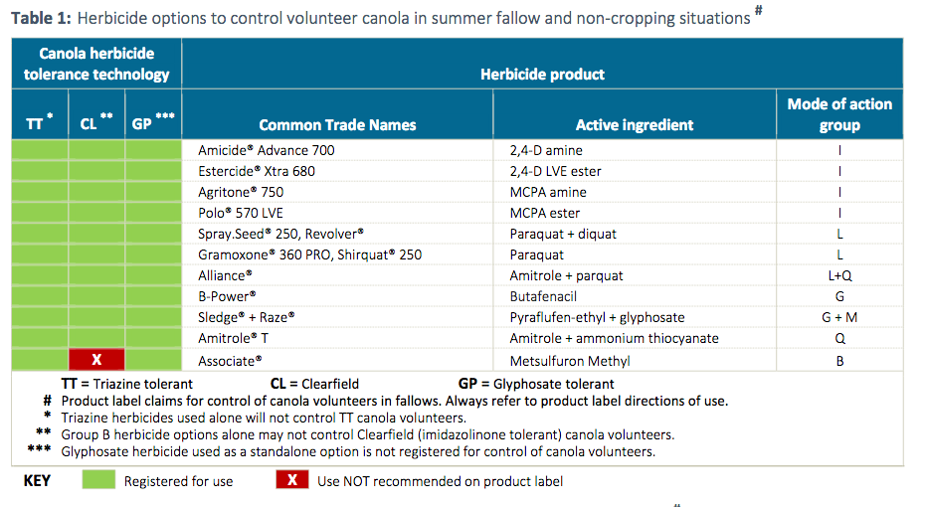

Source: Canola Volunteer Control, Australian Oilseeds Federation, Spring Edition Version 2, 2019.

**Table 4. Pre-plant herbicide options to control canola volunteers in winter crop situations#**

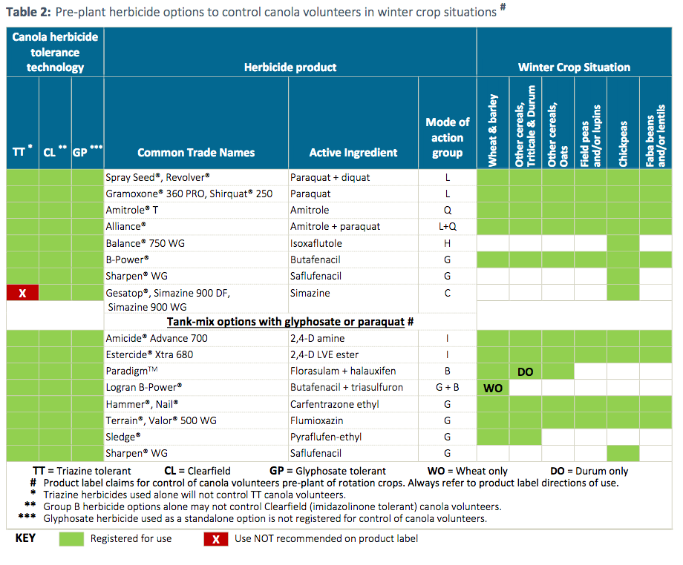

Source: Canola Volunteer Control, Australian Oilseeds Federation, Spring Edition Version 2, 2019.

**Table 5. Post-emergent herbicides to control volunteer canola in winter crop situations#**

Table 5. Post-emergent herbicides to control volunteer canola in winter crop situations#


Source: Canola Volunteer Control, Australian Oilseeds Federation, Spring Edition Version 2, 2019.

**Table 6. Herbicide options to control volunteer cotton**

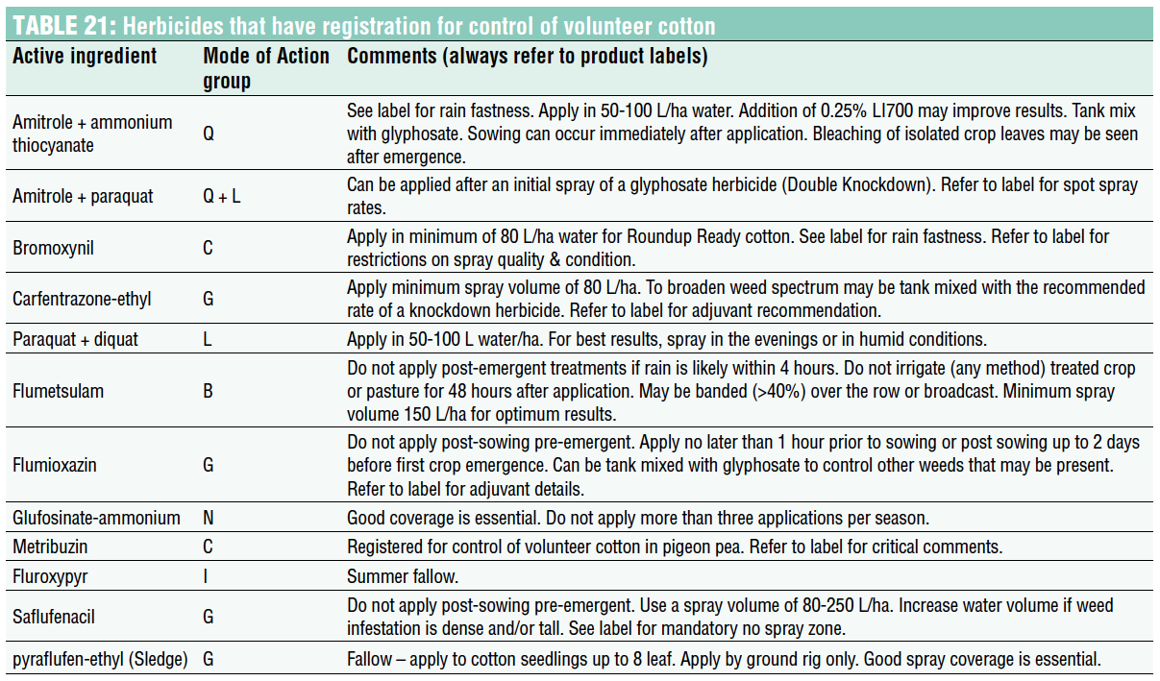

Source: Cotton Pest Management Guide 2019-20, CRDC and Cotton Info, 2019.

**Table 7. Herbicide options to control large 15 to 30 node volunteer cotton and rattoon cotton**

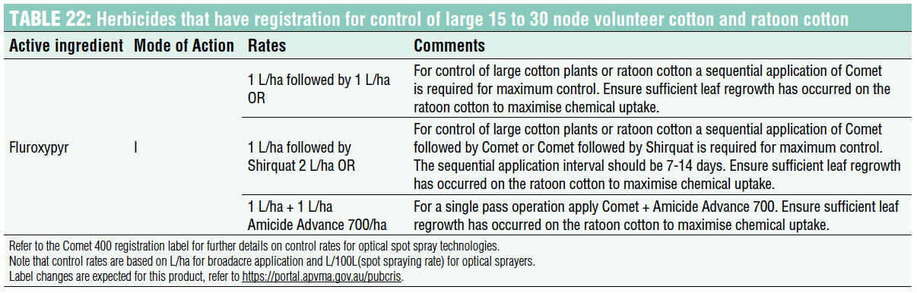

Source: Cotton Pest Management Guide 2019-20, CRDC and Cotton Info, 2019.

## Appendix 2. Herbicide resistance in Australia

**Table 8. Herbicide resistance confirmed to at least one herbicide mode of action group in Australia in grass weeds**

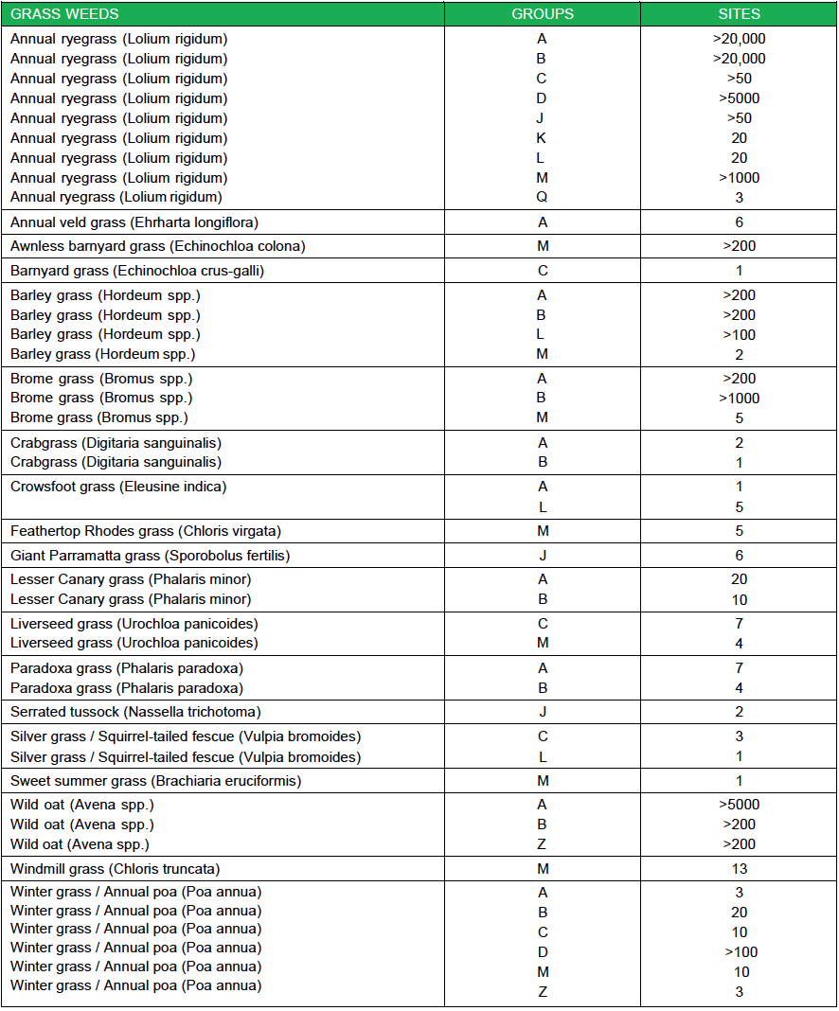

Source: CropLife Australia, [List of herbicide resistant weeds in Australia](https://www.croplife.org.au/wp-content/uploads/2019/06/Herbicide-Resistant-Weeds.pdf), complied by Chris Preston University of Adelaide, valid as at 27 June 2019, accessed as at 22 June 2020.

**Table 9. Herbicide resistance confirmed to at least one herbicide mode of action group in Australia in broadleaf weeds**

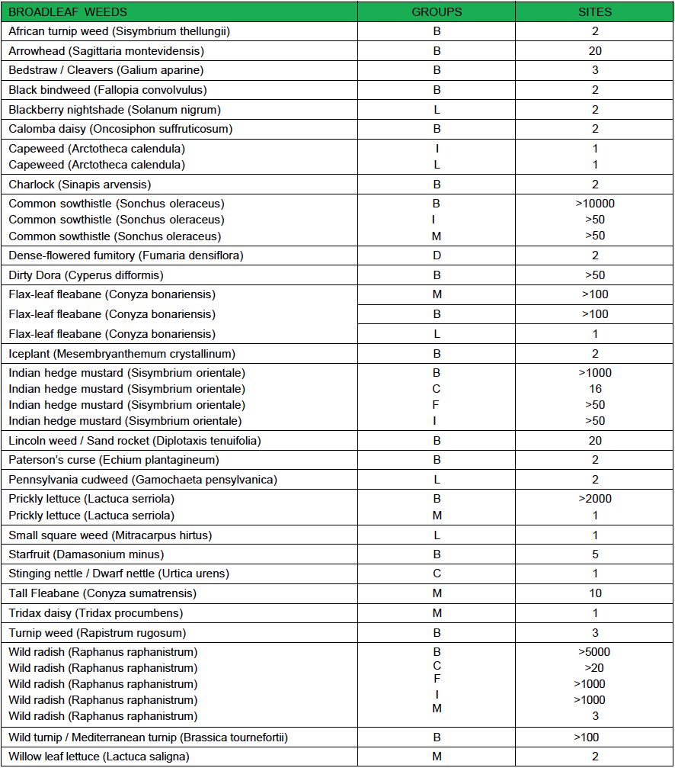

Source: CropLife Australia, [List of herbicide resistant weeds in Australia](https://www.croplife.org.au/wp-content/uploads/2019/06/Herbicide-Resistant-Weeds.pdf), complied by Chris Preston University of Adelaide, valid as at 27 June 2019, accessed as at 22 June 2020.

**Table 10. Herbicide resistance reported in Australian cotton and canola crops**

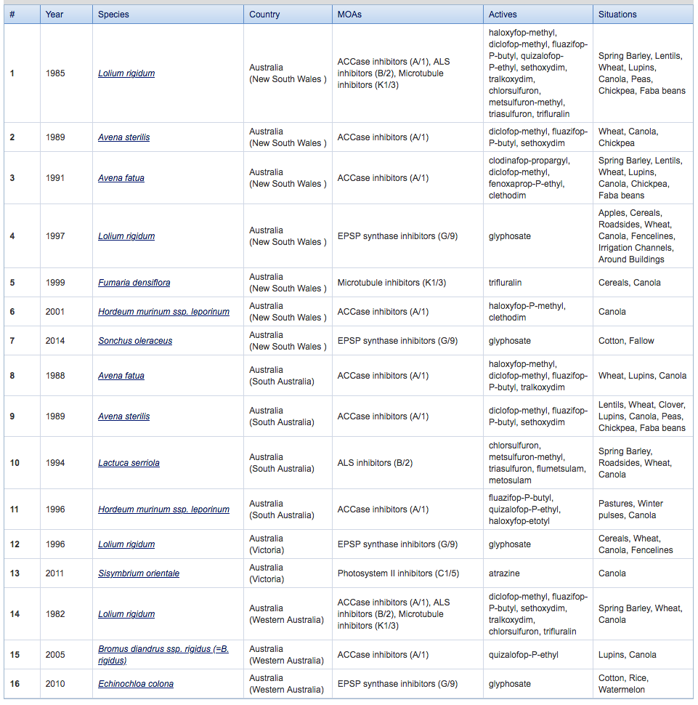

Source: Heap I, [The International Survey of Herbicide Resistant Weeds](http://weedscience.org), accessed 22 June 2020.

# Background on Author

Rohan Rainbow is Managing Director of Crop Protection Australia, a wholly owned business of Rainbow & Associates Pty Ltd established in 2001. Originally from a farming family background, Dr Rainbow has over 30 years of experience in industry leadership in the fields of agronomy, farming systems development, crop protection technology, breeding for biotic traits and biosecurity preparedness. Dr Rainbow is also a national specialist in agricultural engineering, precision agriculture, robotics and automation, which integrate with these biological technologies. Dr Rainbow has extensive experience in leadership, strategic planning, management and delivery of new agricultural technologies resulting in industry practice change.

With established relationships at senior levels of government, plant science and chemical manufacturers, research and development corporations (RDCs), agricultural machinery and technology manufacturers, and grower organisations nationally and internationally, Dr Rainbow has significant experience in the delivery of reforms to national programs, technology development, agricultural industry practice change and technology adoption.

Dr Rainbow has overseen the development and implementation of a number of industry strategies in plant breeding, GM biotic trait development, crop protection, biosecurity, food and feed safety, farming systems, precision agriculture, robotics and automation and digital data. During the 7.5 years as the GRDC senior plant health manager including Theme leader - Protecting Your Crop, Dr Rainbow oversaw the delivery of over $40 million pa investment in plant genetics, including GMO biotic traits, cultural management, pesticide and biosecurity RD&E investment programs.

Dr Rainbow also managed the delivery of a number of reviews including the Australian Cereal Rust Control Program, Australian Centre for Necrotrophic Fungal pathogens, Australian Herbicide Resistance Initiative and National Pathology Review. In his role with the ACRCP and other biotic pre-breeding programs, Dr Rainbow has overseen GRDC engagement in the Global Rust Initiative and Russian Wheat Aphid pre breeding programs, which have operated under the International Treaty for Plant Genetic Resources for Food and Agriculture.

Since re-establishing his role as an industry consultant in Canberra, Dr Rainbow has used his significant experience in the delivery of reforms to crop protection, pesticide minor and emergency use plus industry initiated pesticide registration programs. Dr Rainbow has continued with a significant role on the Executive Committee with the cross-industry National Working Party on Pesticide Applications, has facilitated the establishment of a cross-industry AgVet Collaborative Forum and has supported Grain Producers Australian in establishing a cross-industry Pesticide Taskforce.

Dr Rainbow has recently supported CropLife Australia in delivery of national chemical stewardship programs and an [Official Australian reference guide for organic, synthetic and biological pesticides](https://www.croplife.org.au/resources/reports/the-official-australian-reference-guide-for-organic-synthetic-and-biological-pesticides/) (CropLife Australia 2021).

1. [Cornell University College of Agriculture & Life Sciences](http://turf.cals.cornell.edu/pests-and-weeds/environmental-impact-quotient-eiq-explained/)
2. [Weed it Precision spraying](https://www.weed-it.com/)
3. [WeedSeeker 2 Spot Spray](https://agriculture.trimble.com/product/weedseeker-spot-spray-system/)
4. [Landcare Australia](https://landcareaustralia.org.au/project/usq-and-john-deere-partnership-developing-next-generation-of-agricultural-technology/)
5. [Agrifac](https://www.agrifac.com/condor/new-innovations/aicplus)
6. [Blue River Technology](http://www.bluerivertechnology.com/)
7. [CropLife Australia Resistance Management](https://www.croplife.org.au/resources/programs/resistance-management/)
8. [CropLife Australia Stewardship](https://www.croplife.org.au/our-focus/stewardship/)
9. [CropLife Australia MyAgCHEMuse](https://www.croplife.org.au/resources/programs/myagchemuse/)
10. [European Commission](https://ec.europa.eu/food/plant/pesticides/eu-pesticides-database/public/)
11. [United States Environmental Protection Agency](https://www.epa.gov/ingredients-used-pesticide-products/paraquat-dichloride)
12. [Australian Pesticides and Veterinary Medicines Authority](https://apvma.gov.au/node/12666)
13. [OGTR Website](https://www.ogtr.gov.au/about-ogtr/australias-gene-technology-regulatory-system)
14. [Food Standards Australia New Zealand Website](https://www.foodstandards.gov.au/consumer/gmfood/safety/Pages/default.aspx)
15. [APVMA website](https://apvma.gov.au/node/15866)
16. [APVMA Trade Advice Notices](https://apvma.gov.au/node/11046)
17. [Grain Trade Australia Website](https://www.graintrade.org.au/nwpgp)
18. [The University of Sydney Cereal Rust Research](https://www.sydney.edu.au/science/our-research/research-areas/life-and-environmental-sciences/cereal-rust-research.html)
19. [Department of Agriculture, Water and the Environment Crops Cotton](https://www.agriculture.gov.au/ag-farm-food/crops/cotton)
20. [Department of Agriculture, Water and the Environment ABARES Financial performance of cropping farms](https://www.agriculture.gov.au/abares/research-topics/surveys/grains)