* 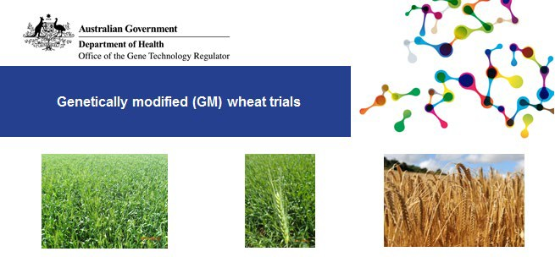Wheat is one of a number of GM crops that have been approved for experimental field planting in Australia.
* There have been trials of GM wheat that sought to improve salt tolerance, drought resistance, disease resistance, yield, grain quality, grain nutrients and nutrient use efficiency.
* GM wheat is not grown commercially in Australia, and is not licenced for commercial release.
* The Gene Technology Regulator (the Regulator) carries out science-based risk analysis before approving field trials of GM wheat.
* Any work with GM wheat in Australia must be licenced by the Regulator. Criminal charges can apply for unauthorised dealings with GM plants of any kind.

Since 2005, the Regulator has issued 22 licences for small- field, early-stage research trials of GM wheat. To date, four of these field trial licences are still current. For further details, see the table on the next page.

There has been no commercial release of GM wheat in Australia, and to date the Regulator has not received any licence applications for the commercial release of GM wheat.

Each field trial is limited in its size and duration. For example, DIR 165 allows up to 2 hectares per site per year over 5 years. This is limited to 2 sites in the first year and 10 sites per year in the remaining 4 years.

The trials are subject to strict containment conditions to manage the potential for spread and persistence of the GM wheat and its introduced genes into the wider environment.

The OGTR actively inspects trials to make sure they are compliant with licence conditions. There have been no breaches of containment with any of these field trials.

GM wheat from these trials is not permitted to enter commercial human food or animal feed supplies. CSIRO researchers are developing wheat and wheat products that

might improve nutritional properties such as glycaemic index. The Regulator has authorised CSIRO to conduct trials involving feeding foods containing GM wheat to animals and people under some licences. These studies are also subject to approval by ethics committees who consider animal and human ethical issues.

Some of these trials are ongoing, while some have concluded. For full details on each trial visit the [GMO record](https://www.ogtr.gov.au/what-weve-approved/dealings-involving-intentional-release).

Related factsheets

Genetically modified (GM) crops in Australia

Genetically modified (GM) canola in Australia

Stockfeed and genetically modified (GM) crops

Further reading

Genetically modified organisms in Australia

How are genetically modified organisms (GMOs) regulated in Australia?

|  |  |
| --- | --- |
| Version 1.4 | March 2021 |

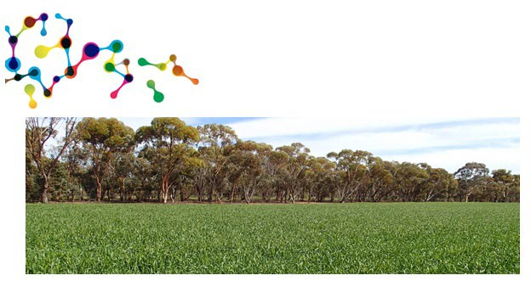

**Current licences for limited and controlled releases (field trials) of GM wheat (as of March 2021)**

|  |  |  |  |
| --- | --- | --- | --- |
| **Licence No** | **Licence holder** | **Modified Trait** | **Issued** |
| [DIR 165](https://www.ogtr.gov.au/gmo-dealings/dealings-involving-intentional-release/dir-165) | The University of Melbourne | Composition – food (human nutrition) | April 2019 |
| [DIR 162](https://www.ogtr.gov.au/gmo-dealings/dealings-involving-intentional-release/dir-162) | CSIRO | Disease resistance | July 2018 |
| [DIR 152](https://www.ogtr.gov.au/gmo-dealings/dealings-involving-intentional-release/dir-152) | University of Adelaide | Enhanced yield, Abiotic stress tolerance | July 2017 |
| [DIR 151](https://www.ogtr.gov.au/gmo-dealings/dealings-involving-intentional-release/dir-151) | CSIRO | Disease resistance, Drought tolerance, Composition - food (processing), Composition - food (human nutrition) | May 2017 |