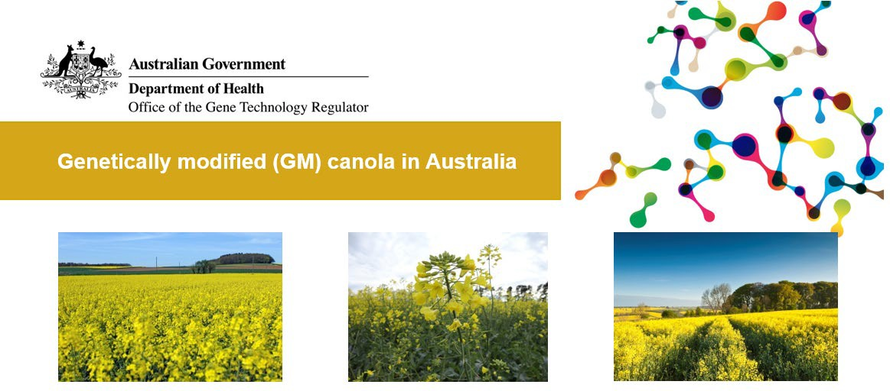

* GM canola currently grown in Australia is resistant to glyphosate herbicides. It offers potential economic and environmental gains for farmers.
* GM canola can only be grown with the approval of the Gene Technology Regulator (the Regulator), who carries out a science-based risk assessment before the crop is approved for release.
* Some state governments have further restrictions on growing GM canola.
* There are additional guidelines for use of GM canola in stockfeed and for dealing with GM canola growing on the roadside (volunteer plants)
* Criminal charges can apply for non- authorised dealings with GM crops of any kind.

Canola is grown for its seed which is crushed for the oil used in margarine, cooking oils, salad oils and edible oil blends. After the oil is extracted, the by-product is a protein-rich meal used to feed livestock. Canola is grown around Australia and is easily recognised by its vivid yellow flowers.

About 20 per cent of the national canola crop is genetically modified. GM canola currently licenced to be commercially grown in Australia is resistant to herbicides. The ACT, South Australia and Tasmania have legislation banning farming of GM canola due to marketing concerns.

# Assessment of GM canola

The OGTR carried out scientific assessments of GM canola and the Regulator authorised the first commercial release of two herbicide- resistant types in 2003. The OGTR risk assessment found that these types of GM canola posed no more risk to

health and the environment than non- GM canola.

Since 2003, the Regulator has issued seven additional licences for the commercial release of GM canola. This allowed the approved GM canola to be grown throughout Australia.

Currently, the only GM canola grown commercially in Australia is glyphosate-tolerant canola.

Other types of GM canola have been approved for commercial release in Australia including canola tolerant to the herbicide glufosinate, canola tolerant to both glyphosate and glufosinate and canola producing long chain omega-3 oil. However, these are not currently being grown commercially.

The commercial approvals of GM canola to date are listed below. The latest information on commercial approvals is available online as part of the [GMO Record](https://www.ogtr.gov.au/what-weve-approved/dealings-involving-intentional-release).

|  |  |  |  |  |
| --- | --- | --- | --- | --- |
| Licence number | Licence holder | Trade name | Modified trait/s | Issued |
| [DIR 178](https://www.ogtr.gov.au/gmo-dealings/dealings-involving-intentional-release/dir-178) | BASF Australia Ltd | N/A | Herbicide tolerance; hybrid breeding system | 16 Sep 2021 |
| [DIR 175](https://www.ogtr.gov.au/gmo-dealings/dealings-involving-intentional-release/dir-175) | BASF Australia Ltd | N/A | Herbicide tolerance; hybrid breeding system | 12 May 2021 |
| [DIR 155](https://www.ogtr.gov.au/gmo-dealings/dealings-involving-intentional-release/dir-155) | Nuseed Pty Ltd | DHA canola | Omega-3 oil content | 13 Feb 2018 |
| [DIR 139](https://www.ogtr.gov.au/gmo-dealings/dealings-involving-intentional-release/dir-139) | Pioneer Hi-Bred Australia Pty Ltd | OptimumTM GLY canola | Herbicide tolerance | 29 Mar 2016 |
| [DIR 138](https://www.ogtr.gov.au/gmo-dealings/dealings-involving-intentional-release/dir-138) | BASF Australia Ltd | InVigor® x TruFlex™ Roundup Ready® canola | Herbicide tolerance; hybrid breeding system | 22 Mar 2016 |
| [DIR 127](https://www.ogtr.gov.au/gmo-dealings/dealings-involving-intentional-release/dir-127) | Monsanto Australia Ltd | TruFlex™ Roundup Ready® canola (MON 88302) | Herbicide tolerance | 21 Nov 2014 |
| [DIR 108](https://www.ogtr.gov.au/gmo-dealings/dealings-involving-intentional-release/dir-108) | BASF Australia Ltd | InVigor® x Roundup Ready® canola | Herbicide tolerance; hybrid breeding system | 2 Dec 2011 |
| [DIR 021/ 2002](https://www.ogtr.gov.au/gmo-dealings/dealings-involving-intentional-release/dir-0212002) | BASF Australia Ltd | InVigor® canola | Herbicide tolerance; hybrid breeding system | 25 Jul 2003 |
| [DIR 020/ 2002](https://www.ogtr.gov.au/gmo-dealings/dealings-involving-intentional-release/dir-0202002) | Monsanto Australia Ltd | Roundup Ready® canola | Herbicide tolerance | 19 Dec 2003 |



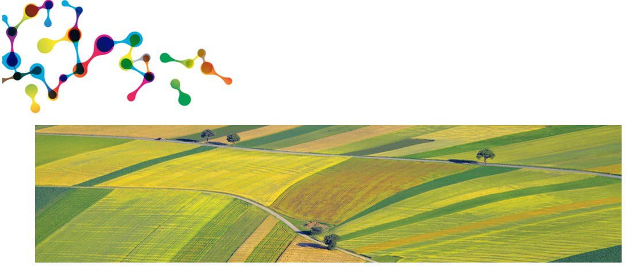

The OGTR monitors scientific and other literature for any new information relevant to GM crops, and assesses that information in relation to existing licences. The OGTR also maintains oversight of commercially grown GM canola, to ensure it remains safe.

If something changes, and a GM crop can no longer be considered safe, the Regulator has the power to revoke existing licences to grow the crop. To date, no information has arisen in Australia or internationally to indicate that GM canola commercially grown in Australia is no longer safe, or that licences issued since 2003 should be suspended.

You can read the risk assessment and risk management plan for each application and other details of the licences through the [GMO Record](https://www.ogtr.gov.au/what-weve-approved/dealings-involving-intentional-release).

# Other regulators

The OGTR does not regulate the use of GM products in food. This is the role of Food Standards Australia New Zealand (FSANZ). They have a process for assessing the safety of GM foods. Read more at the [FSANZ website](http://www.foodstandards.gov.au/).

The use of herbicides on GM herbicide-tolerant canola varieties is regulated by the [Australian Pesticides and Veterinary Medicines Authority](http://www.apvma.gov.au/), which applies conditions to ensure responsible use of herbicides, and to minimise the development of weeds with herbicide resistance.

# Why isn’t GM canola grown in all states?

Each state and territory has the power to temporarily or indefinitely ban GM crops for trade or marketing reasons on a case-by-case basis.

GM canola is grown in many states in Australia. Canola is generally not grown in the Northern Territory. The

Australian Capital Territory and Tasmanian governments have a range of restrictions.

After the Regulator approved GM canola commercial releases in 2003, most states and territories passed laws to delay the commercial release of GM crops (including GM canola), allowing them to investigate issues such as marketability and trade before the first commercial plantings of GM canola.

Some states and territories have since allowed GM crops such as canola, while some moratoria (bans) remain in place.

The following list describes the status of GM canola in each State and Territory to date:

* **Australian Capital Territory’s**

[moratorium](http://www.legislation.act.gov.au/a/2004-40/default.asp) remains in force.

* **New South Wales** allowed its moratorium on commercial cultivation of GM food crops to lapse at the end of June 2021. GM canola restrictions were lifted in 2008.
* **Northern Territory** allows GM canola but canola isn’t a commercial crop.
* **Queensland** has allowed GM canola since 2003.
* **South Australia** allows GM crops to be commercially cultivated in all areas except Kangaroo Island since late 2020.
* **Tasmania** has indefinitely extended [its GM crop and animal moratorium](http://www.thelaw.tas.gov.au/tocview/index.w3p%3Bcond%3D%3Bdoc_id%3D%2B126%2B2005%2BAT%40EN%2B20170706180000%3Bhiston%3D%3Bpdfauthverid%3D%3Bprompt%3D%3Brec%3D%3Brtfauthverid%3D%3Bterm%3D%3Bwebauthverid%3D).
* **Victoria** allowed its moratorium order on commercial production of GM canola to lapse in 2008.
* **Western Australia** granted an exemption in 2010 allowing cultivation of GM canola and revoked its moratorium legislation in 2016.

It is important to note that the state and territory rules relate to issues of market access and not to safety of human health or the environment. You can get more information from the relevant state or territory government – see the links above.

|  |  |
| --- | --- |
| Version 1 | October 2021 |

**Related factsheets:**

GM in agriculture

Genetically modified (GM) crops in Australia - overview

Genetically modified (GM) canola in Australia

Weed control of genetically modified (GM) canola

Genetically-modified (GM) wheat trials

Stockfeed and GM crops

**Further reading**

Genetically modified organisms in Australia

Genetically modified (GM) crops in Australia

How are genetically modified organisms (GMOs) regulated in Australia?

