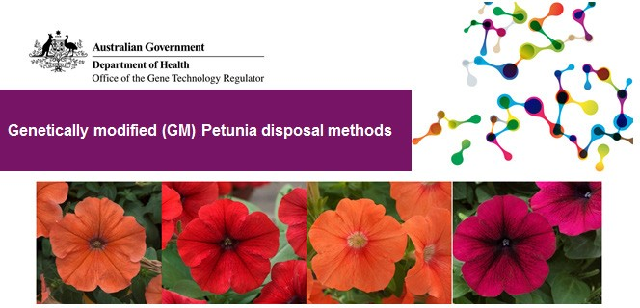

The Gene Technology Regulator (the Regulator) has become aware that unauthorised genetically modified (GM) petunias have entered the Australian and international markets. Although an [OGTR assessment](https://www.ogtr.gov.au/resources/publications/gm-petunia-risk-analysis) has found that these GM petunias do not pose a risk, they have not been approved for commercial release in Australia and therefore must not be marketed.

Petunia plants are unlikely to survive without human help. The GM petunias can be left to die naturally. If you don’t want to wait for them to die naturally the Regulator has provided the following instructions for the disposal of GM petunias and their seeds.

# Live GM petunia plants

Any method of disposal including:

* application of a herbicide that is effective in killing Petunia plants;
* uprooting;
* desiccation;
* incineration; or
* any method expected by a person growing Petunia to kill Petunia plants.

# Viable GM petunia seeds

Any of the following methods of disposal:

* + incineration;
  + autoclaving;
  + boiling in water for at least 20 minutes;
  + heating, for instance in an oven, to a temperature of at least 150°C for at least 30 minutes;
  + microwaving at a power of at least 800W for at least 10 minutes; or
  + deep burial at biosecurity waste class 8.2 site approved by the Department of Agriculture and Water Resources.

More information, including a factsheet about the GM petunias and the Regulator’s risk assessment is available on the [OGTR website](https://www.ogtr.gov.au/what-weve-approved/inadvertent-dealings-id).

Related factsheets:

Genetically modified (GM) Petunias in Australia

Genetically modified (GM) crops in Australia

Further reading

Genetically modified organisms in Australia

How are genetically modified organisms (GMOs) regulated in Australia?

|  |  |
| --- | --- |
| Version 1 | 1 June 2017 |
| Version 2 | June 2018 |
| Version 3 | November 2021 |

