The Gene Technology Regulator (the Regulator) has become aware that unauthorised genetically modified (GM) petunias have entered the Australian and international markets. The Regulator is aware that at least twenty varieties of GM petunia have been imported into Australia and a full list of GM petunia varieties in Australia can be found on the [OGTR website](https://www.ogtr.gov.au/gmo-dealings/inadvertent-dealings/id-001). The petunias have been modified to produce a pigment found naturally in other flowering plants.

The OGTR is working to clarify which GM petunias are present in Australia, and is taking appropriate action where the presence of GM plants is confirmed. This includes issuing of licences to importing nurseries to allow handling and transport for disposal of the GM plants.

# Why are GM petunias not allowed in Australia? What are the risks?

Australia’s Gene Technology Regulatory scheme controls the release of genetically modified organisms (GMOs) and is designed to protect human health and safety and the environment. Although an [OGTR assessment](https://www.ogtr.gov.au/resources/publications/gm-petunia-risk-analysis) has found that these GM petunias do not pose a risk, they have not been approved for commercial release in Australia and therefore must not be marketed.

# What about GM petunias in the Australian supply chain?

The Regulator is working with the Australian based importers, suppliers and industry bodies to make it clear to businesses holding GM petunias that they must not be sold and have to be taken off the market. The Regulator has issued licences to allow people to dispose of any GM petunias they may have in their possession and has provided advice to importers and suppliers that the existing stocks of GM petunias should be destroyed.

# What do I do if I have some GM petunias?

Petunia plants are unlikely to survive without human help. The GM petunias can be left to die naturally. If you don’t want to wait for them to die naturally, or if you have any unplanted seedlings, there are no special methods for disposal (e.g. compost or household rubbish bin is fine). OGTR advice on the destruction of seeds can be found on the [Regulator’s website](https://www.ogtr.gov.au/resources/publications/genetically-modified-gm-petunia-disposal-methods). However, as the GM petunias have not been approved for commercial release it is an offence to knowingly plant or otherwise propagate them.

# What types of GM plants are allowed in Australia? Are GM seeds permitted?

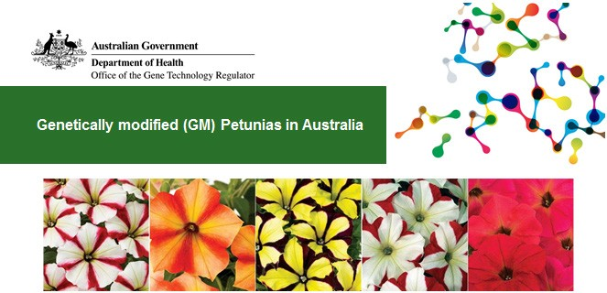GMOs cannot be brought into Australia or grown without appropriate authorisation. The Regulator has approved some types of GM cotton, canola, carnations and safflower for commercial cultivation in Australia, and a number of other GM plants for field trials. GM seeds (and other types of GMOs) can also be brought in by researchers, but this requires authorisation and the GMOs must not be released into the environment.

Details can be found on

the [Regulator’s website](https://www.ogtr.gov.au/). The Department of Agriculture and Water Resources also regulates [the import of seeds into Australia](https://www.awe.gov.au/biosecurity-trade/import/goods/plant-products/seeds-for-sowing).

Related factsheets:

Genetically modified (GM) crops in Australia

Genetically modified (GM) Petunia disposal methods

Further reading

Genetically modified organisms in Australia

How are genetically modified organisms (GMOs) regulated in Australia?

|  |  |
| --- | --- |
| Version 1 | 17 May 2017 |
| Version 2 | 1 June 2017 |
| Version 3 | 29 June 2017 |
| Version 4 | June 2018 |
| Version 5 | November 2021 |

