Commercially available kits are used in Australian schools to help science students learn about genetics. For example, there are kits for adding fluorescent colours to bacteria. The kits generally use bacteria that have a long history of safe use in schools, university teaching laboratories and research and are on the OGTR’s ‘exempt dealings’ list. As such, most GMO studies in schools do not require licensing by the Regulator as long as the school follows good laboratory practice.

To formally determine your obligations if you are using GMOs in your school you should:

* Ask the supplier of the kit if the organisms in the kit are covered by OGTR exempt dealings.
* Ask the supplier about best practice for use of the specific GMO kit in the school laboratory.
* Read about containment of GMOs

– the OGTR has developed [notes on how to avoid releasing a GMO into the environment.](https://www.ogtr.gov.au/resources/publications/guidance-notes-containment-exempt-dealings)

* Follow good laboratory practice and don’t release your GMOs into the environment. This includes:
  + storing any unused GMOs safely in a sealed container;
  + keeping doors and windows shut while you work with the GMOs;
  + disinfecting hands, surfaces and anything that might have touched the GMOs once you are finished; and
  + disposing of all waste and left over reagents properly.

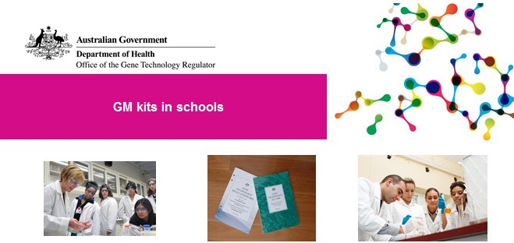Your formal obligations

You must ensure that your experiments are classified as Exempt dealings

To be classified as Exempt Dealings, experiments must meet the definition of an Exempt Dealing in the legislation (as described in Part 1, Schedule 2, of the Regulations) and must not release viable GMOs outside the classroom or the laboratory.

Read what the Act says here: [What dealings with GMOs are classified as exempt dealings?](https://www.ogtr.gov.au/resources/publications/dealings-classified-exempt-1-september-2011)

If a school is unable to meet these conditions, then you must seek approval from the Regulator.

Related factsheets

Who needs to apply to import or use (deal with) a GMO?

Genetically modified organisms in Australia

Genetically modified (GM) crops in Australia

How are genetically modified organisms (GMOs) regulated in Australia?

|  |  |
| --- | --- |
| Version 1 | January 2014 |
| Version 2 | June 2018 |
| Version 3 | November 2021 |

